**Capstone-Project**

**Application:**

Clone the below mentioned repo and deploy the application. (Run the application in port 80 [HTTP])

**Checking Git version:**

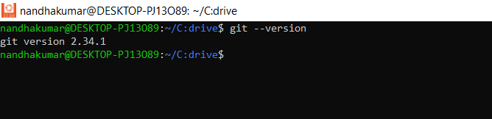

**Cloning the repository:**

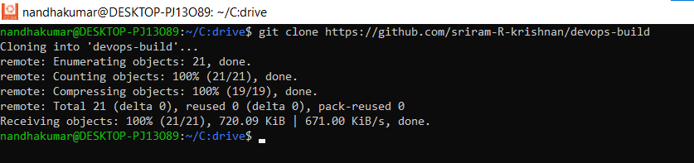

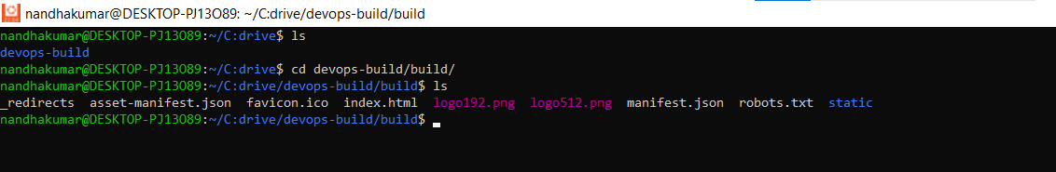

**Checking Docker & Docker-compose version:**

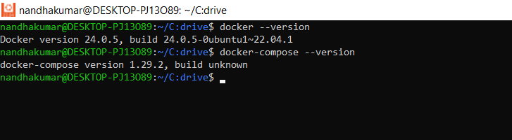

**Creating Dockerfile, Dockerignore file:**

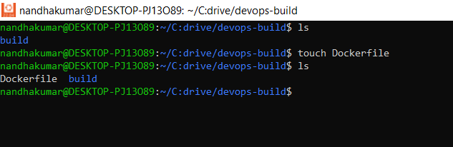

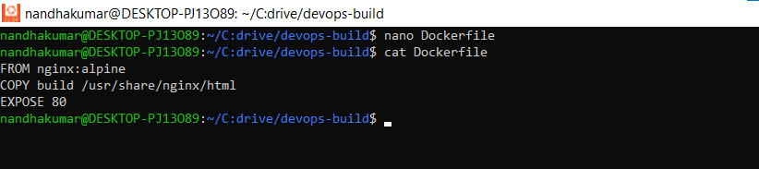

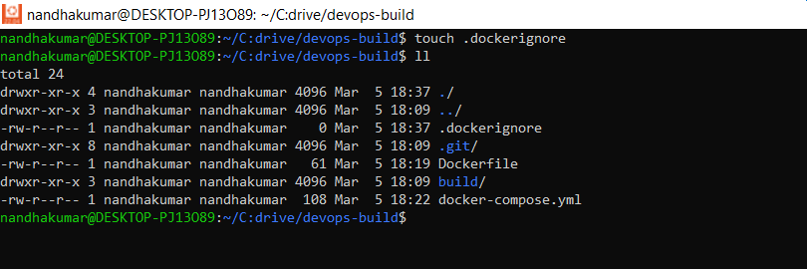

**Creating build.sh file:**

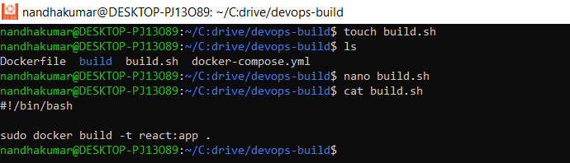

**Building docker image using build.sh file:**

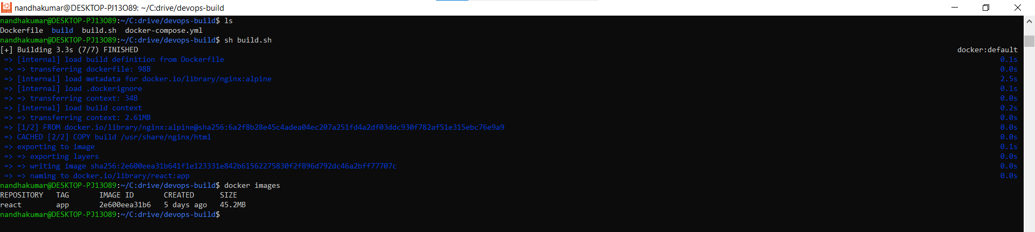

**Creating Docker-compose file:**

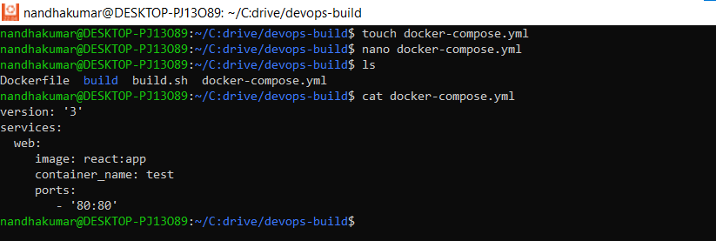

**Creating deploy.sh file: (just to run the image)**

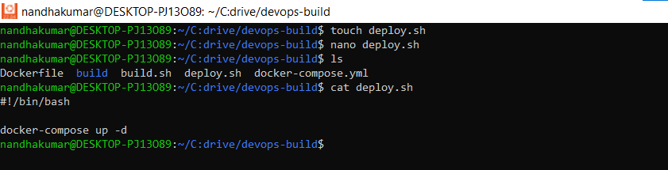

**Deploying docker image using deploy.sh in :**

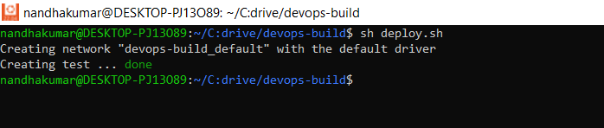

**Running Application in port 80: (http://localhost:80)**

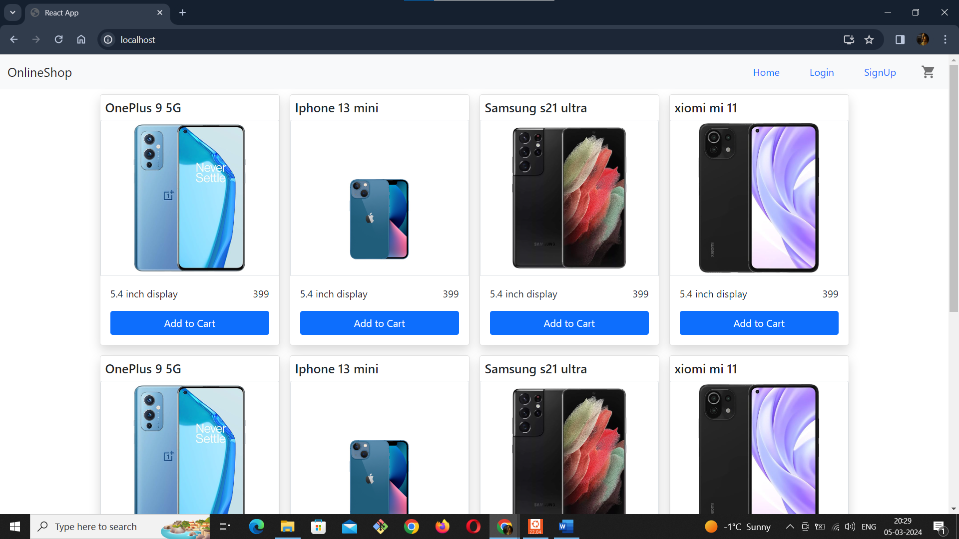

**Creating Git Repository:**

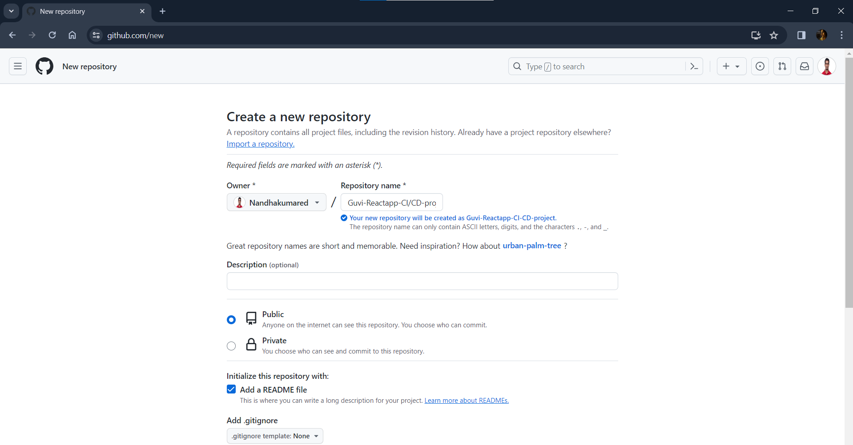

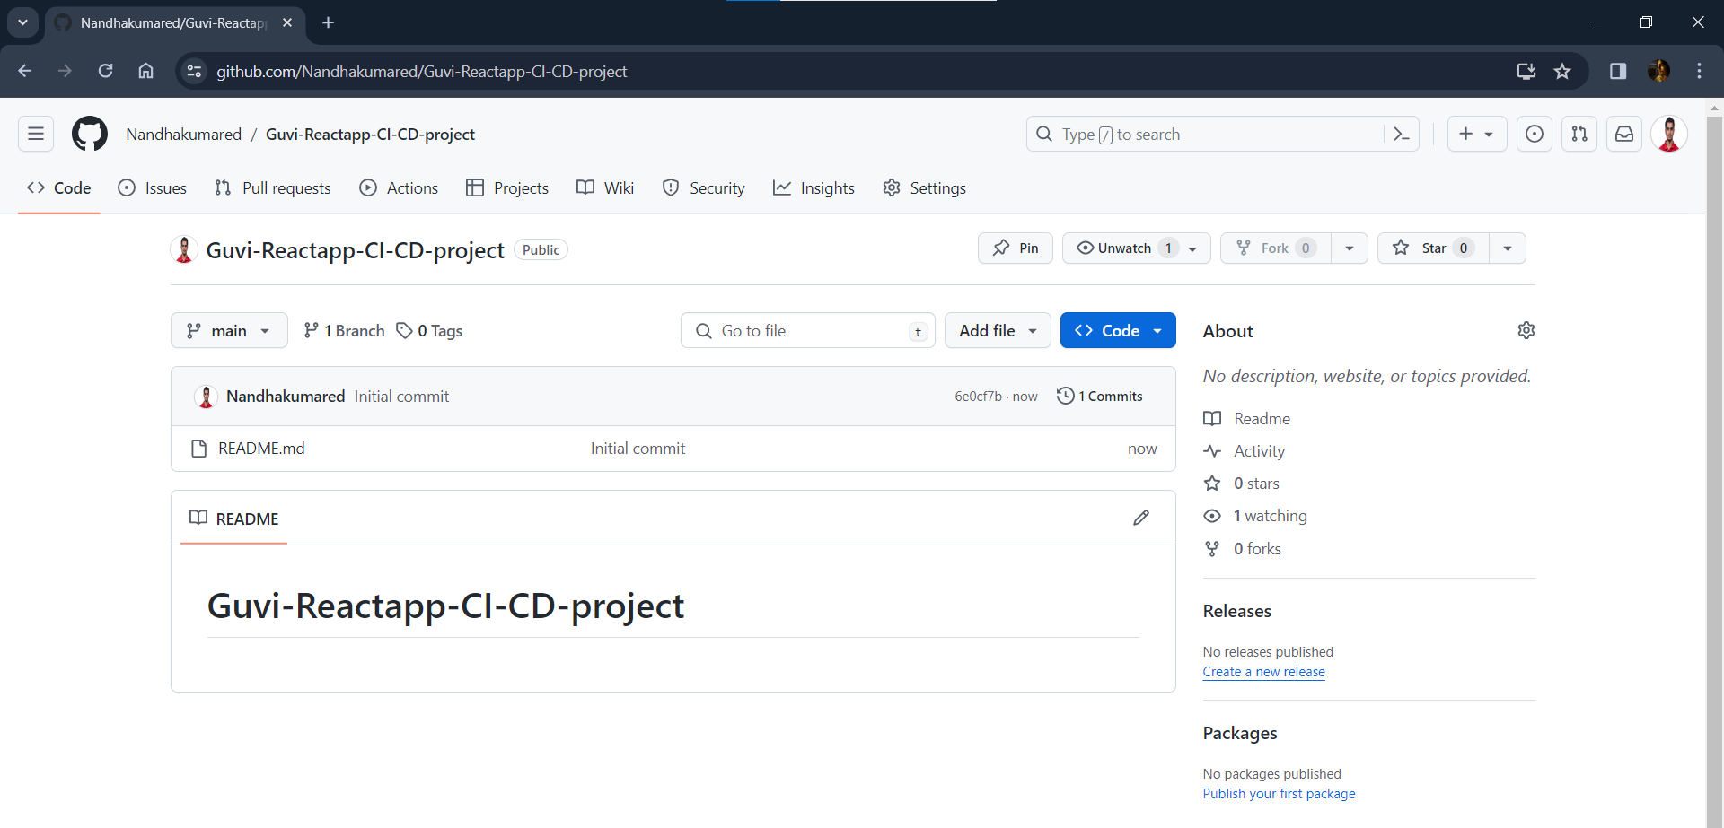

**Renaming main to master:**

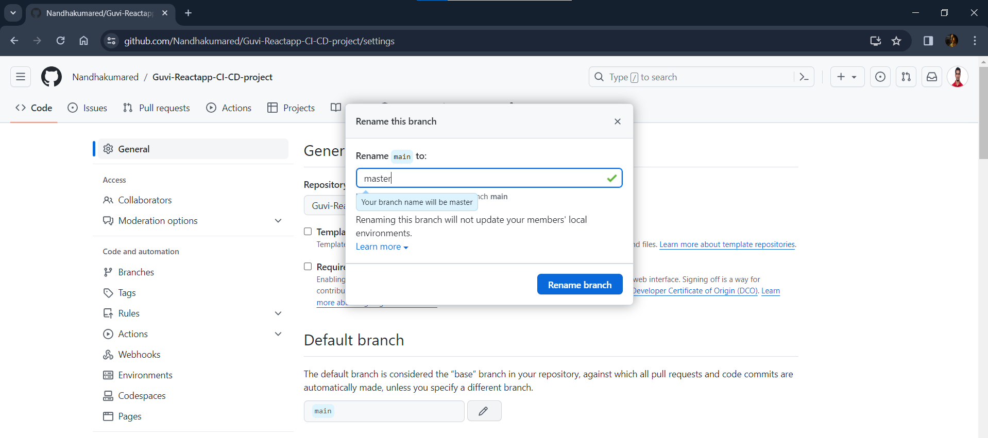

**Creating New branch Dev:**

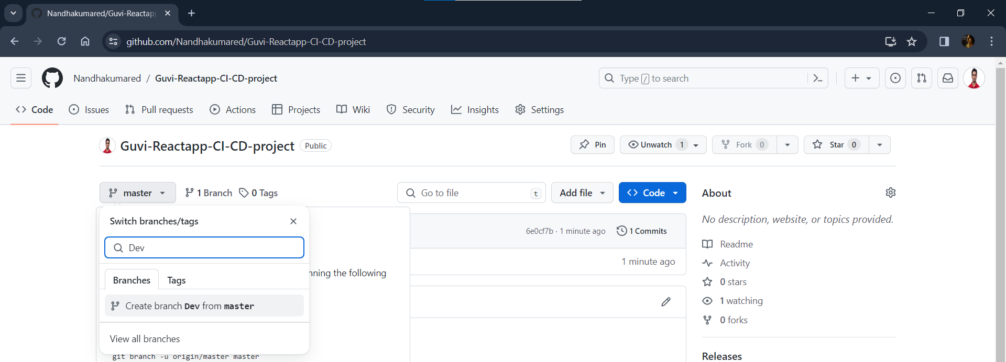

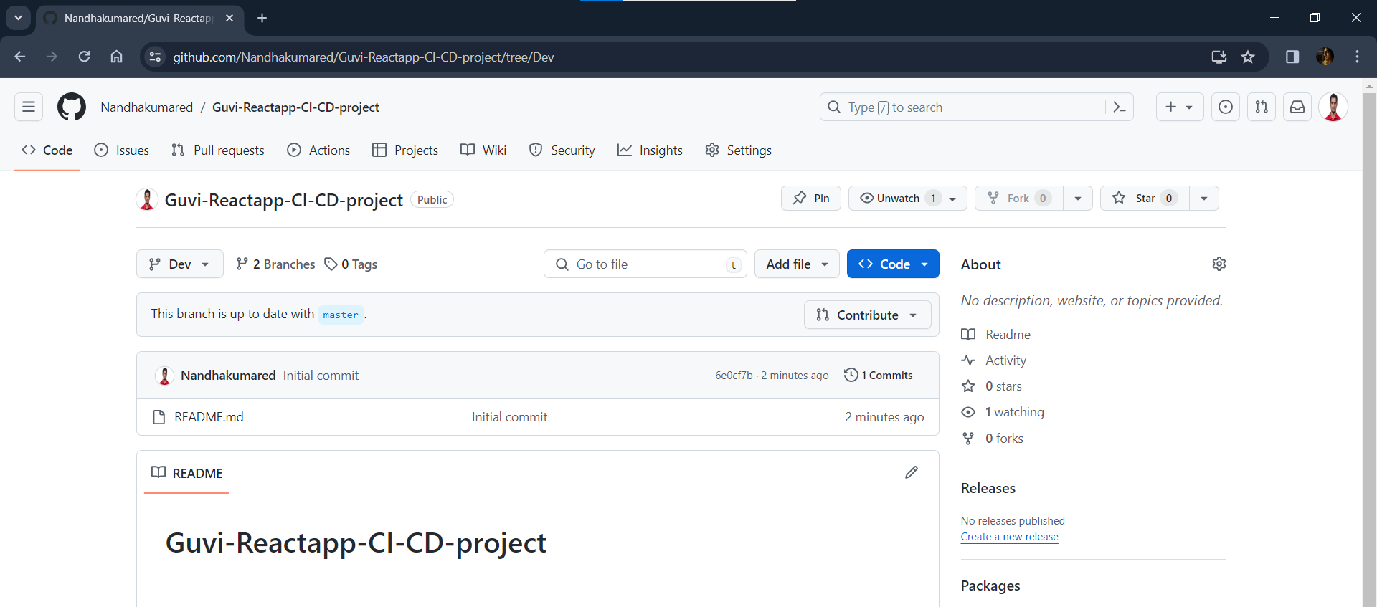

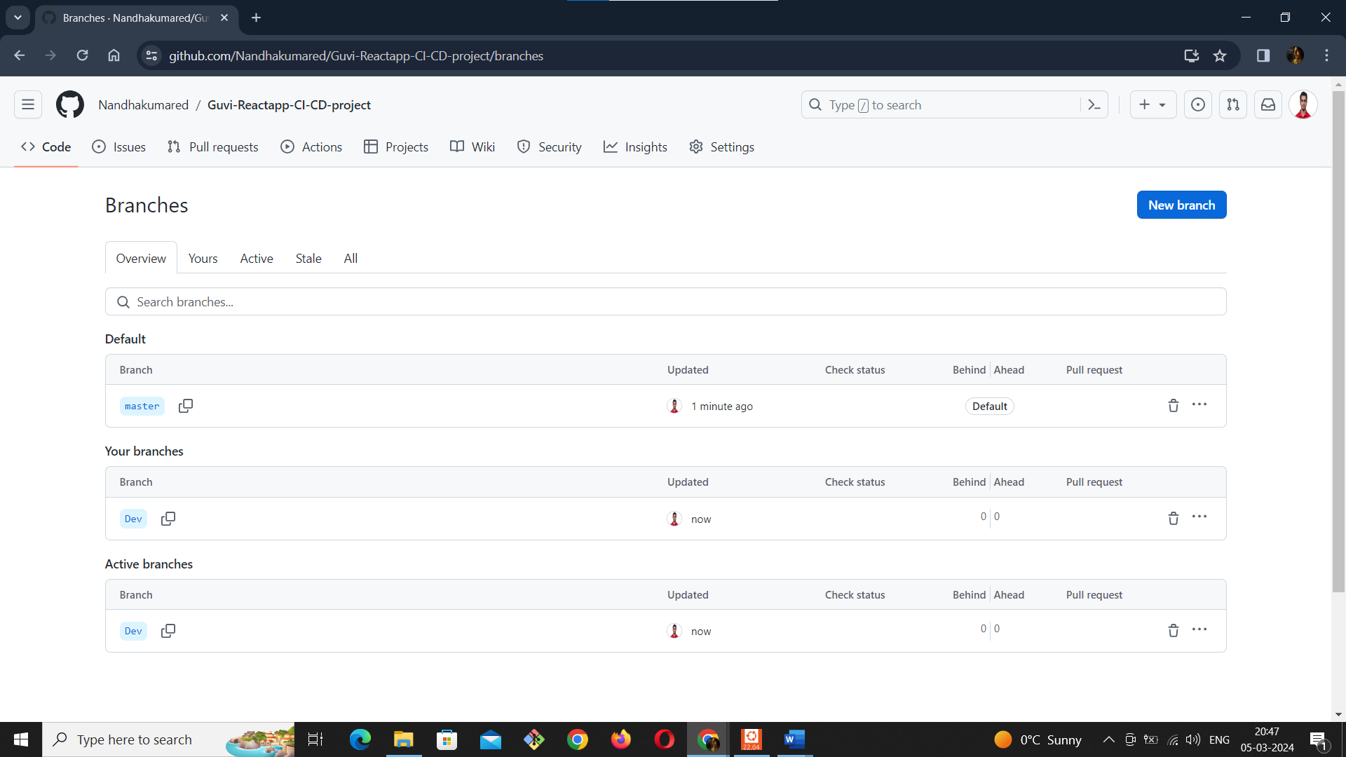

**Creating Two Repositories Docker Hub:**

**Public Repo – Dev:**

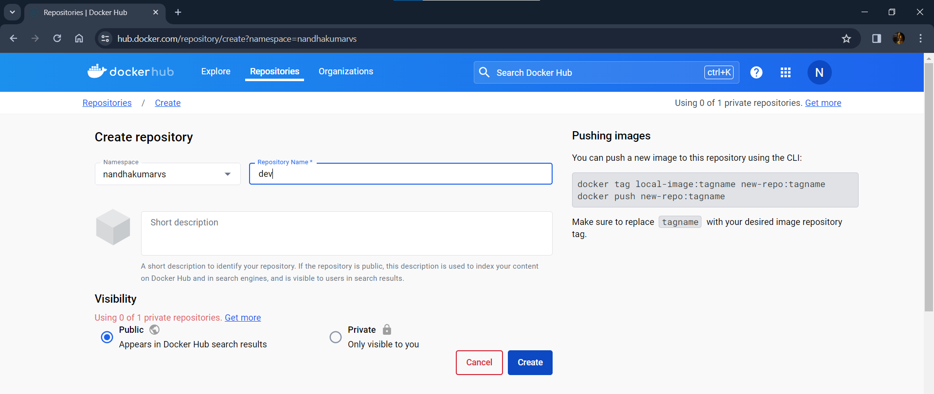

**Private Repo – prod:**

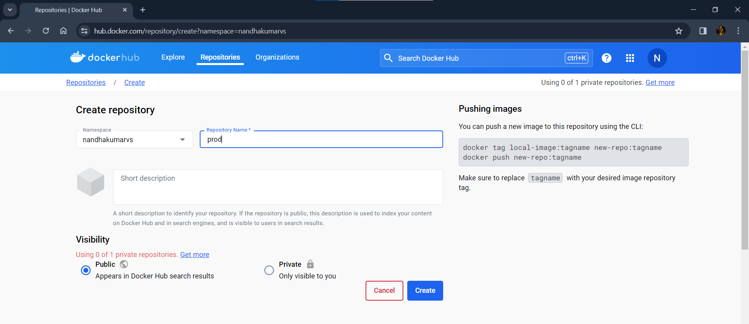

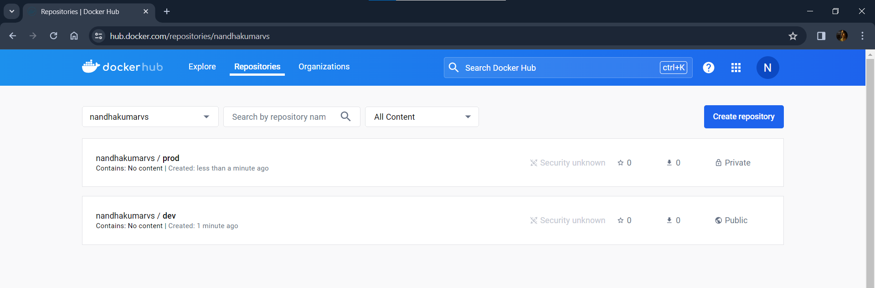

**Jenkins Installation and Configuration process:**

**Creating AWS EC2 for Jenkins server:**

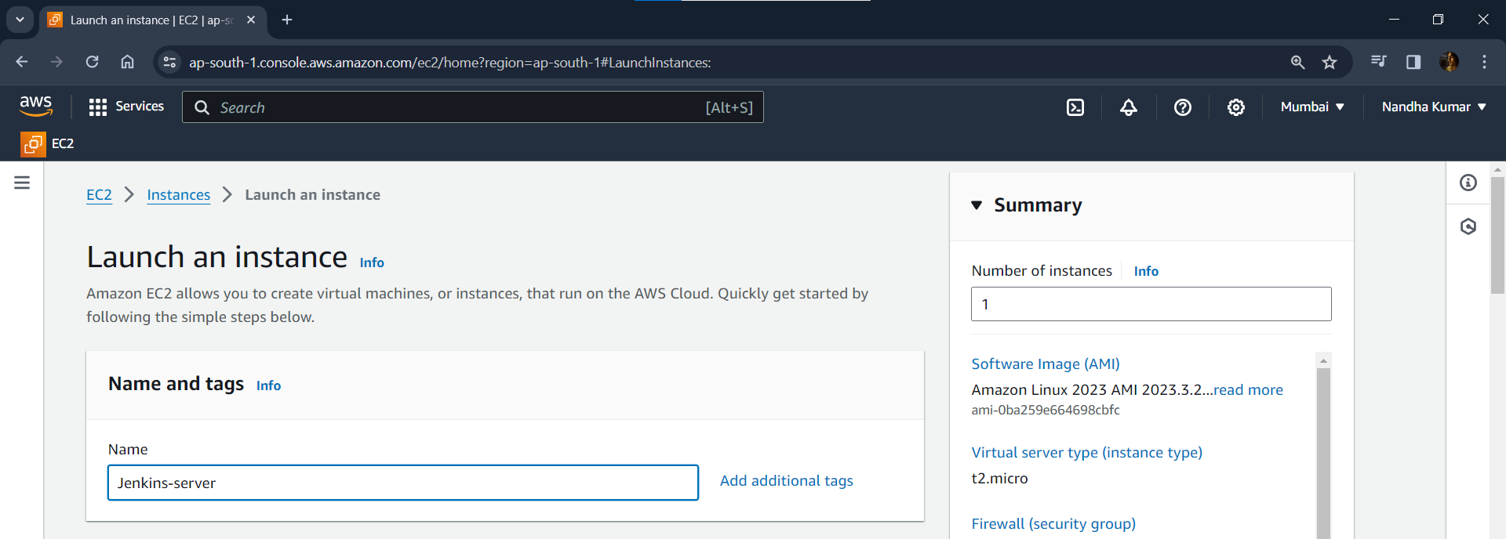

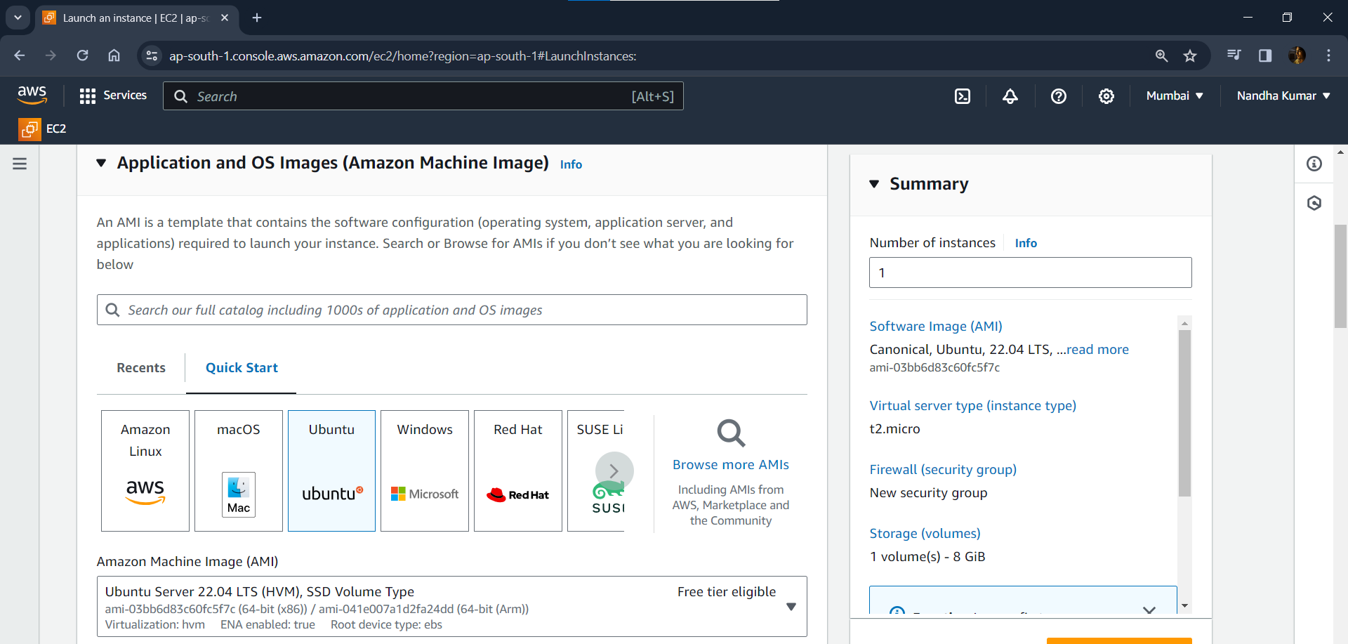

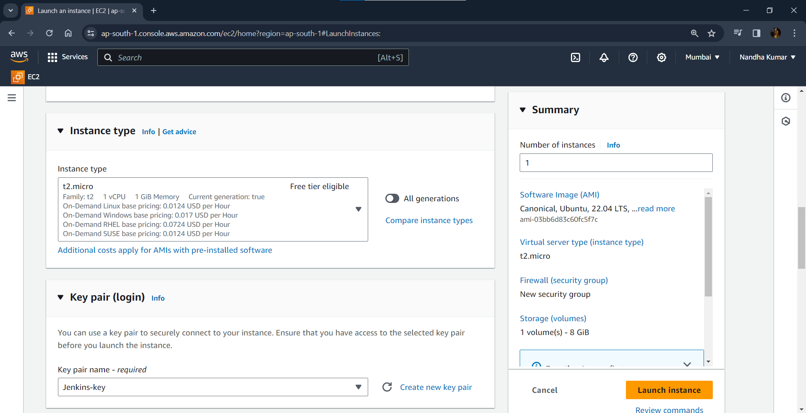 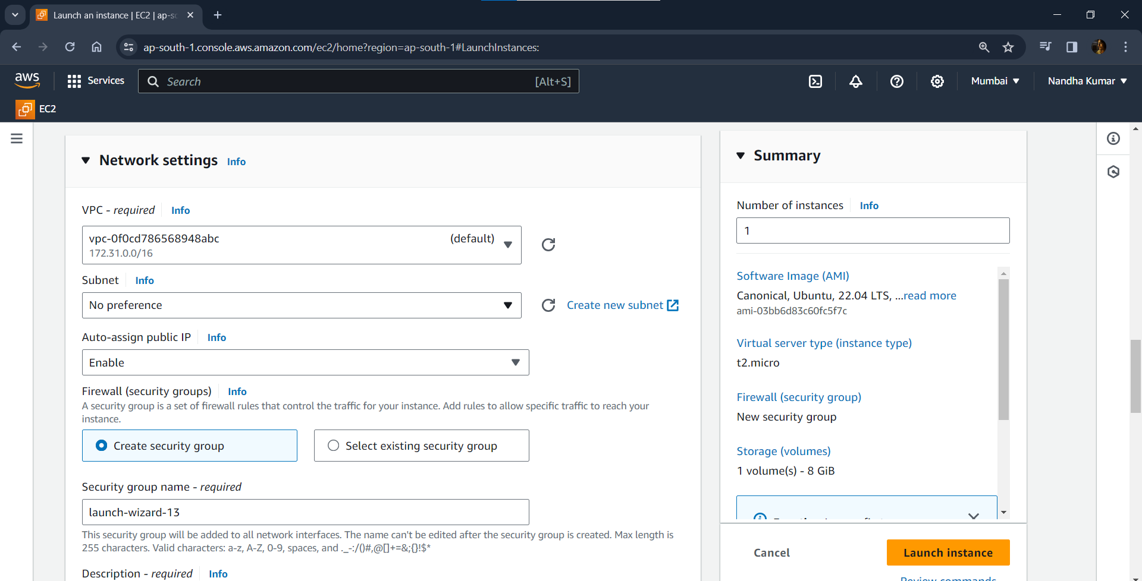 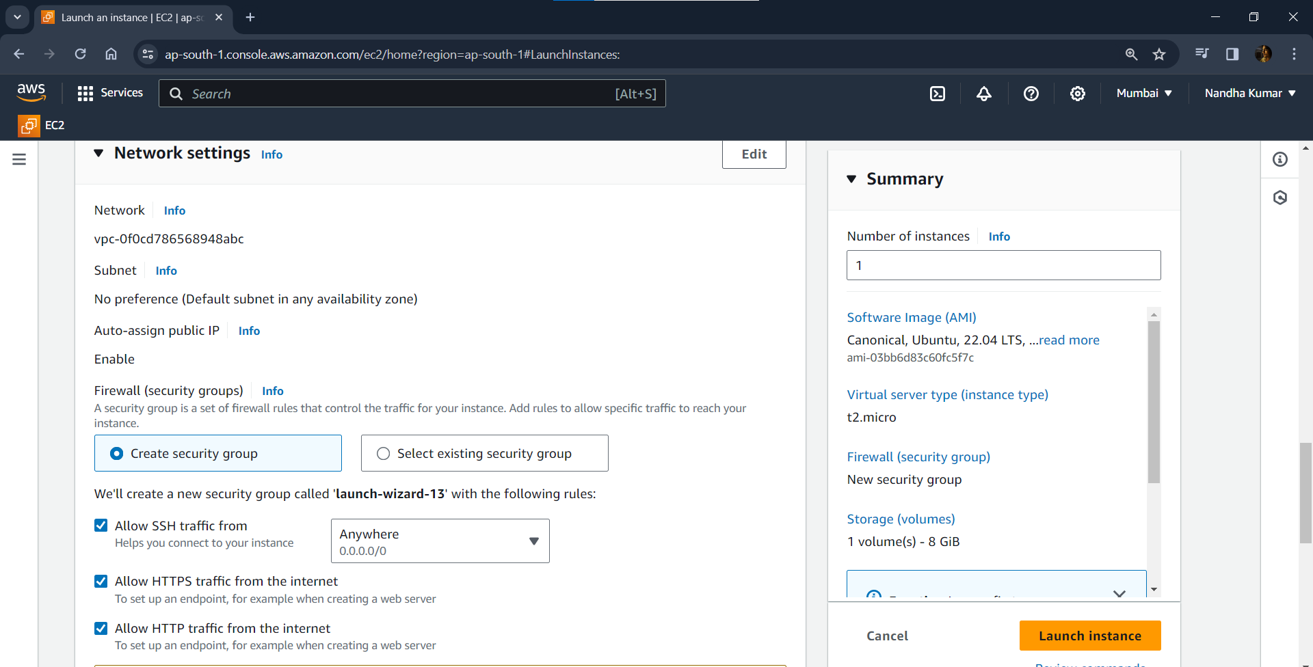

**Editing inbound rules:**

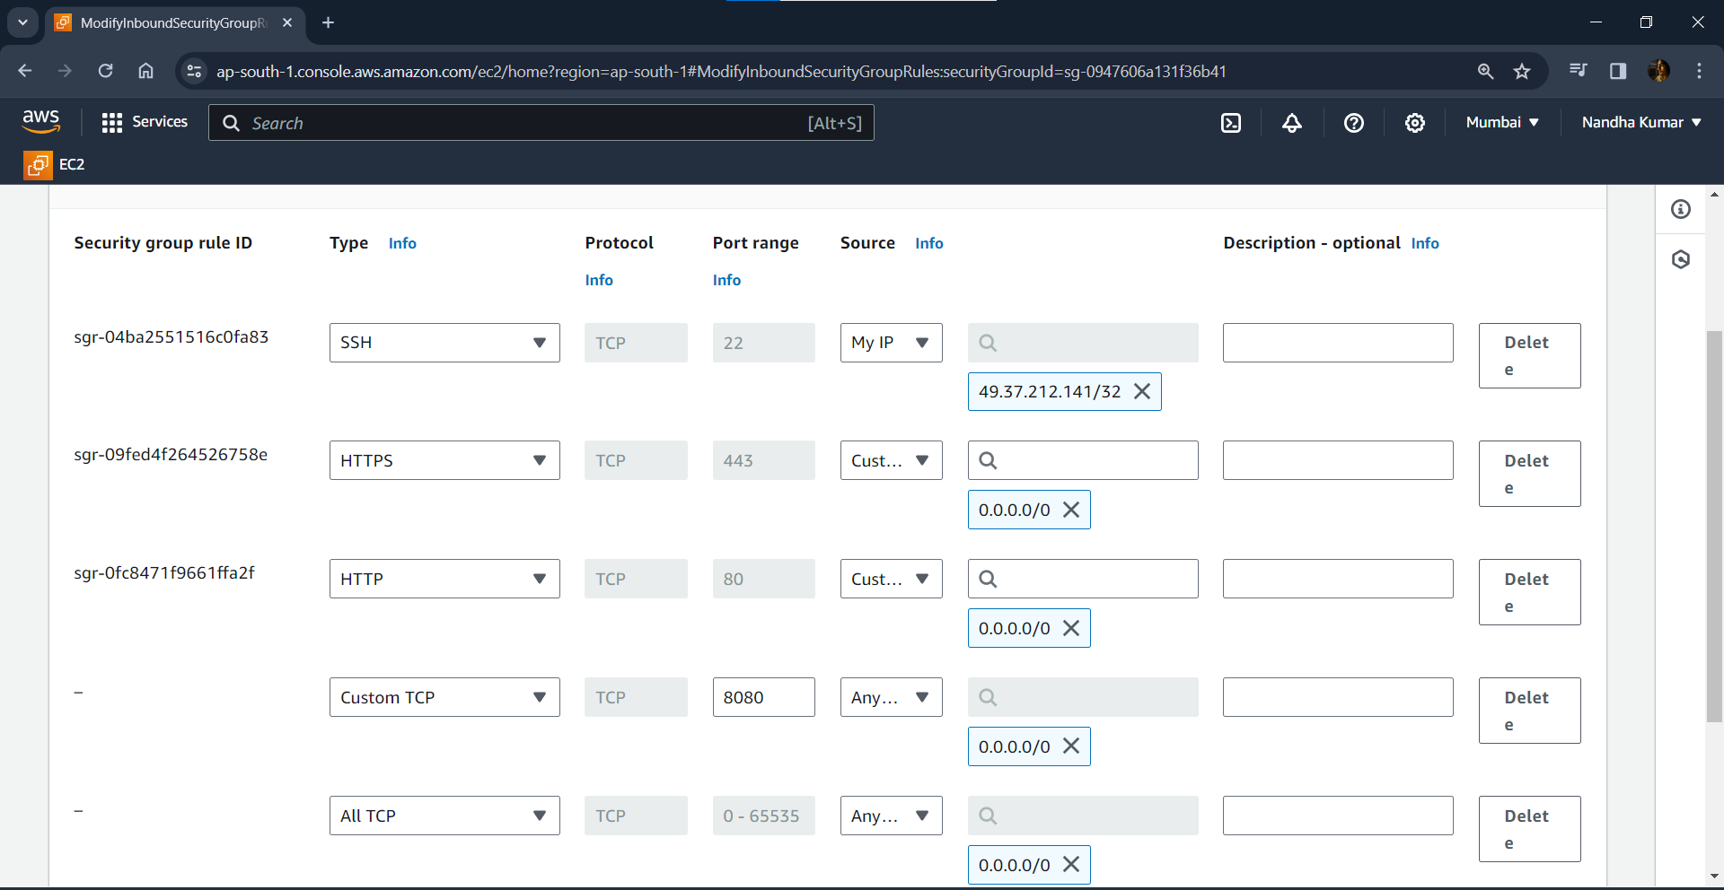

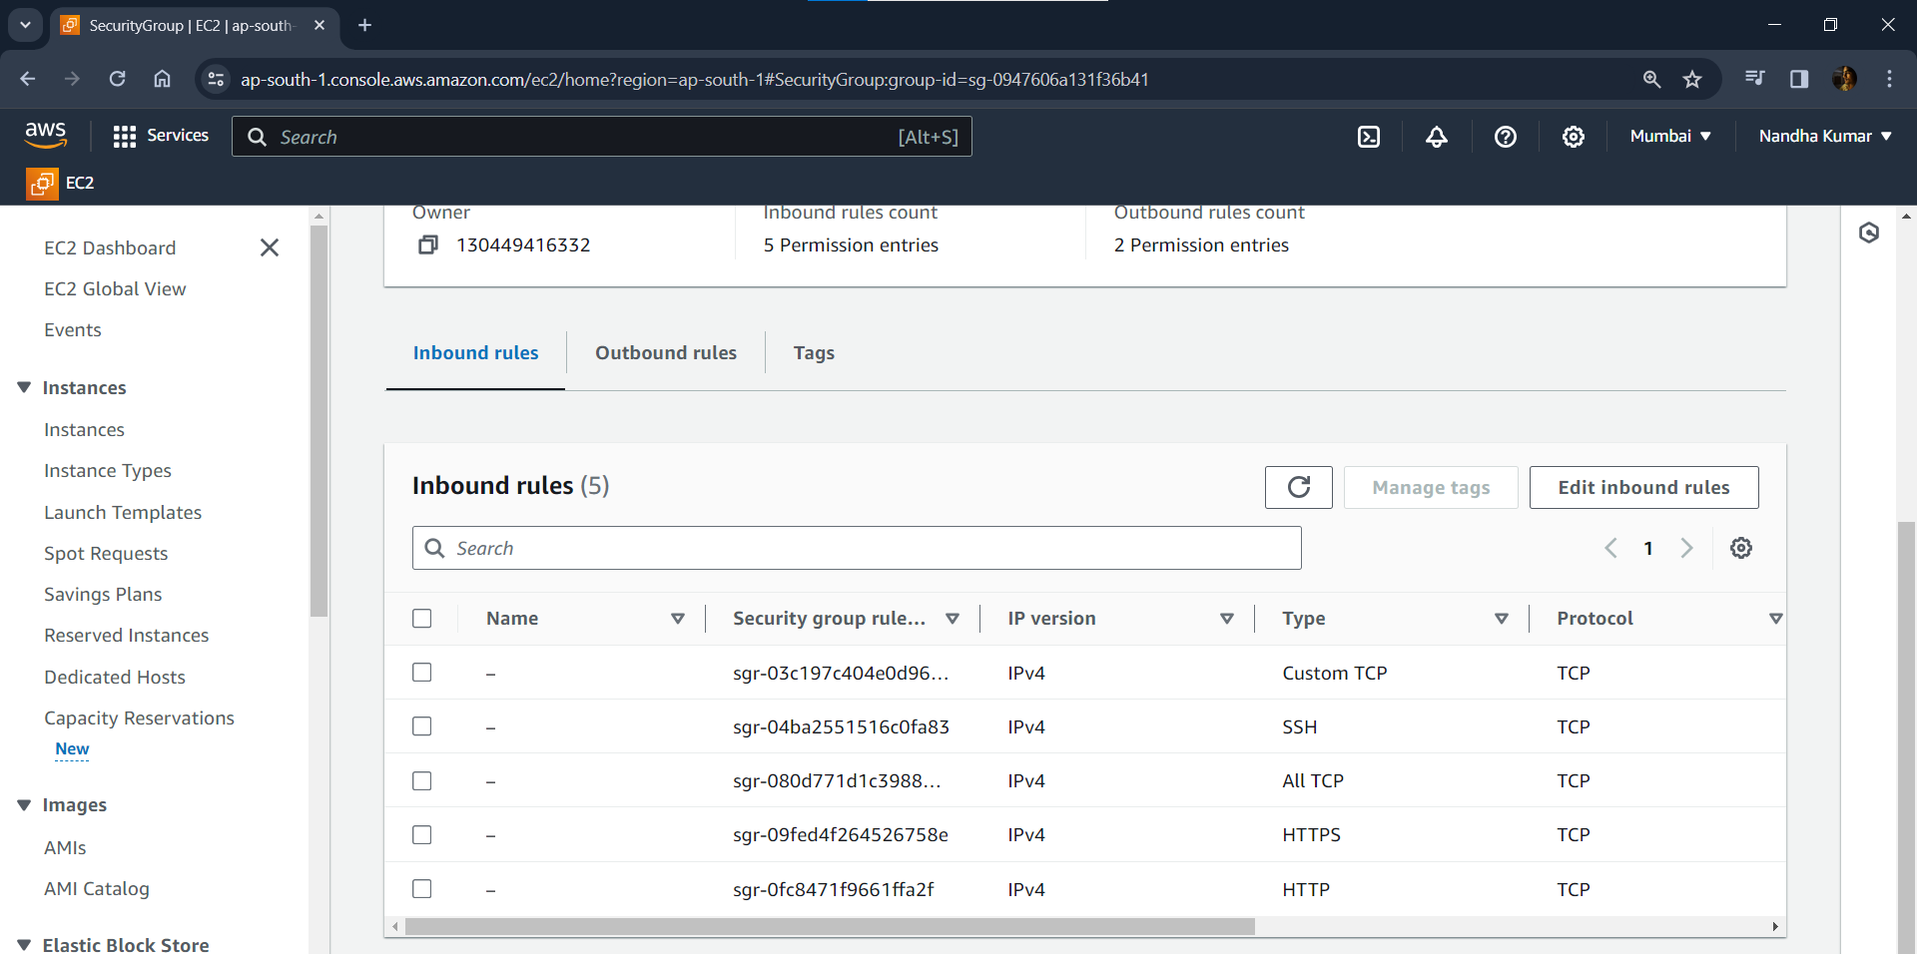

**Connecting to instance via SSH:**

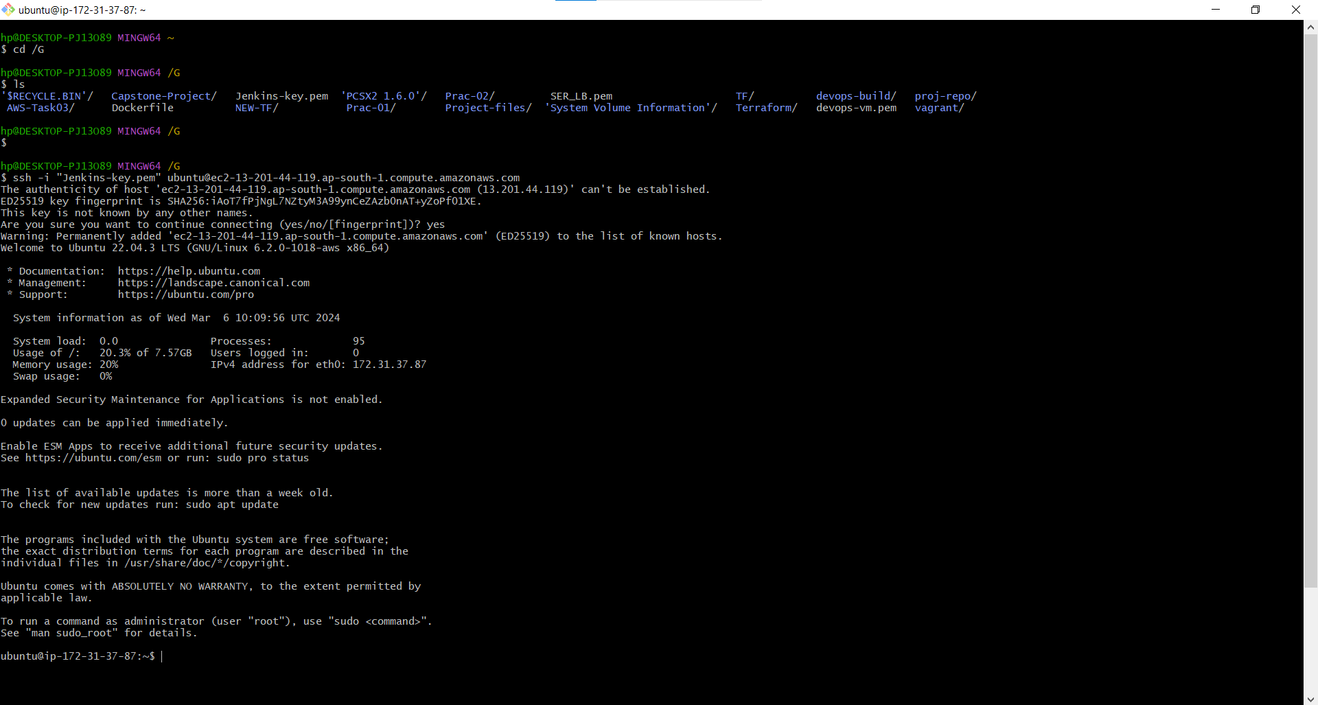

**Installing Jenkins:**

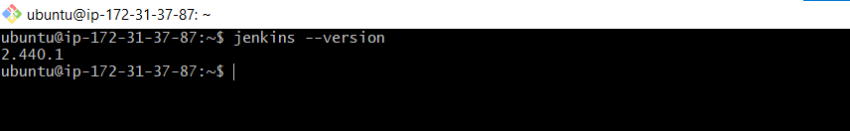 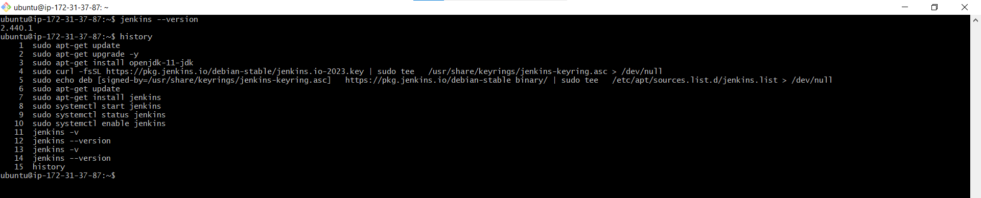

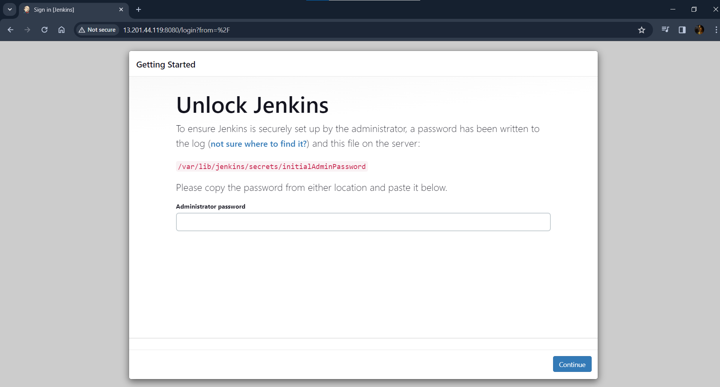

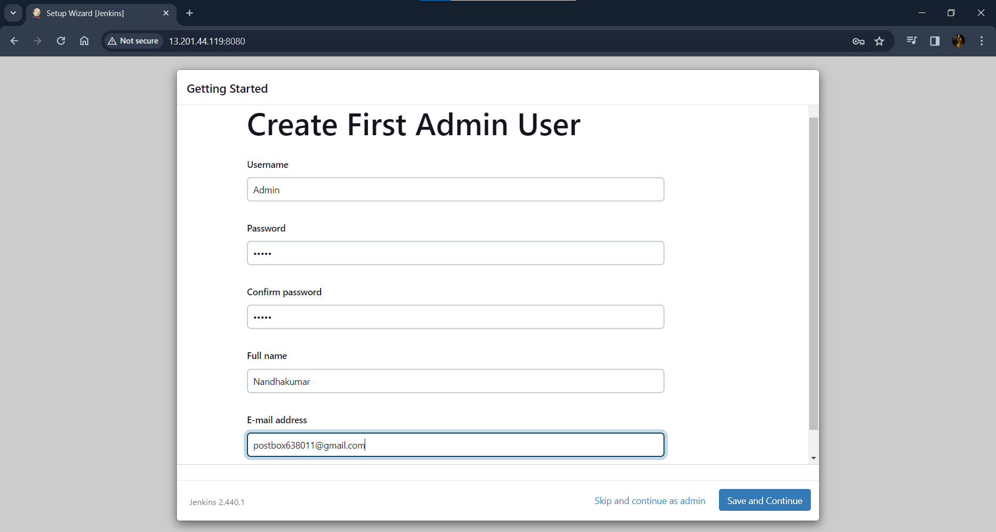

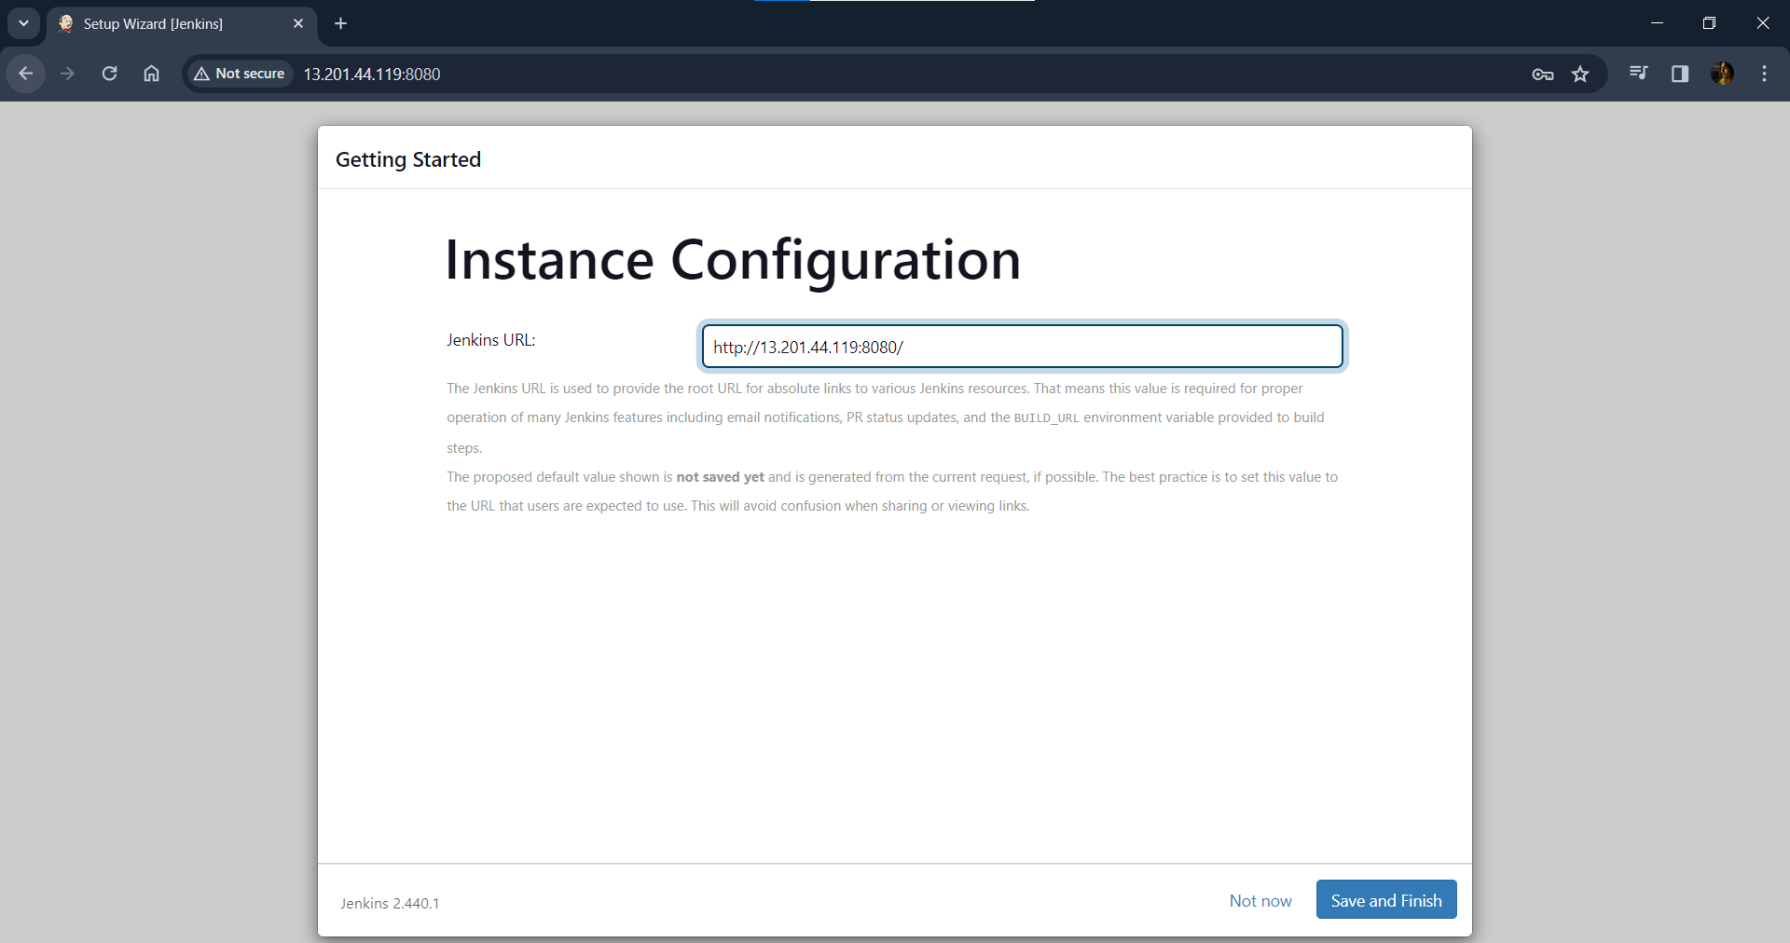

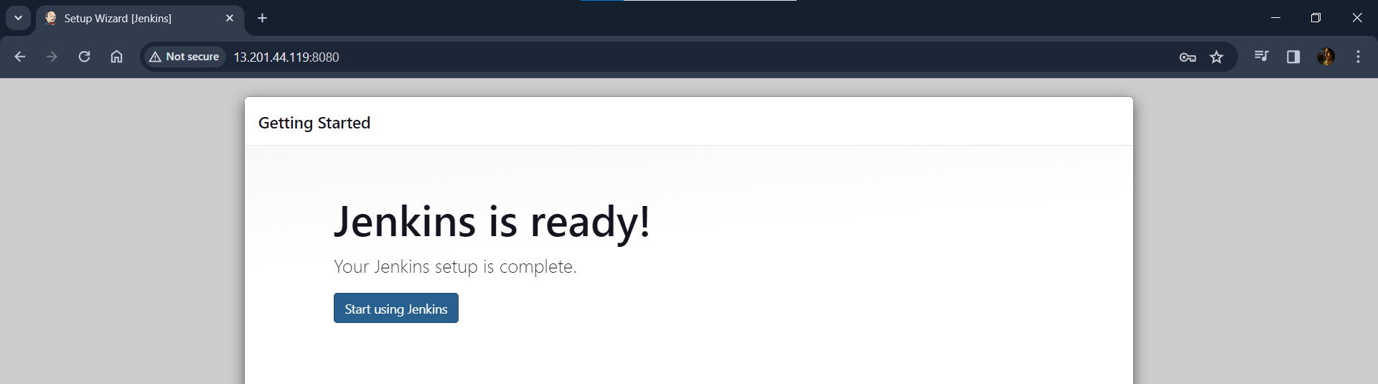

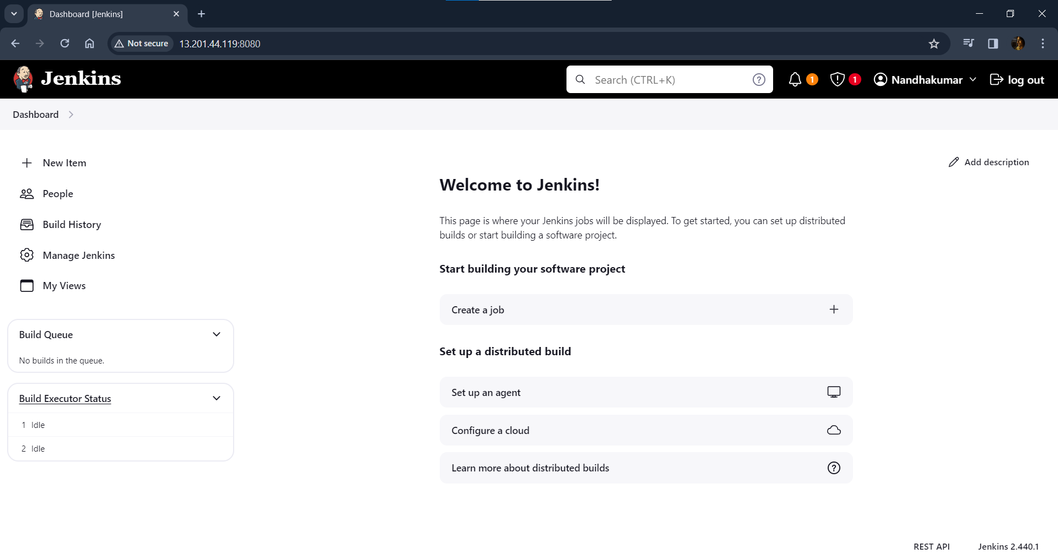

**Installing Docker & Docker-compose:**

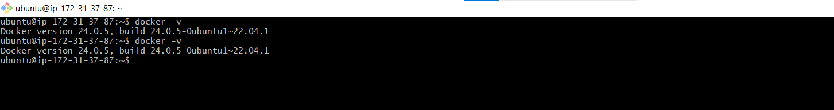

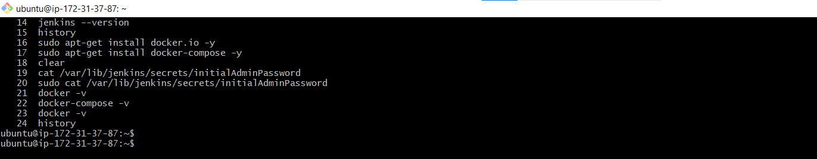

**Adding user & Jenkins to docker group:**

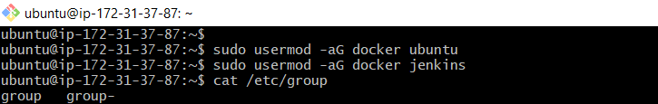

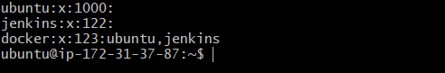

**Installing required Docker & Git Plugins:**

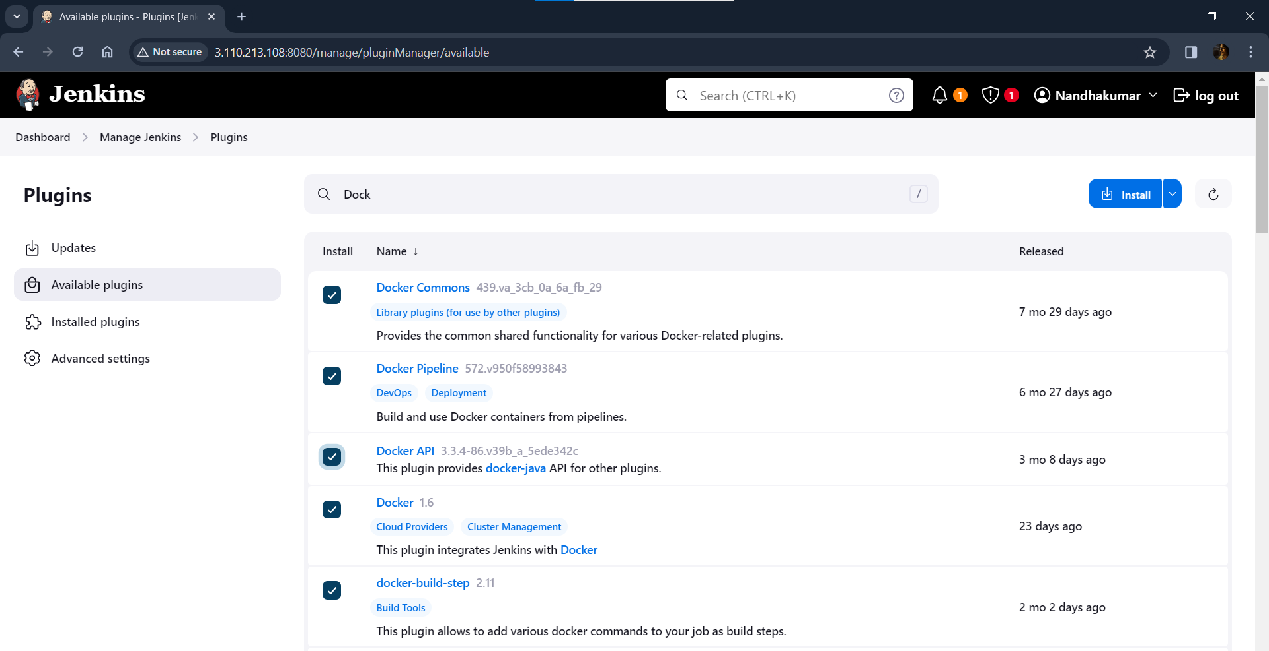

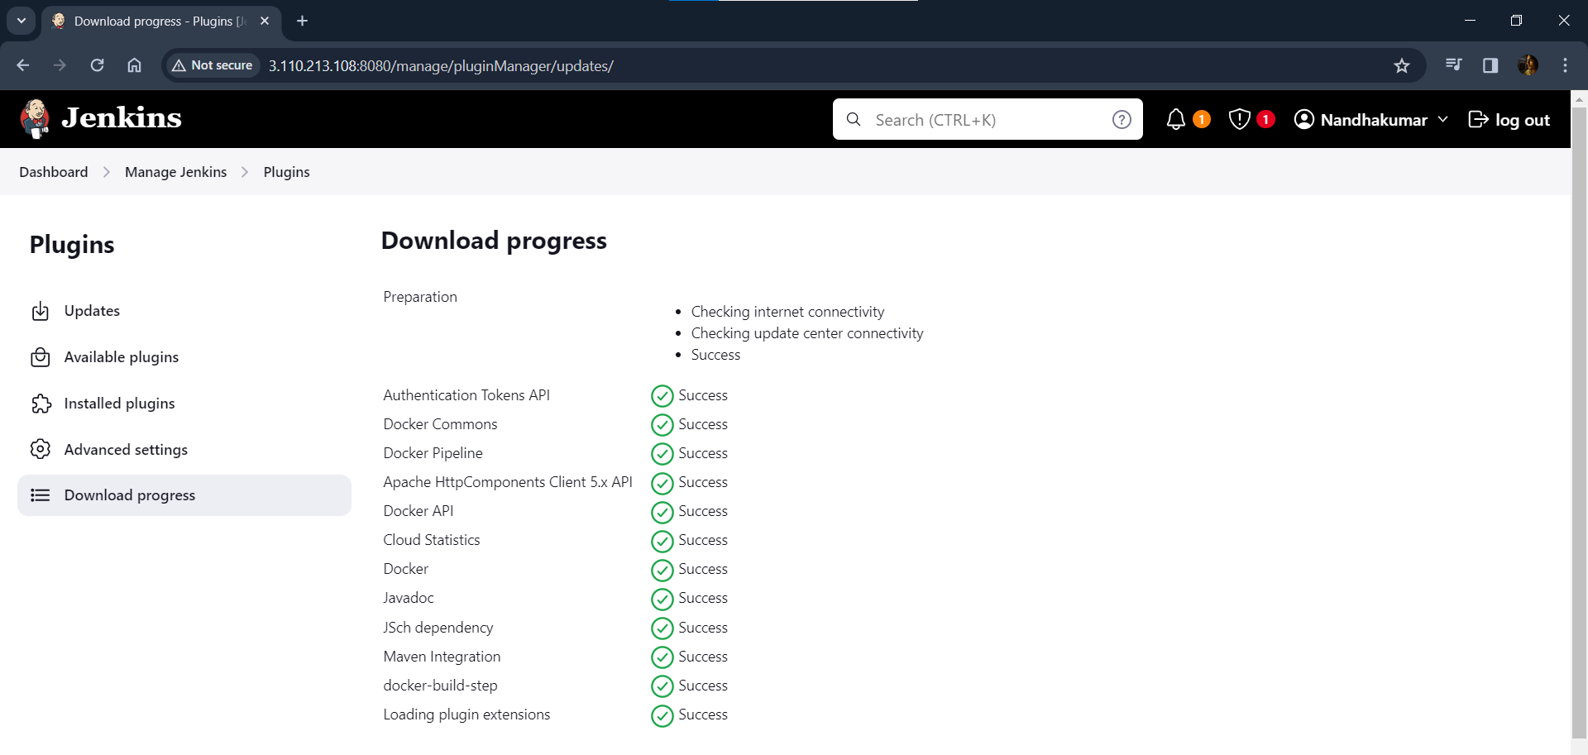

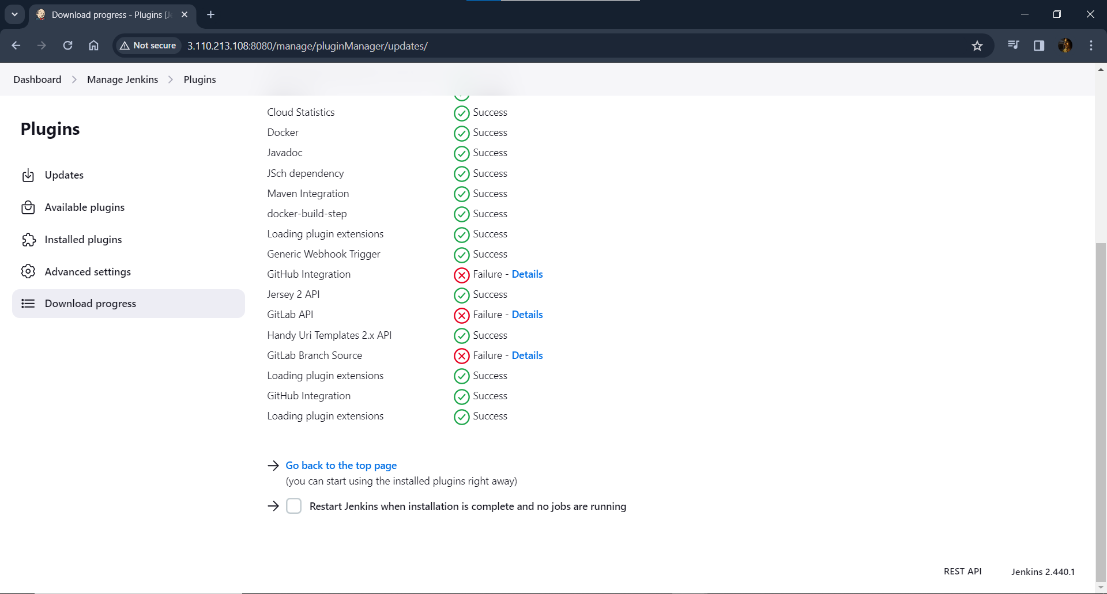

**Creating Free Style project:**

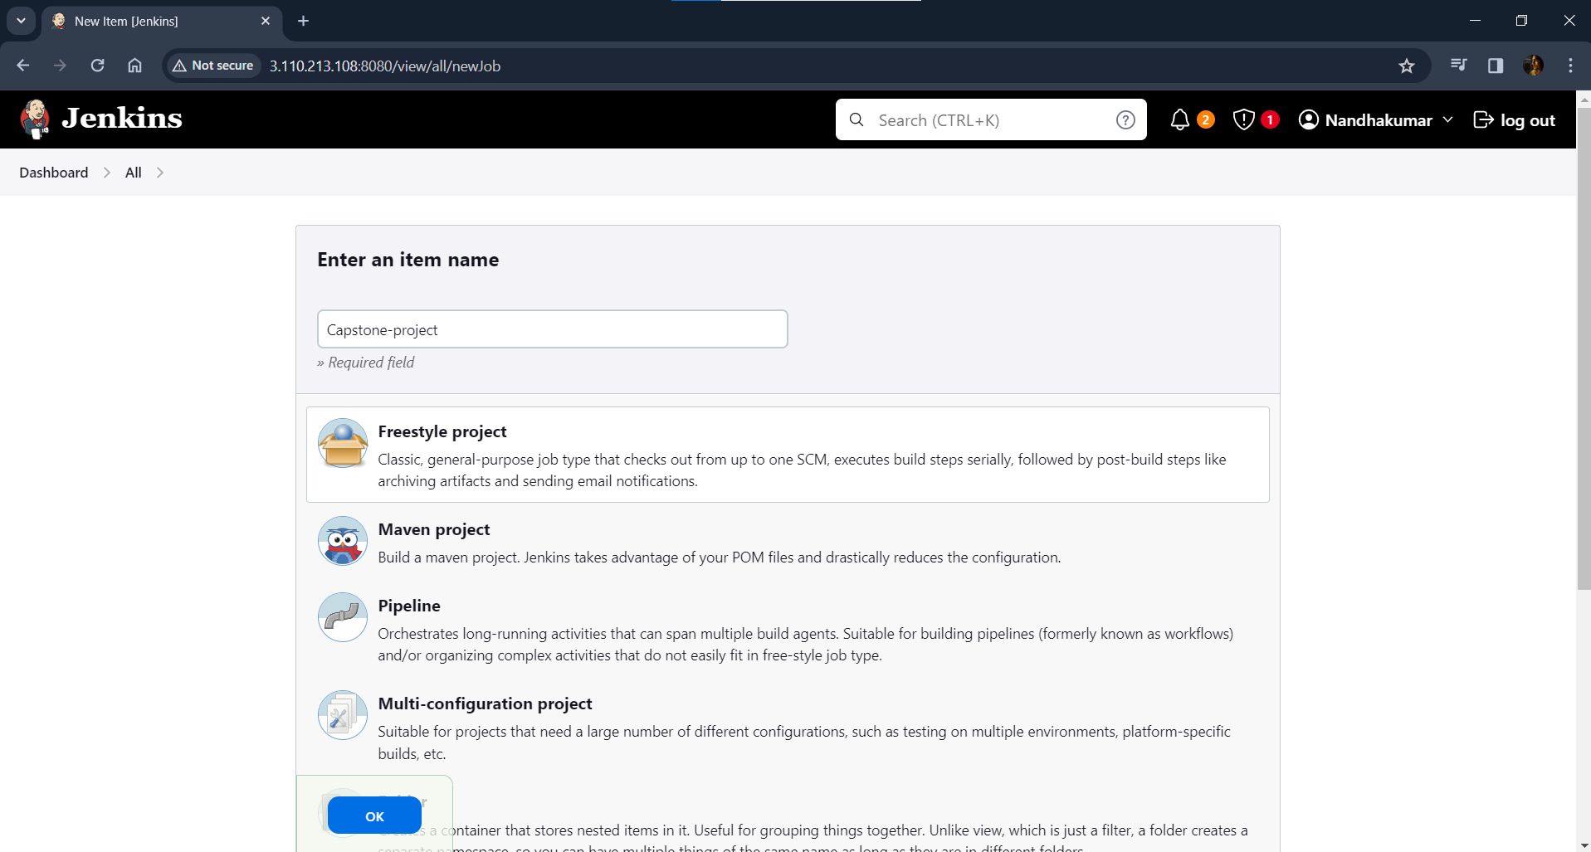

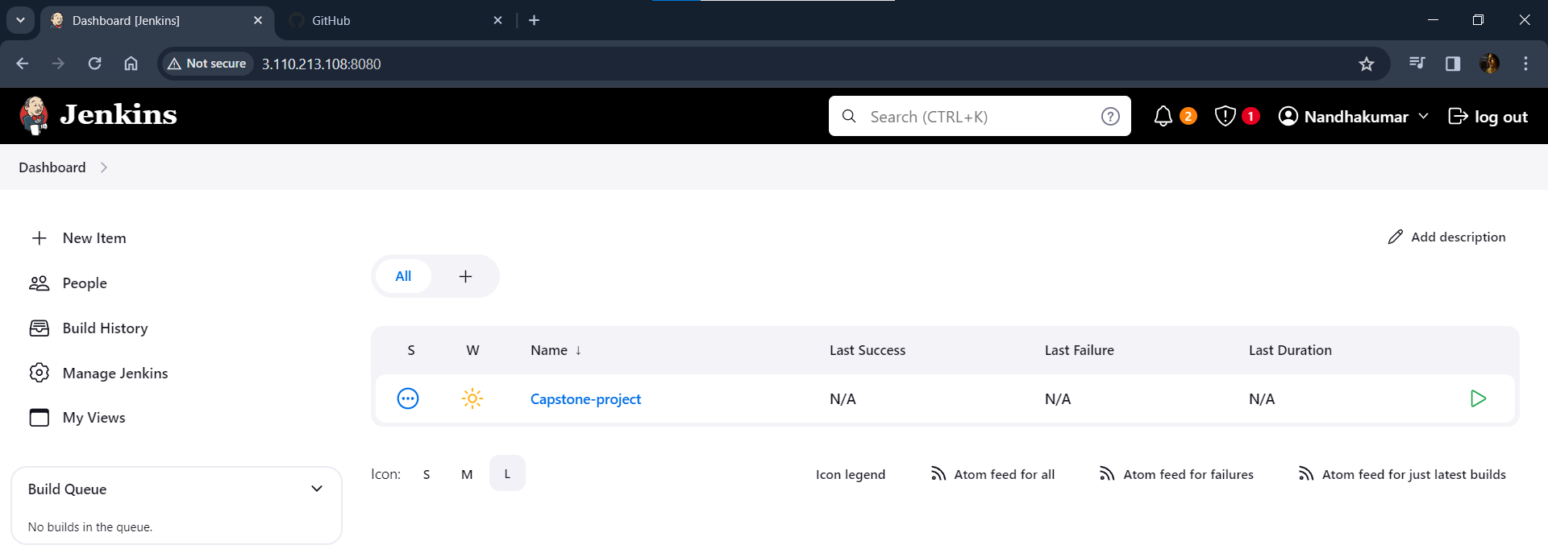

**Configuring project:**

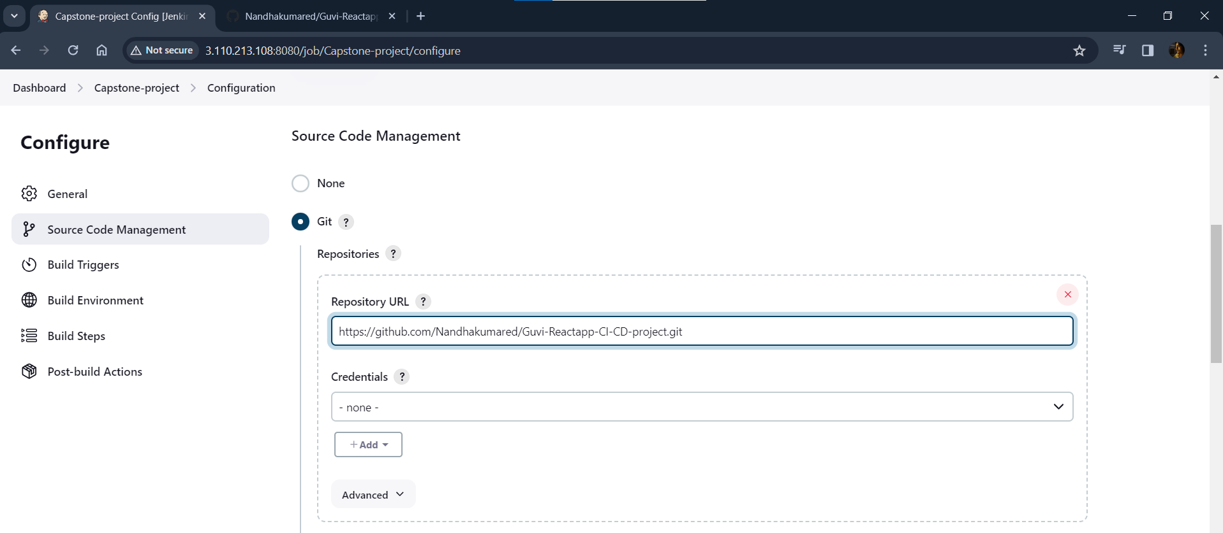

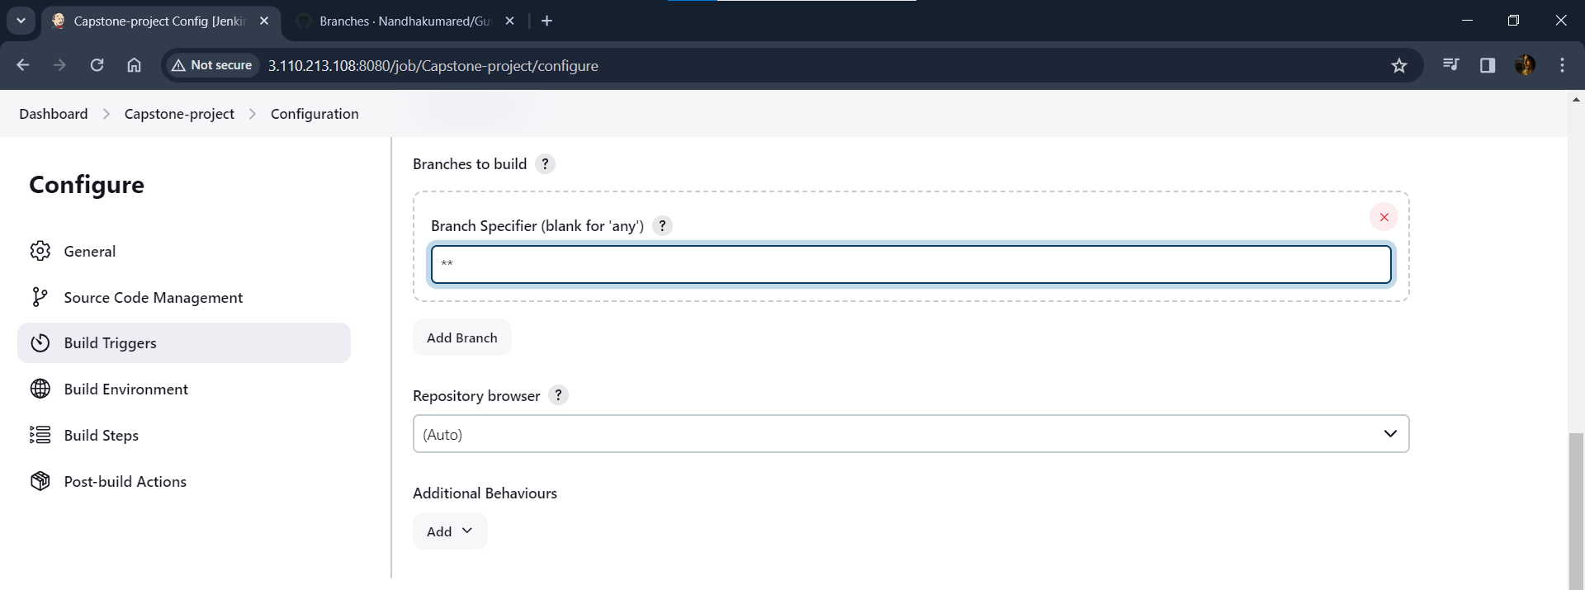

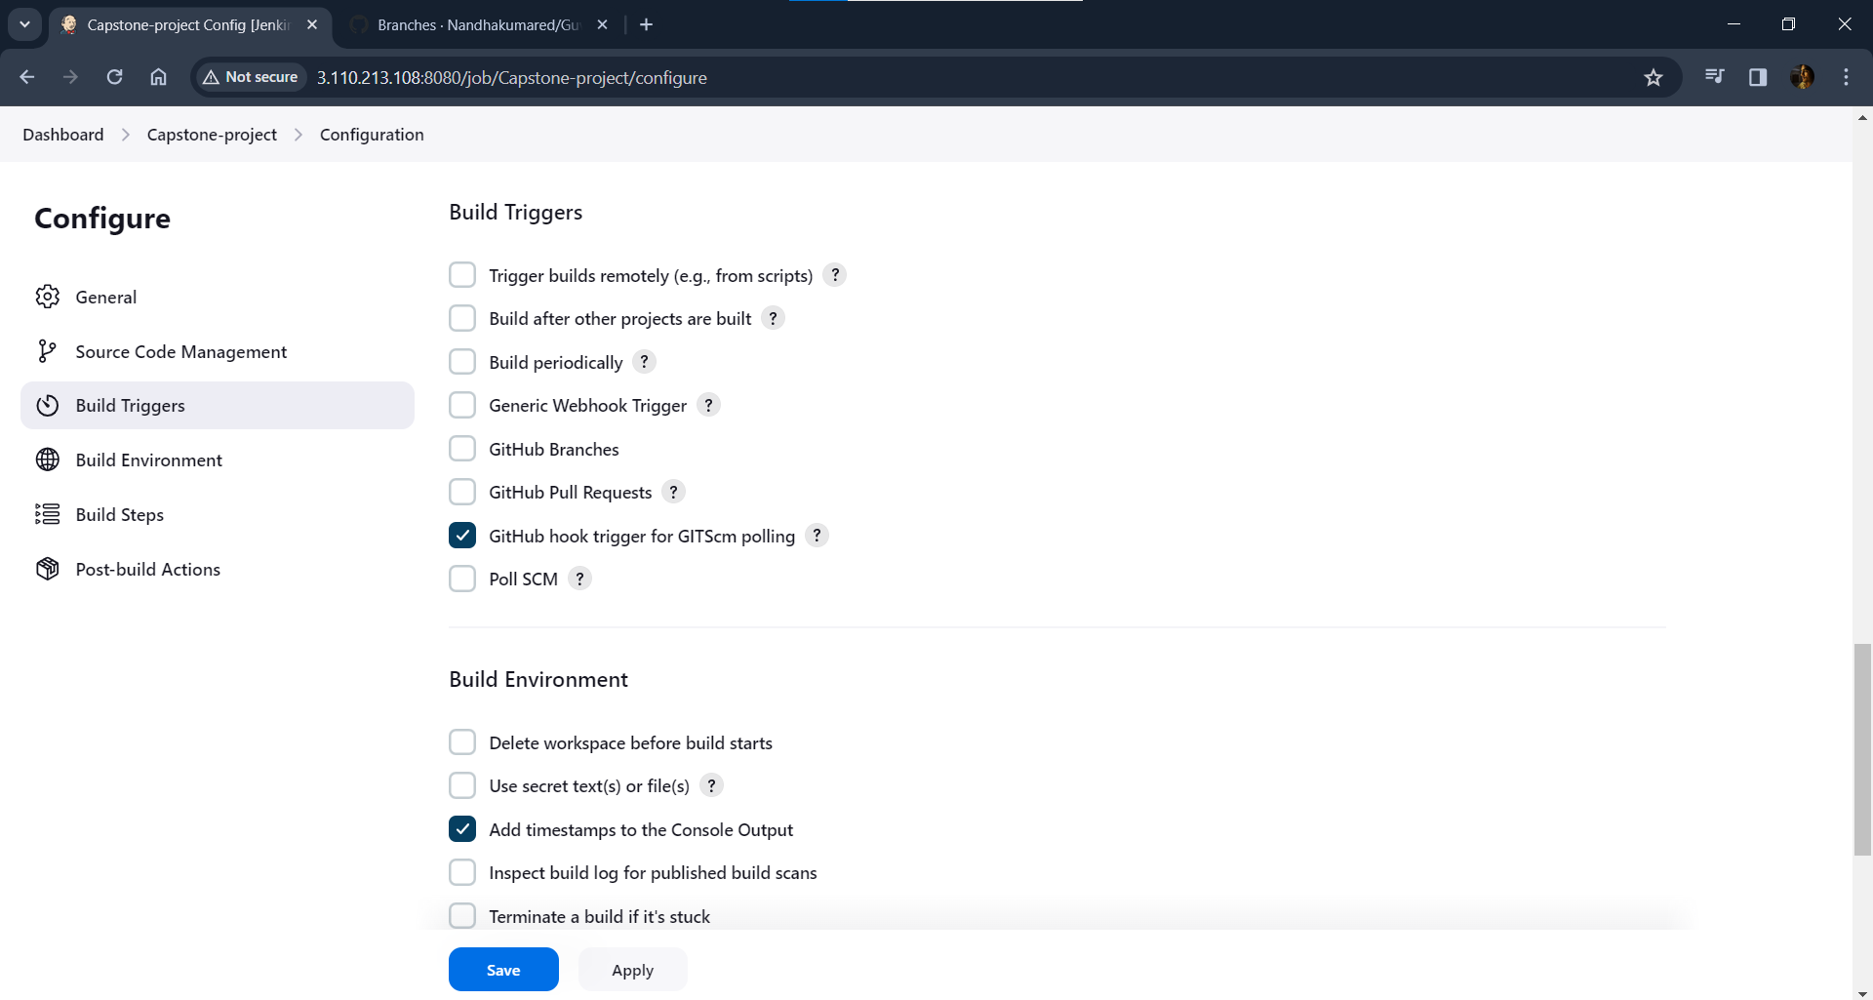

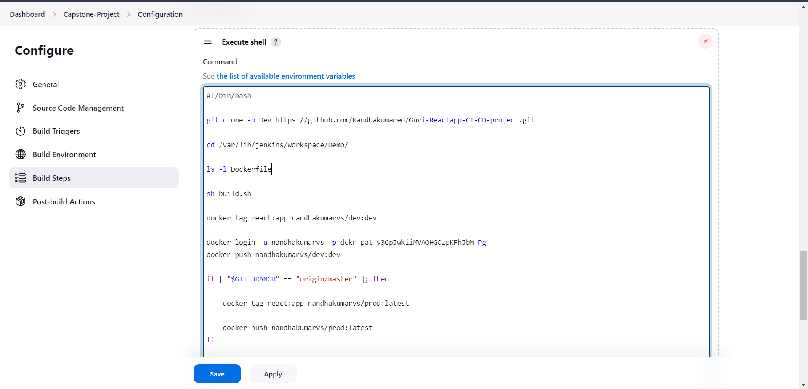

**Adding Webhook in Github repository:**

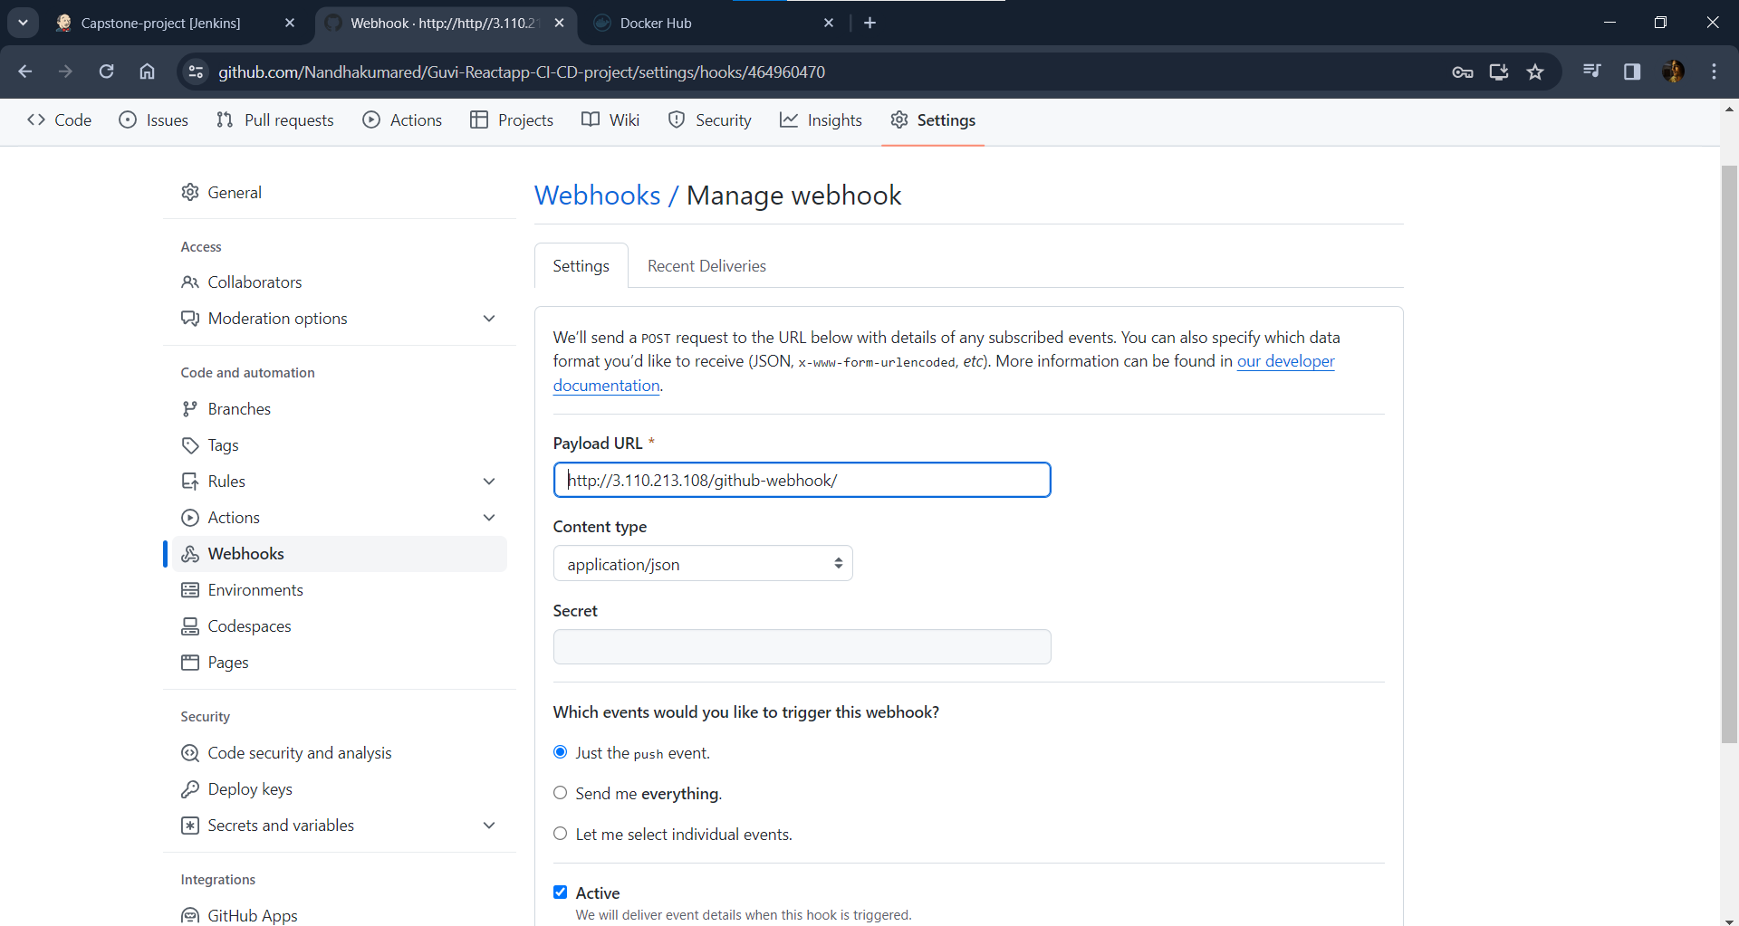

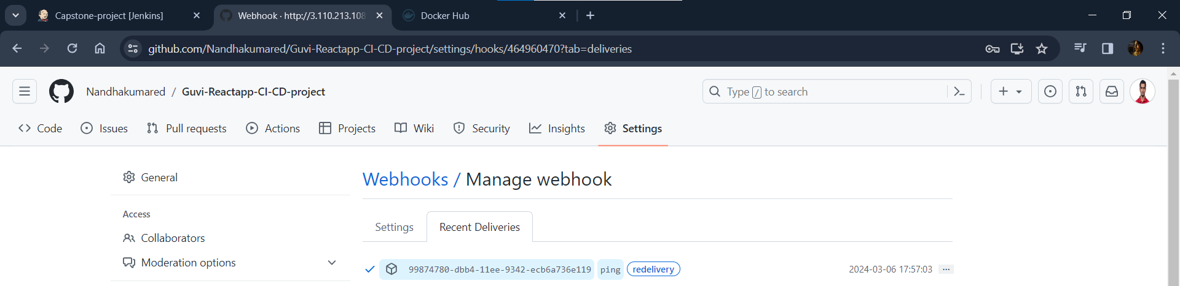

**Running Build by push the codes to Dev branch in GitHub:**

**Currently no build operations:**

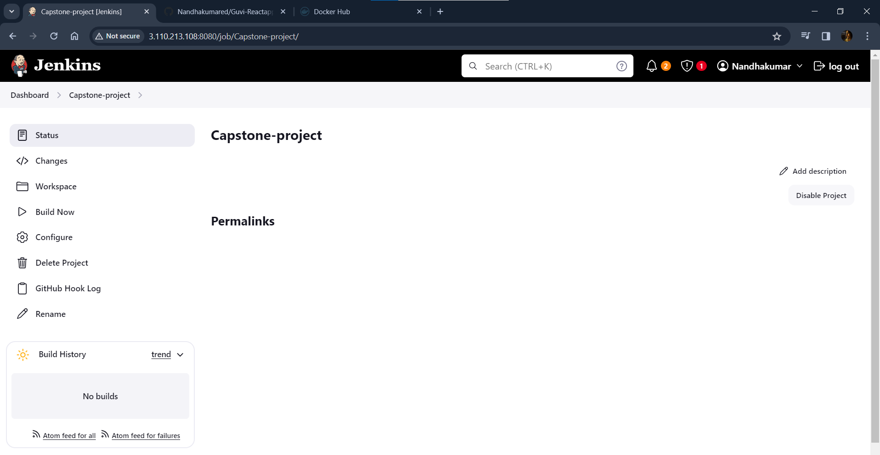

**Cloning Empty Dev Branch:**

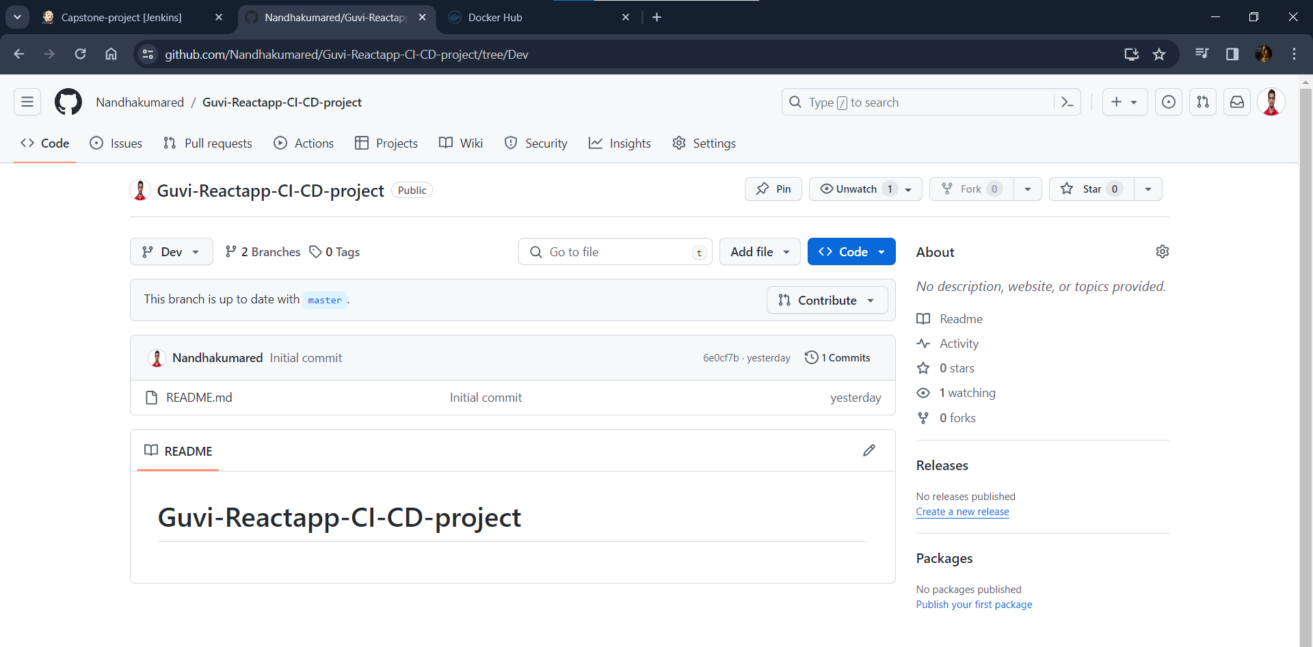

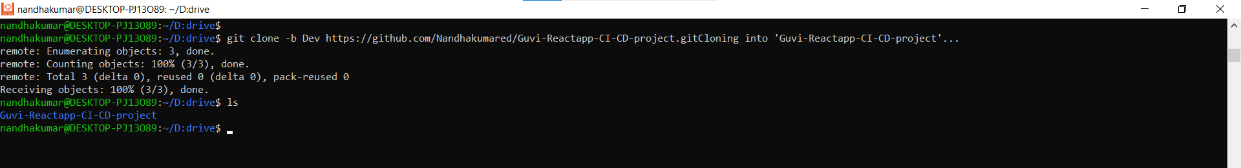

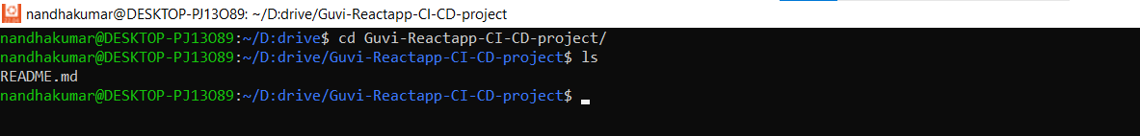

**Moving file to local git repo (Dev branch):**

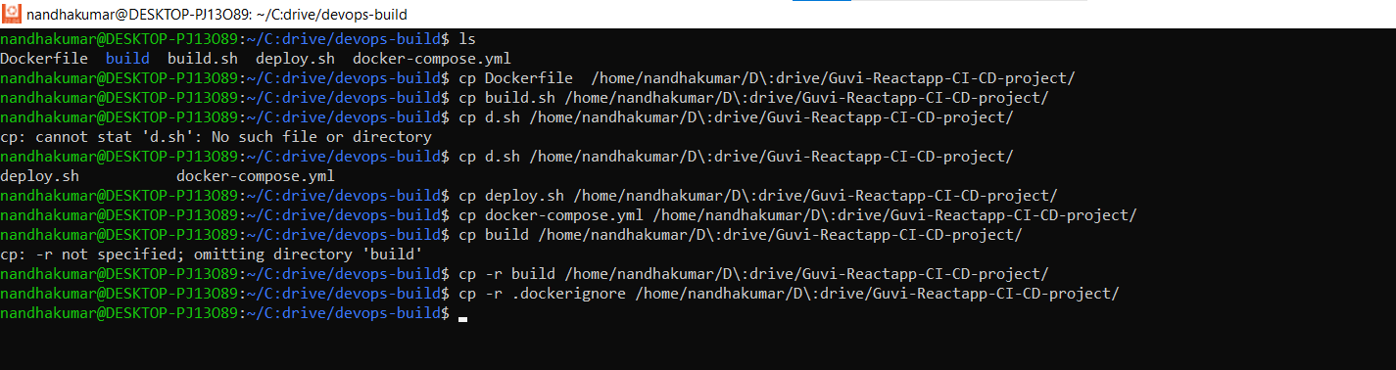

**Creating .gitignore file git repo:**

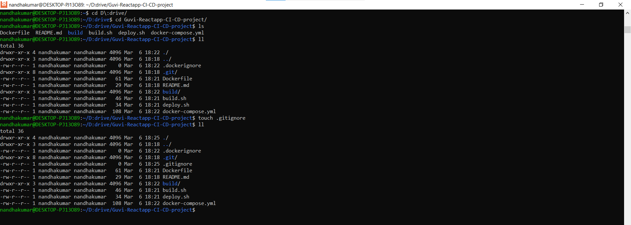

**Pushing files to Dev branch:**

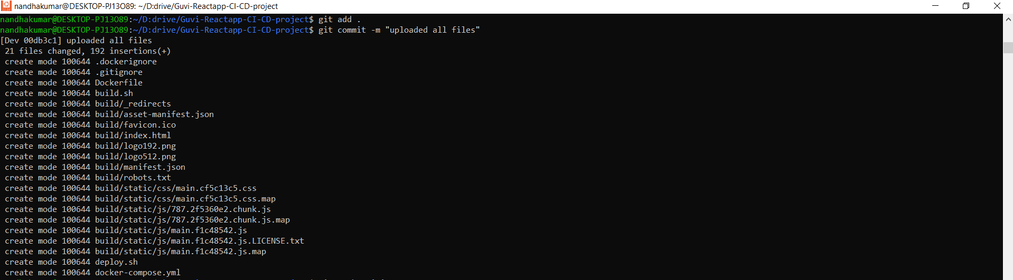

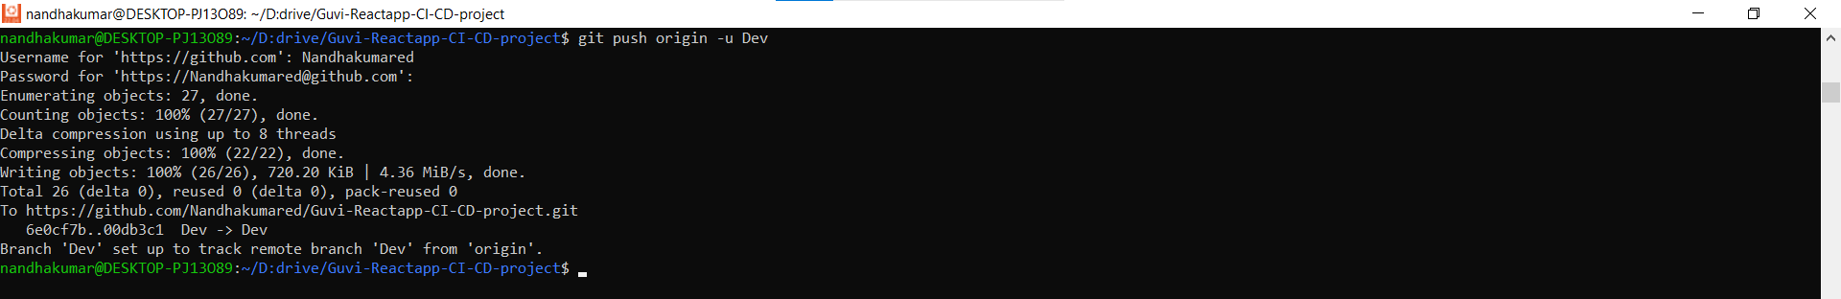

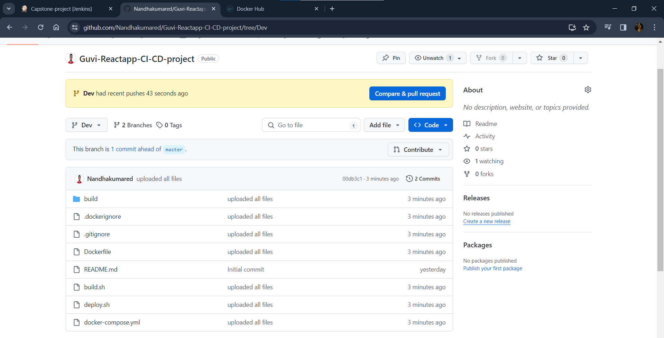

**Automatically build started when code pushed to Dev branch in Github Repo:**

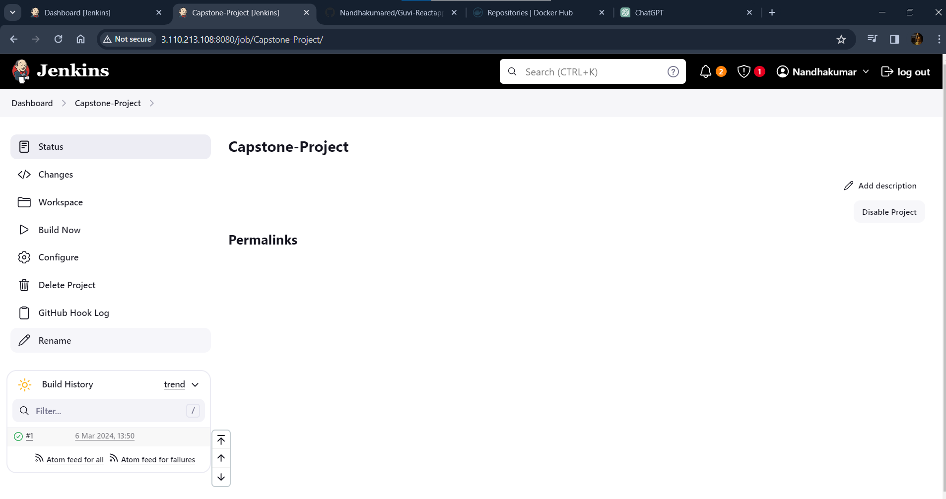

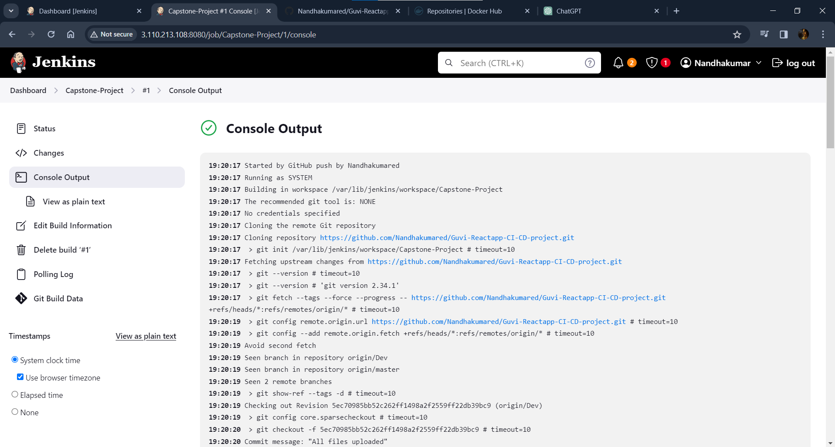

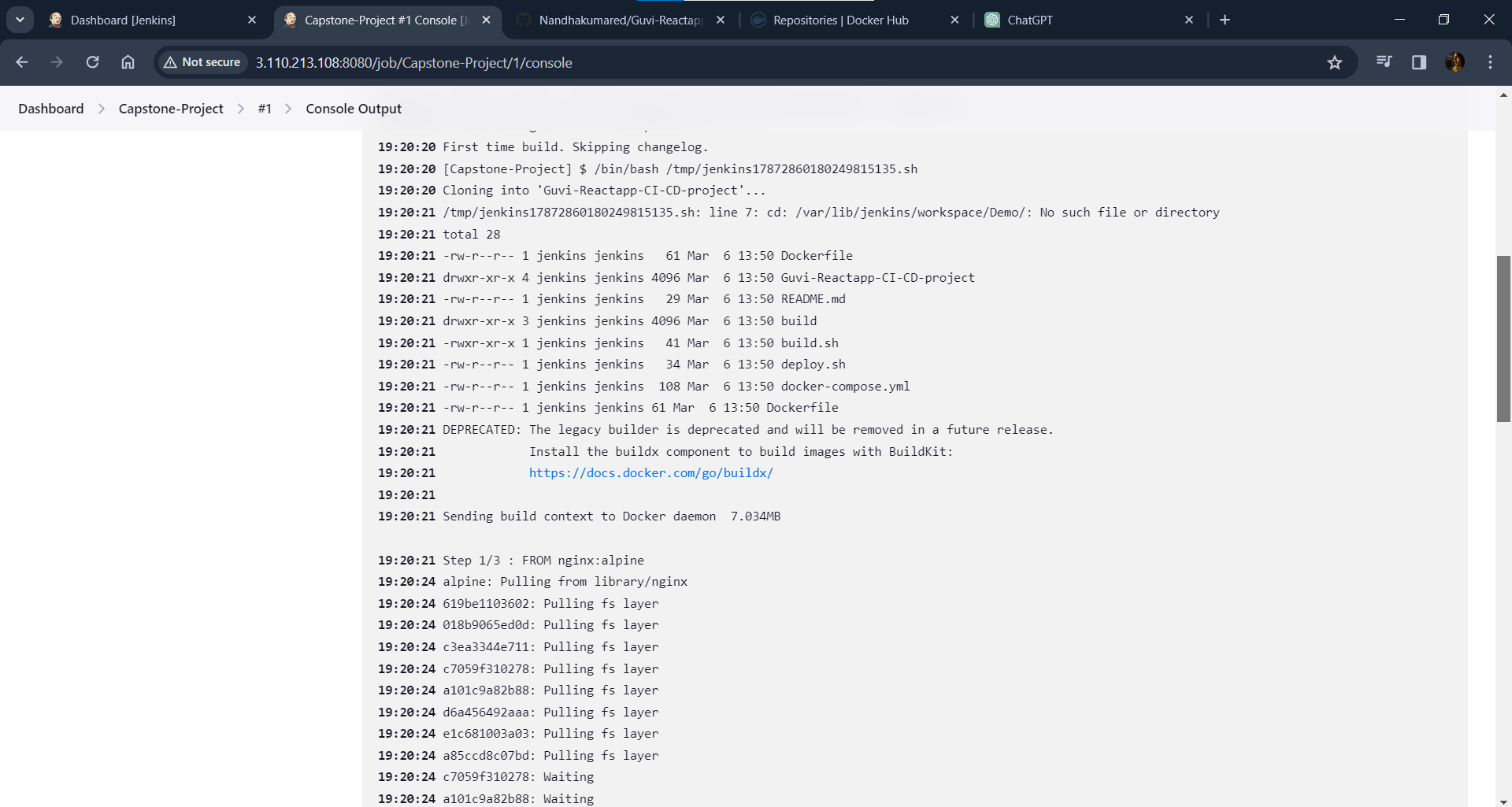

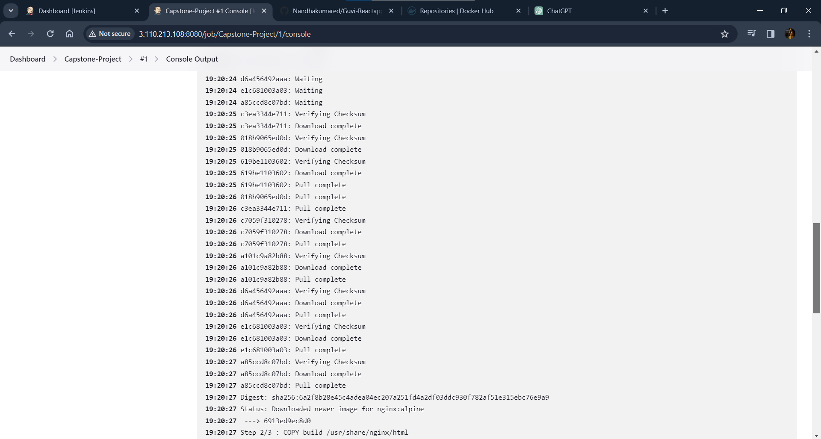

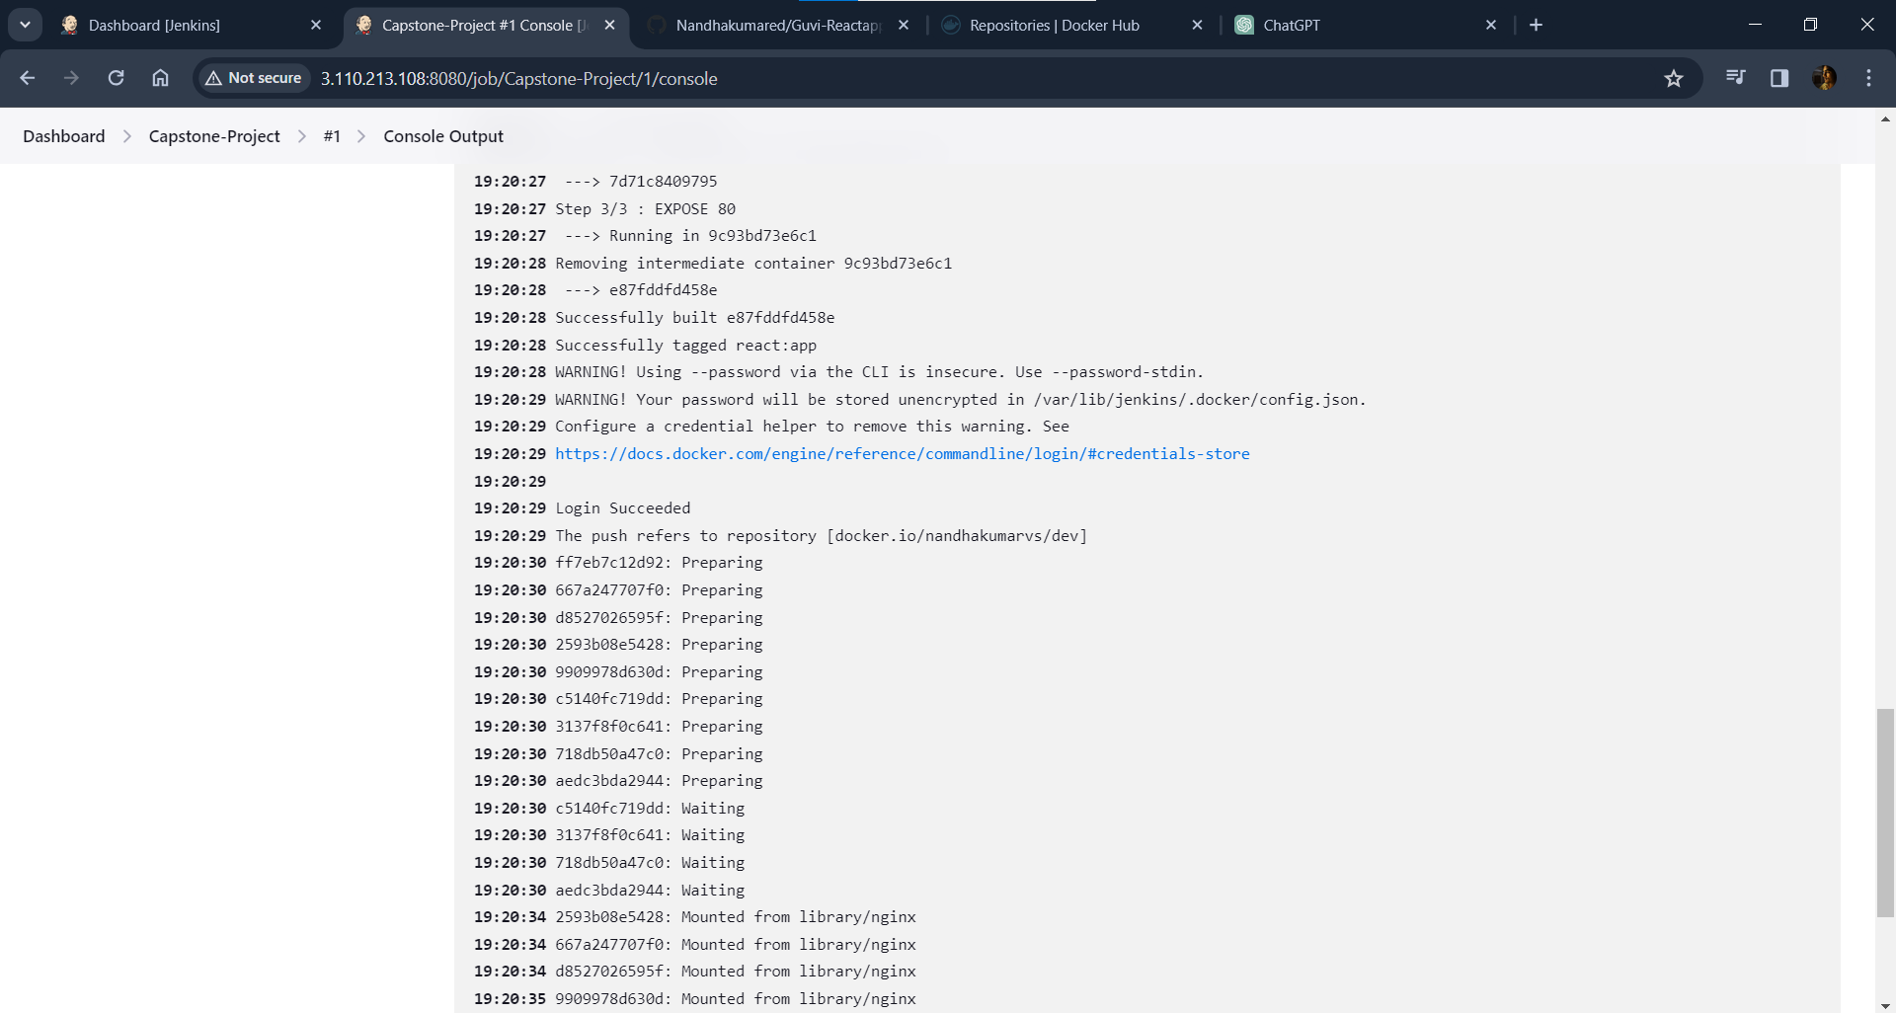

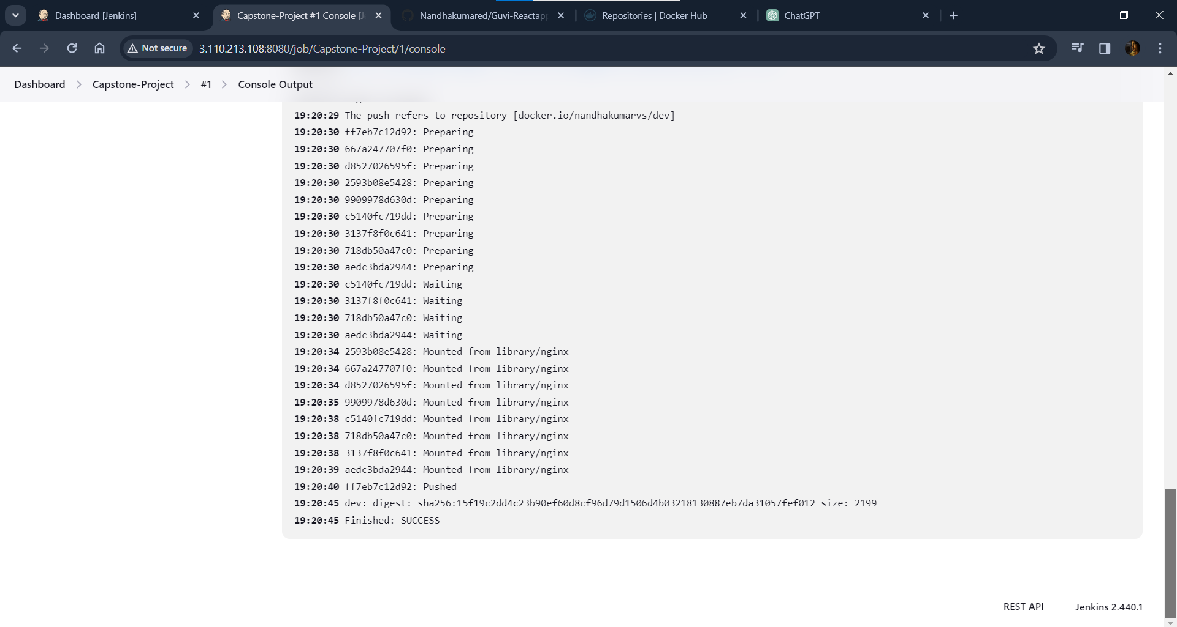

**Login to Jenkins-Server to check Docker image is build and pushed to dockerhub public repo(dev):**

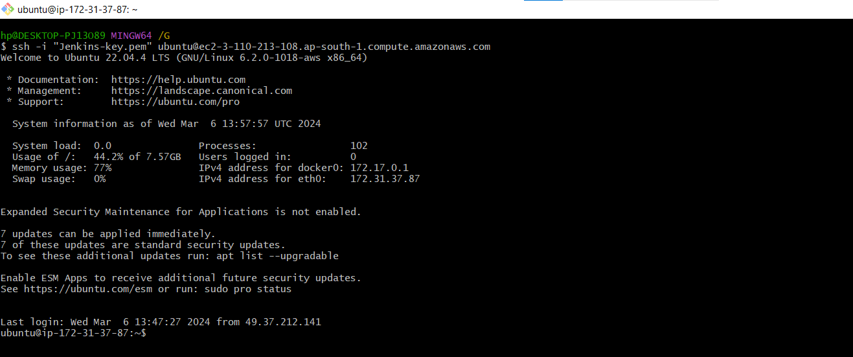

**Moving to Jenkins workspace:**

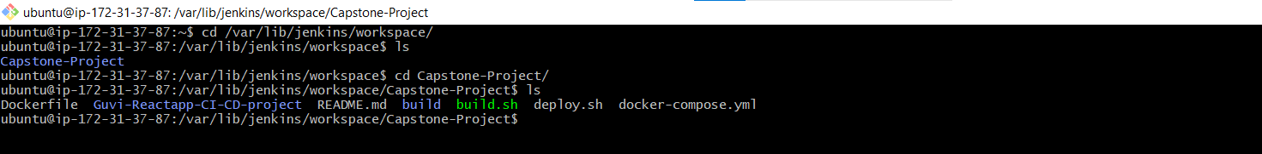

**Checking Docker image is build and tagged with docker hub repo name:**

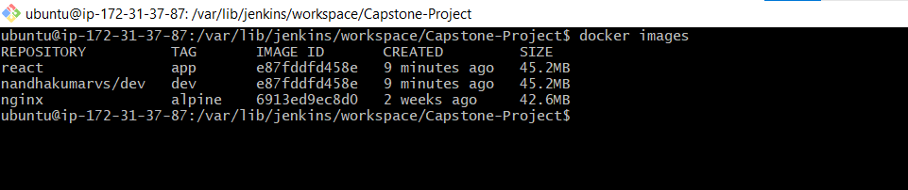

**Checking Docker image is pushed to dockerhub public repo(dev):**

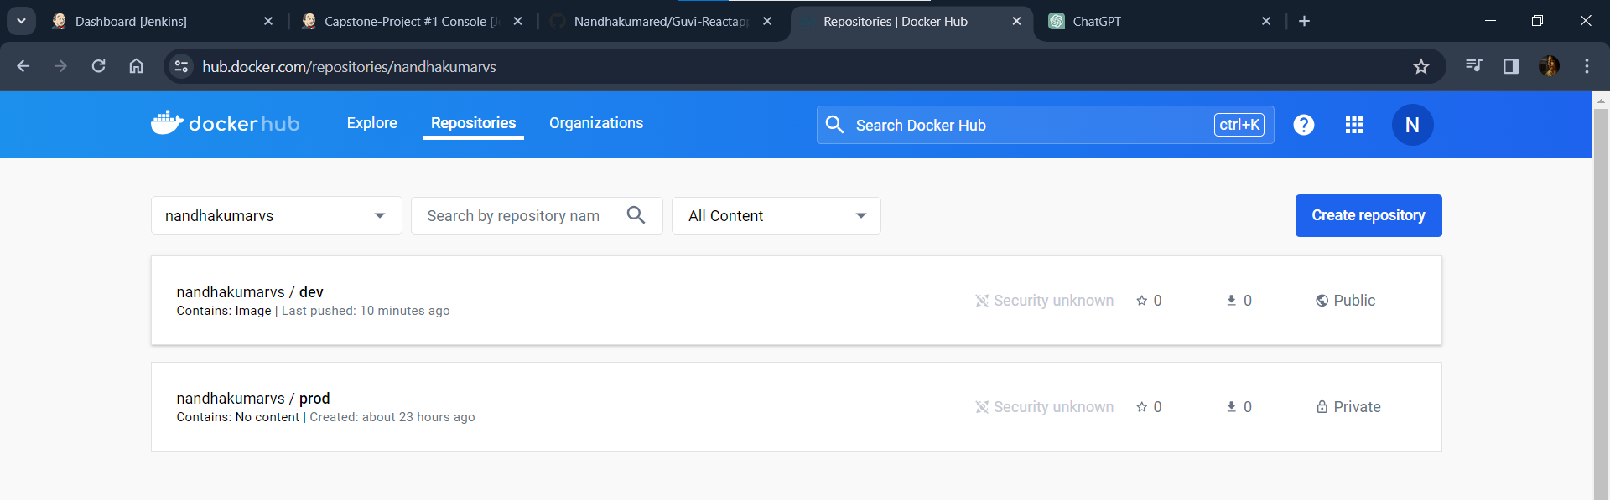

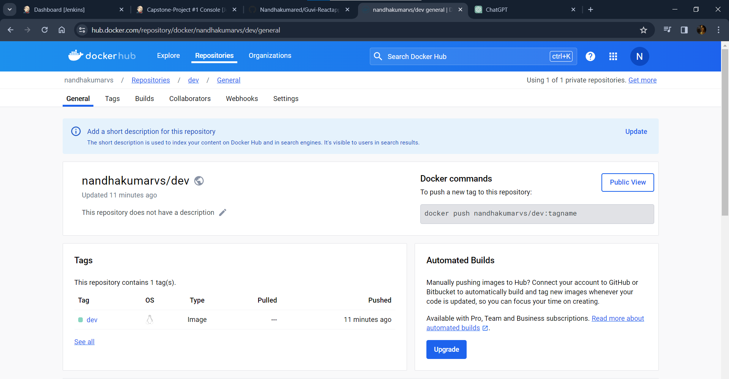

**Merging Dev branch to master branch in Github:**

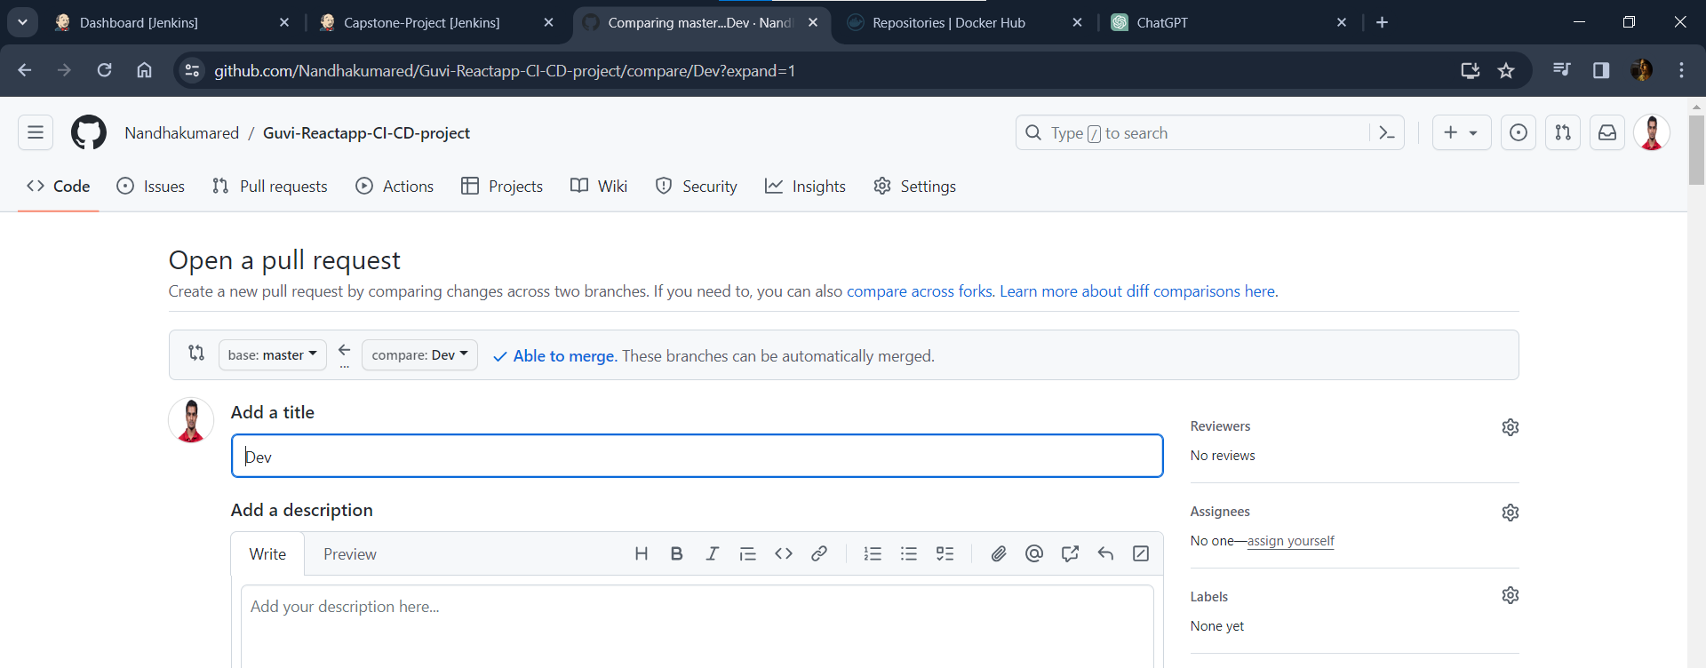

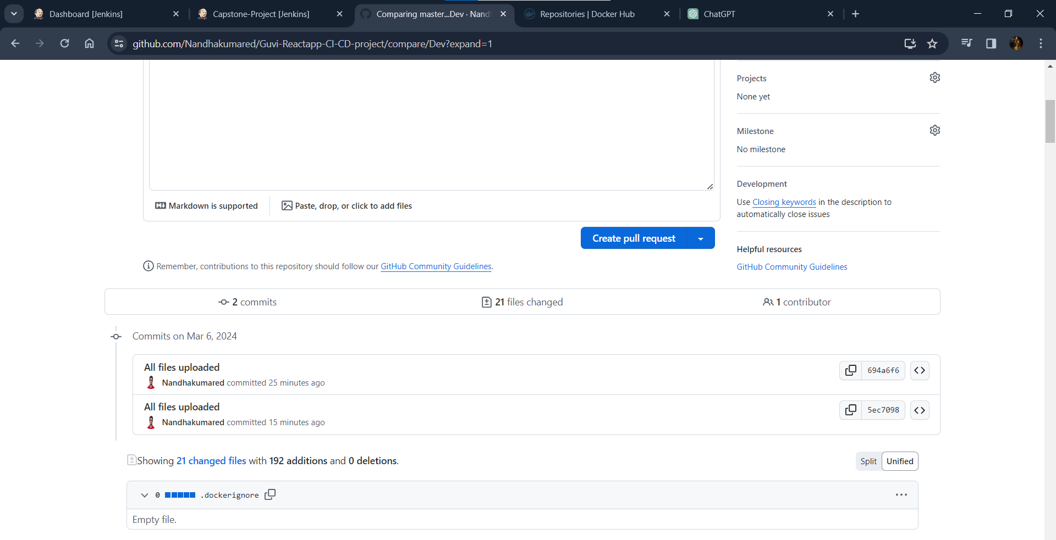

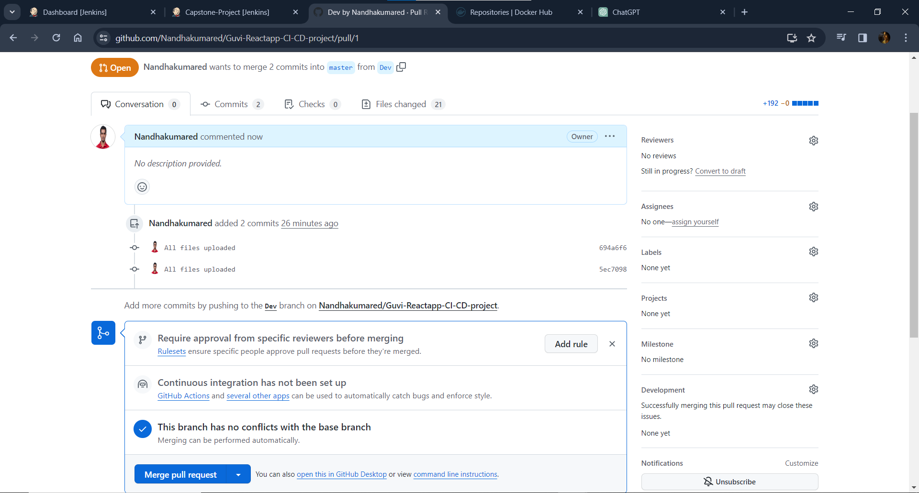

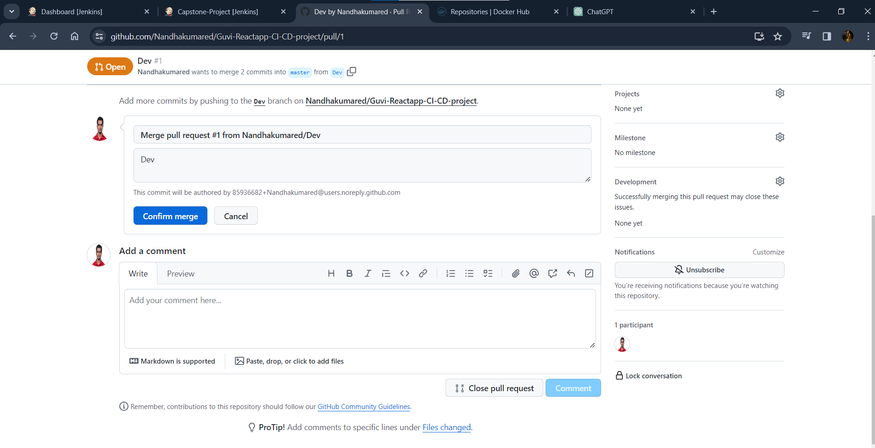

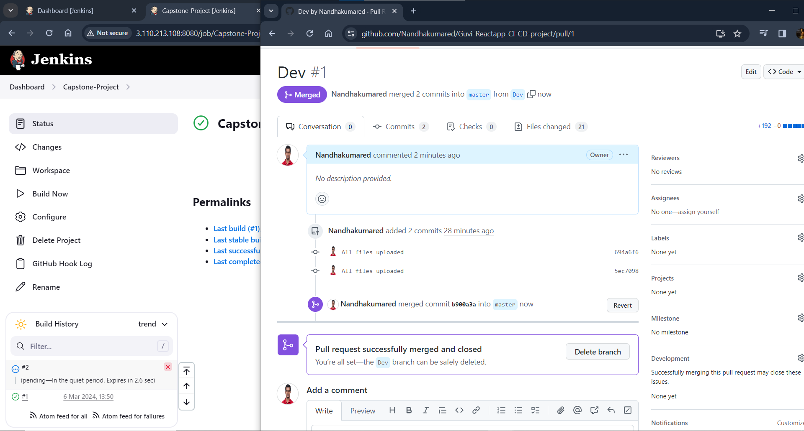

**Automatically build starts after merging Dev branch to master branch in GitHub:**

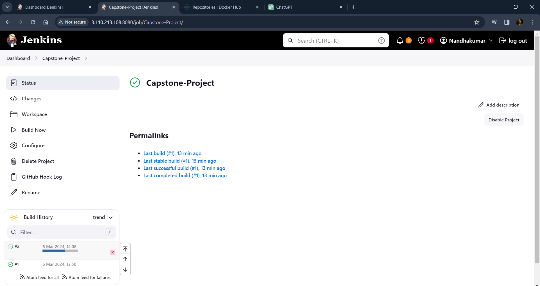

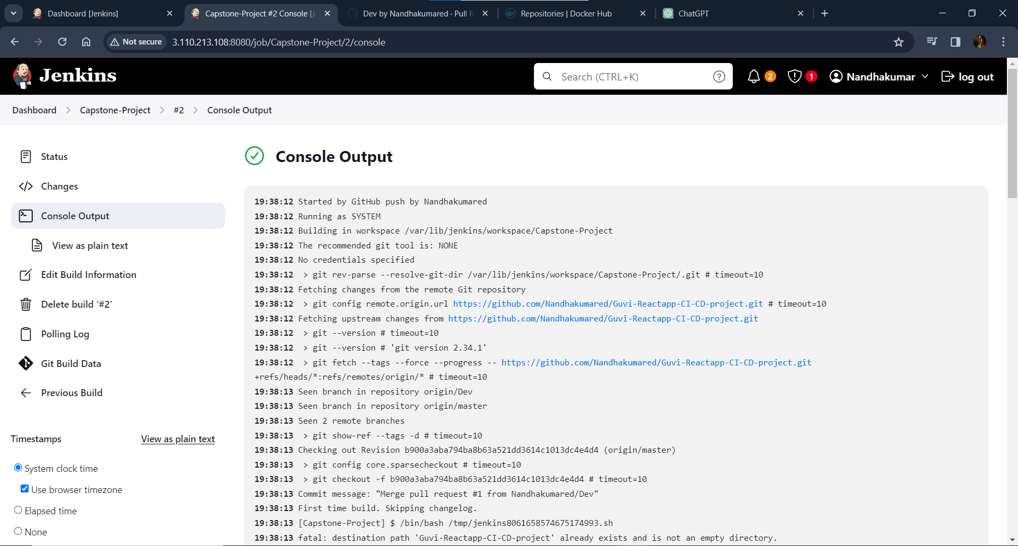

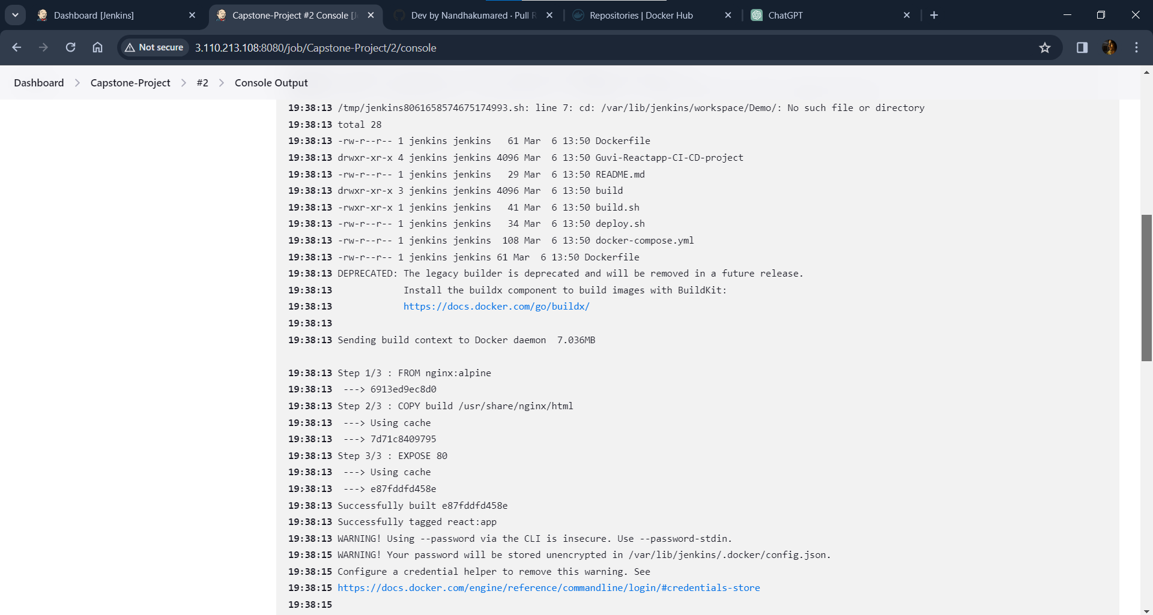

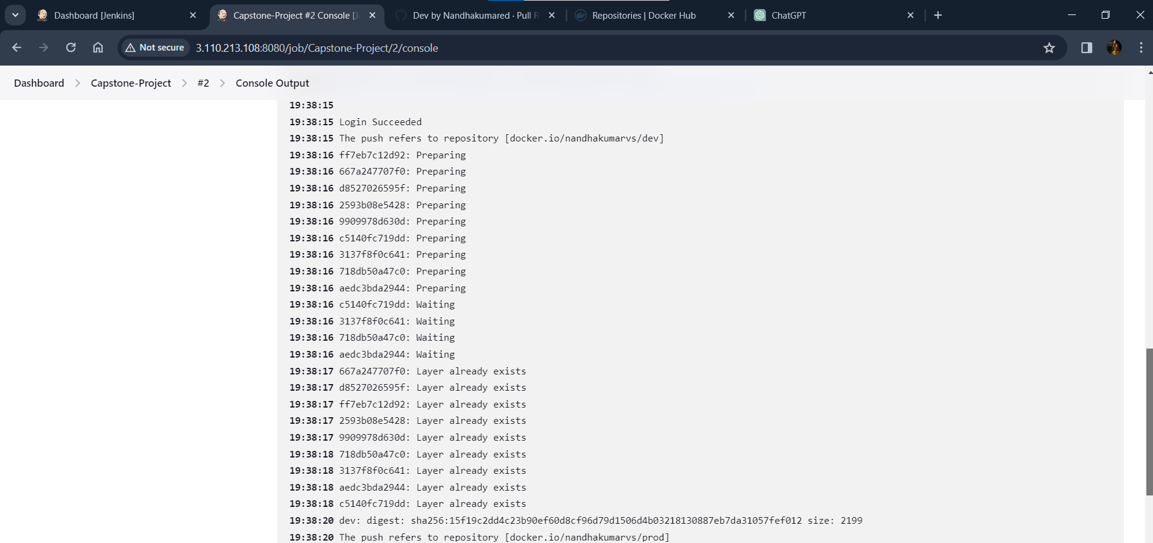

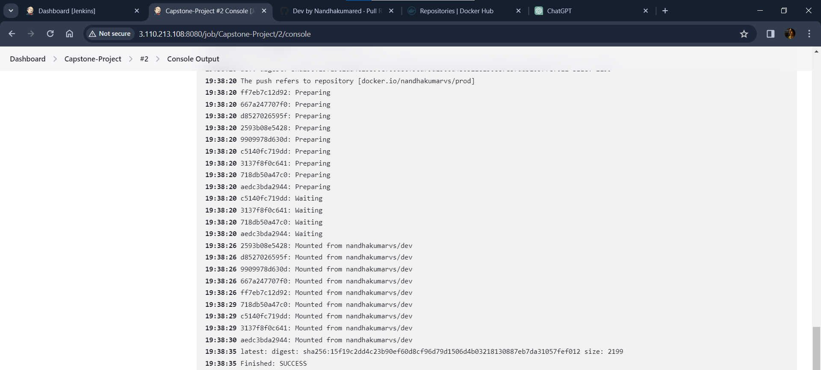

**Checking docker image is tagged and push to Docker hub private repo(prod):**

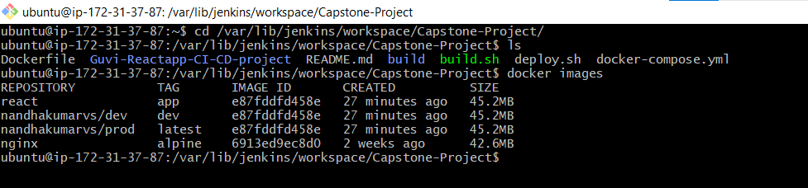

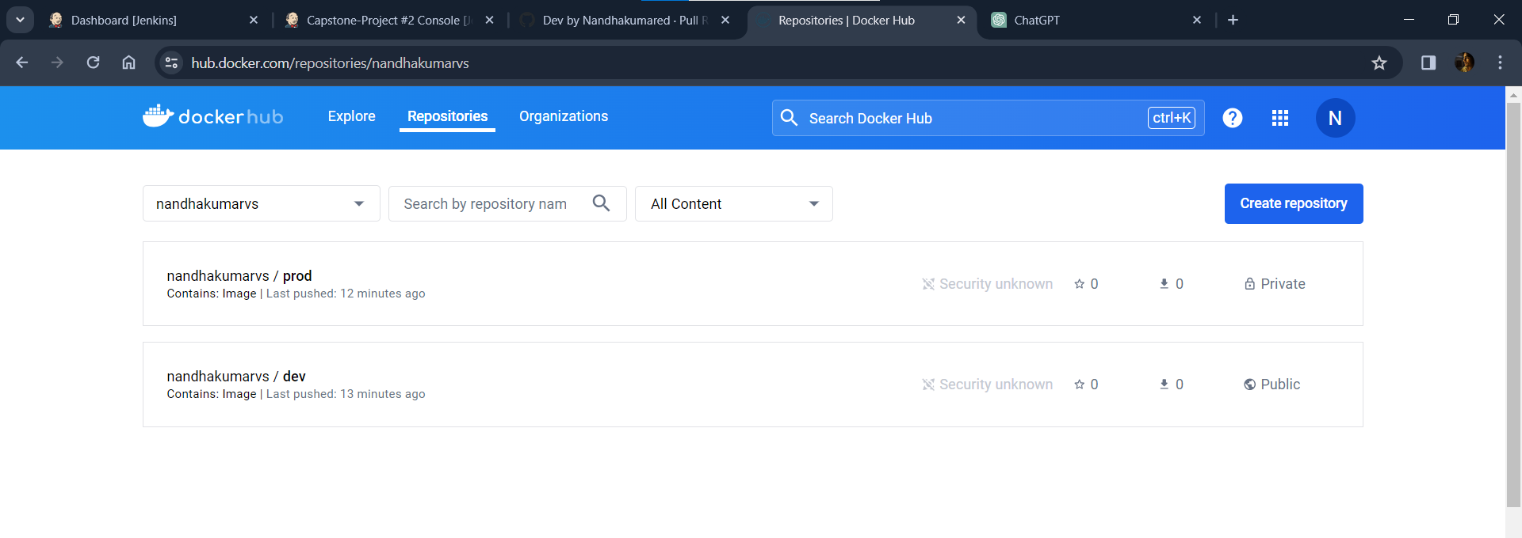

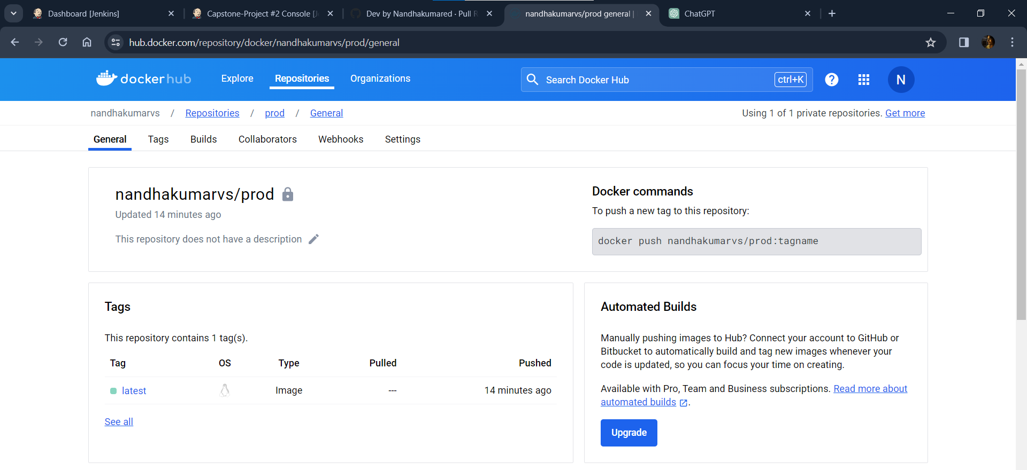

**Running docker image in Jenkins-server using deploy.sh:**

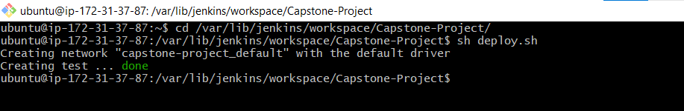

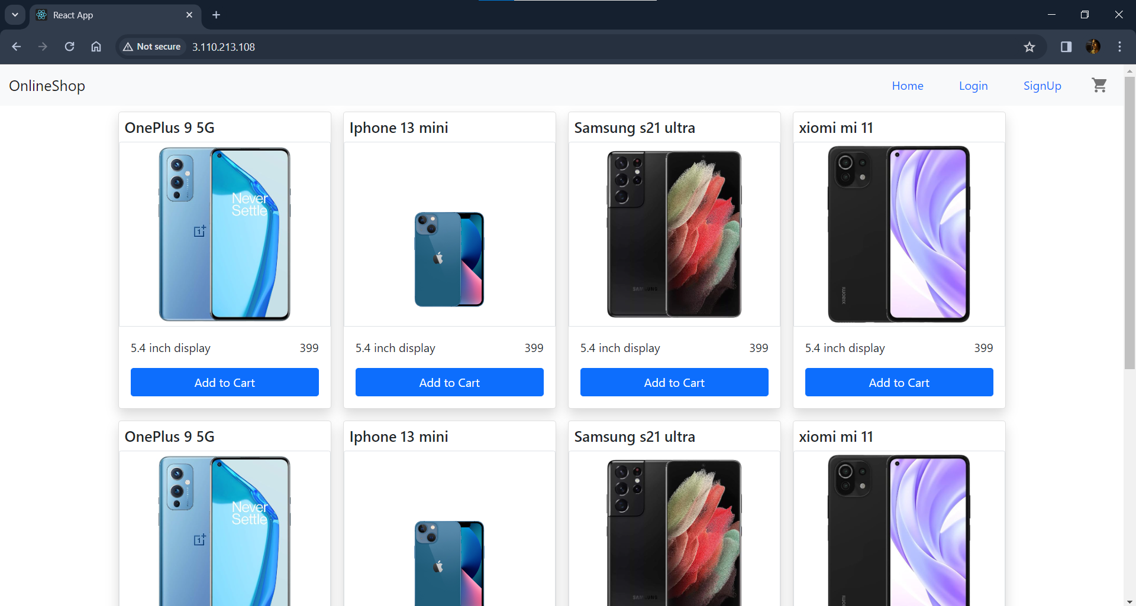

**Launching AWS t2.micro instance: (Deploy-EC2)**

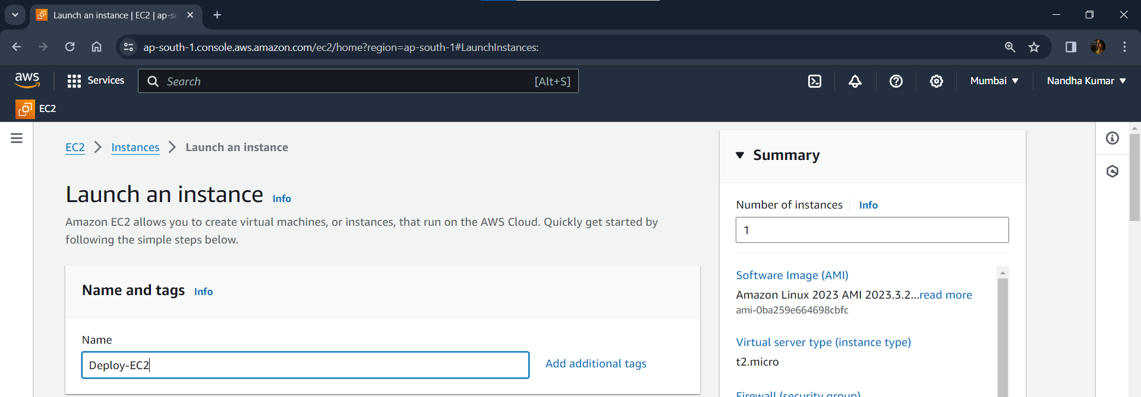

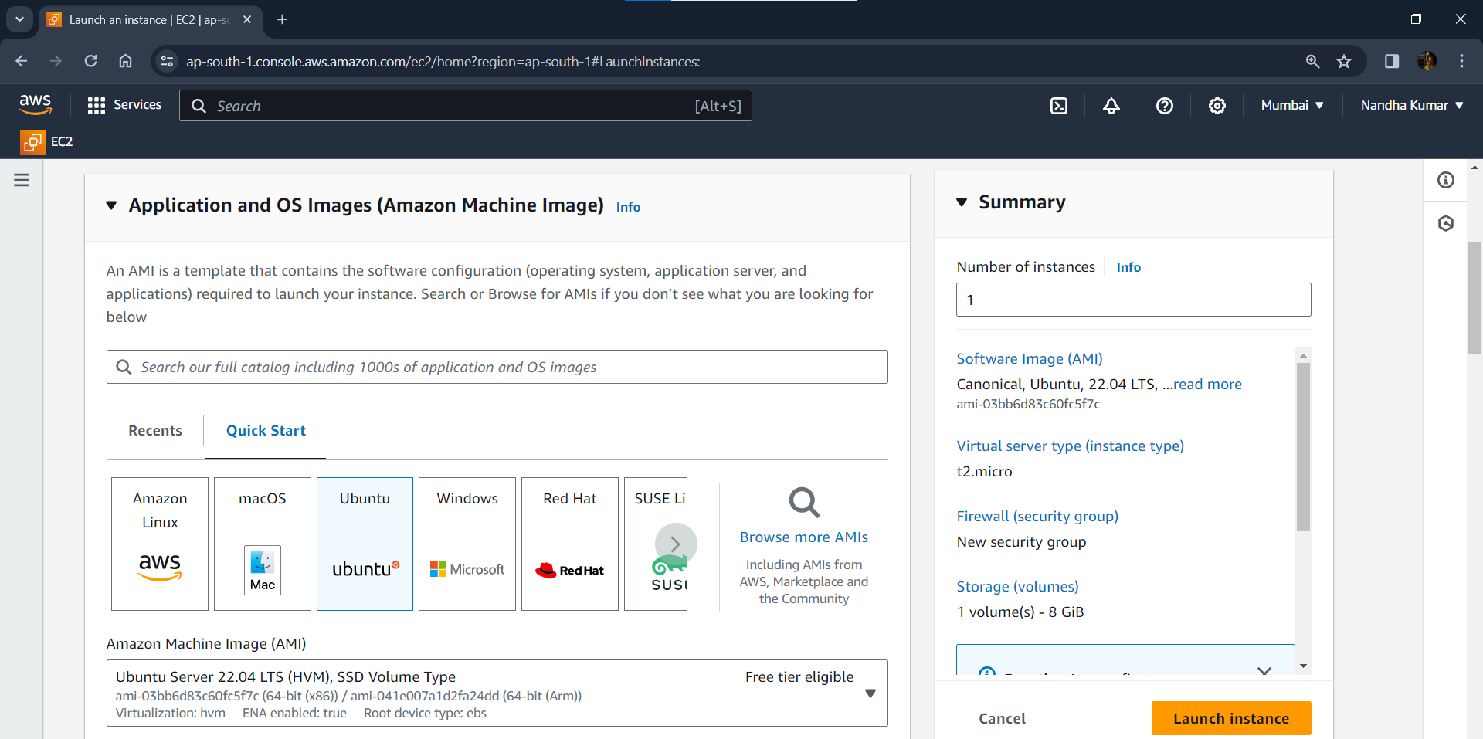

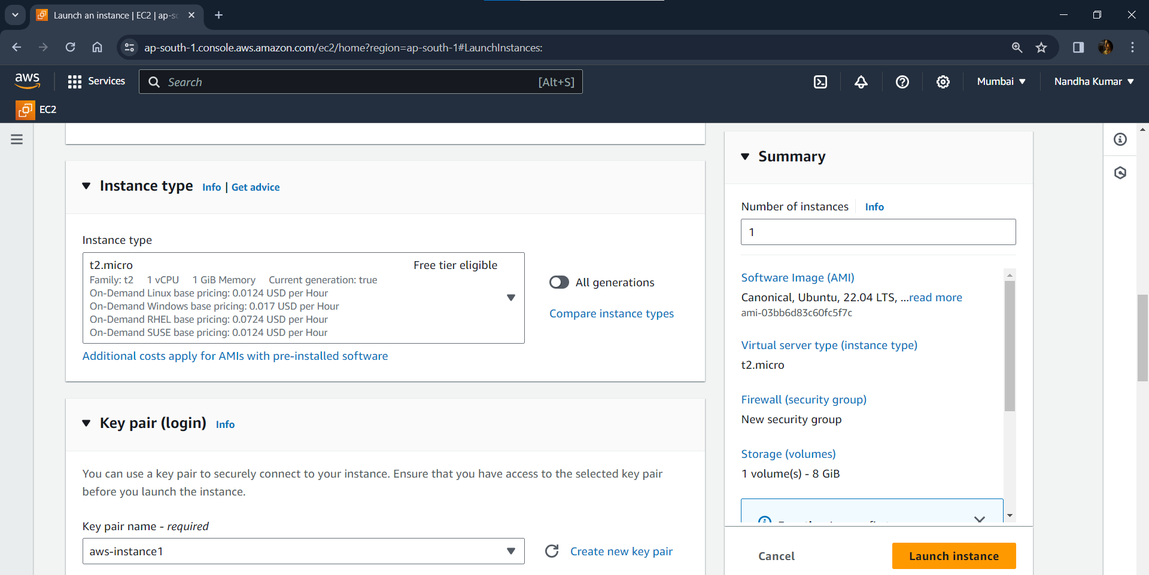

**Configuring Security Group:**

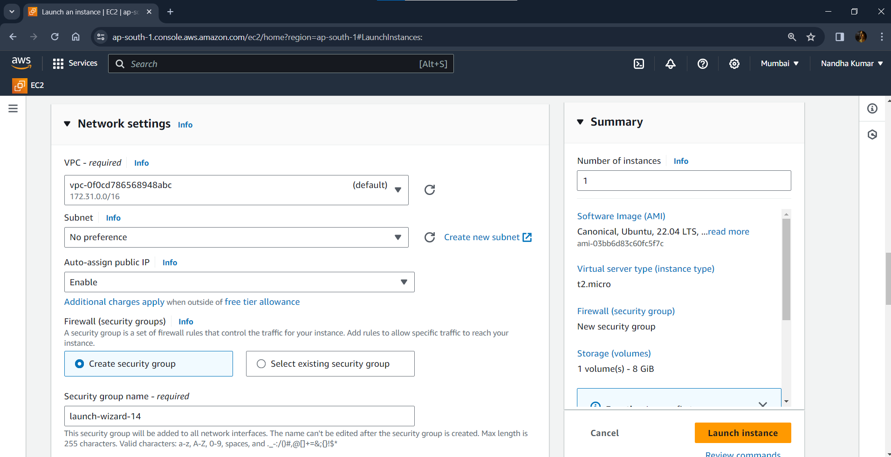

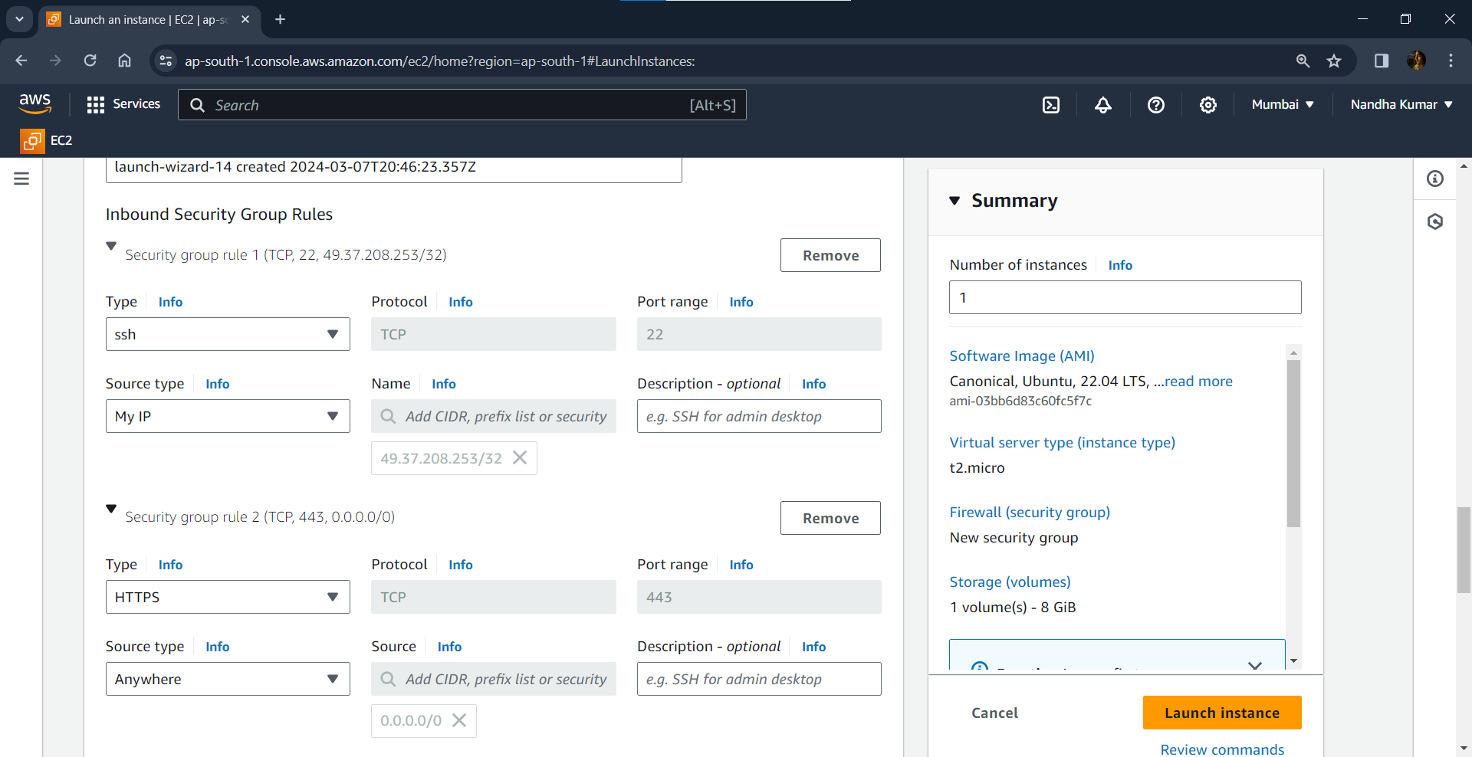

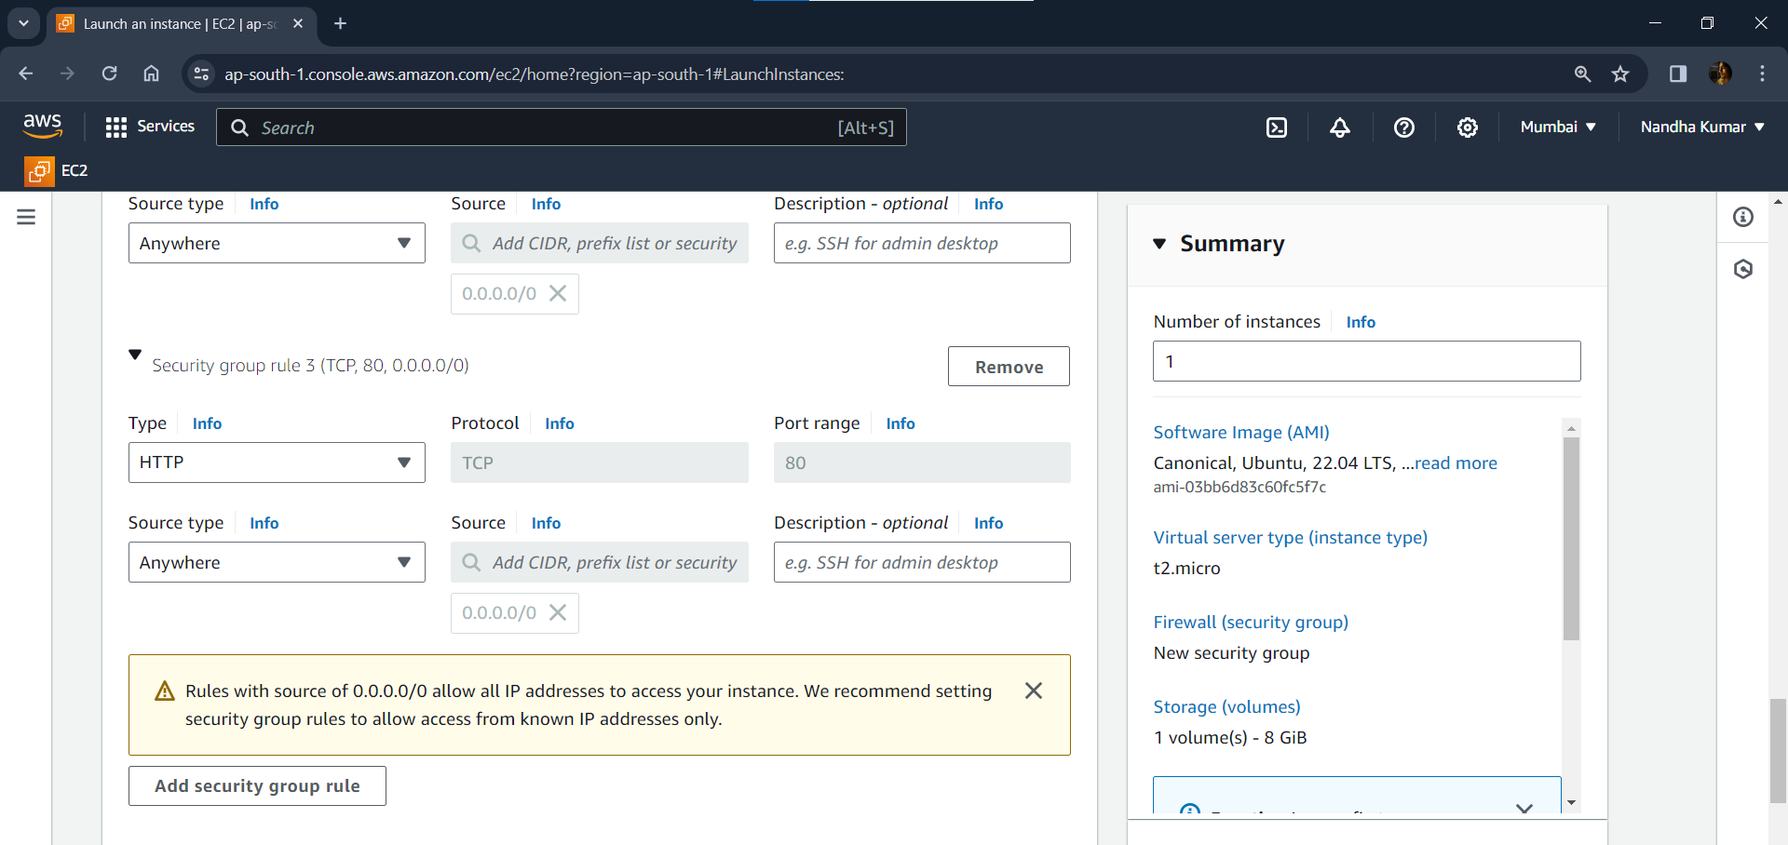

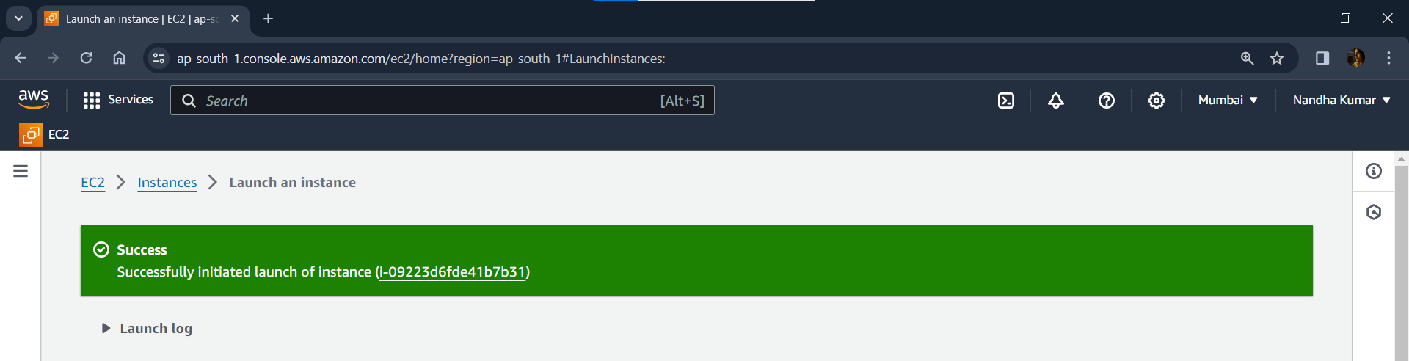

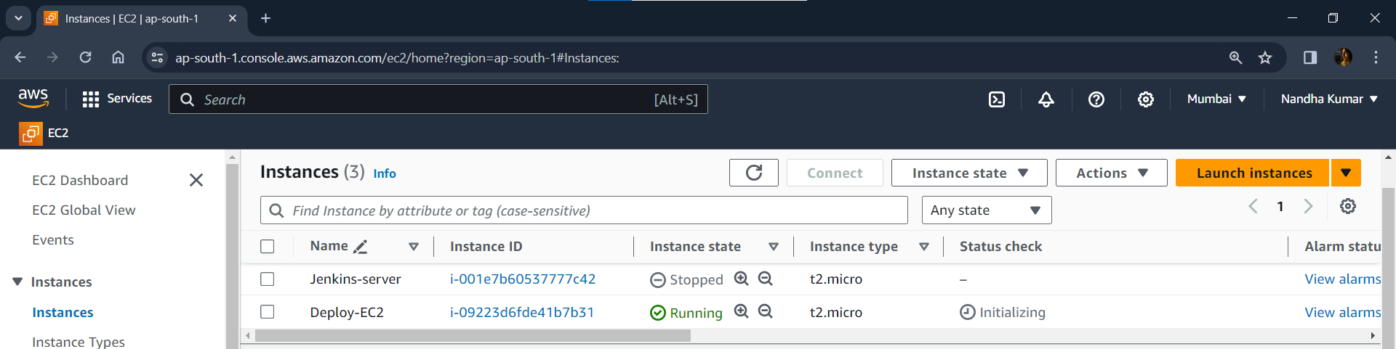

**Connecting this EC2 using SSH:**

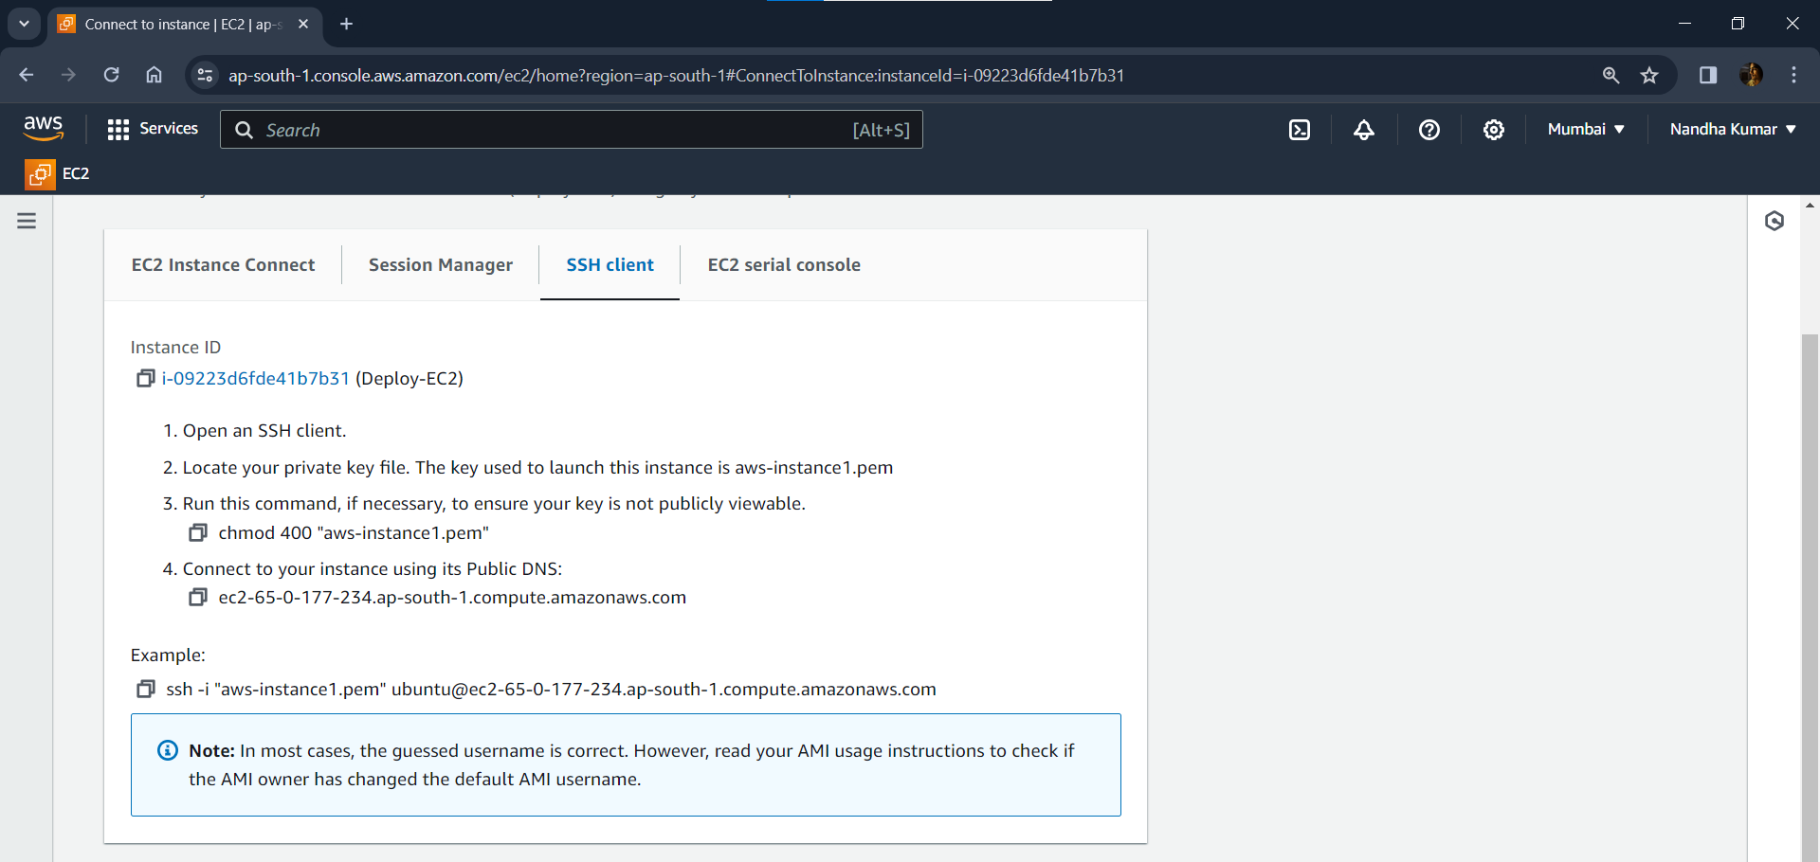

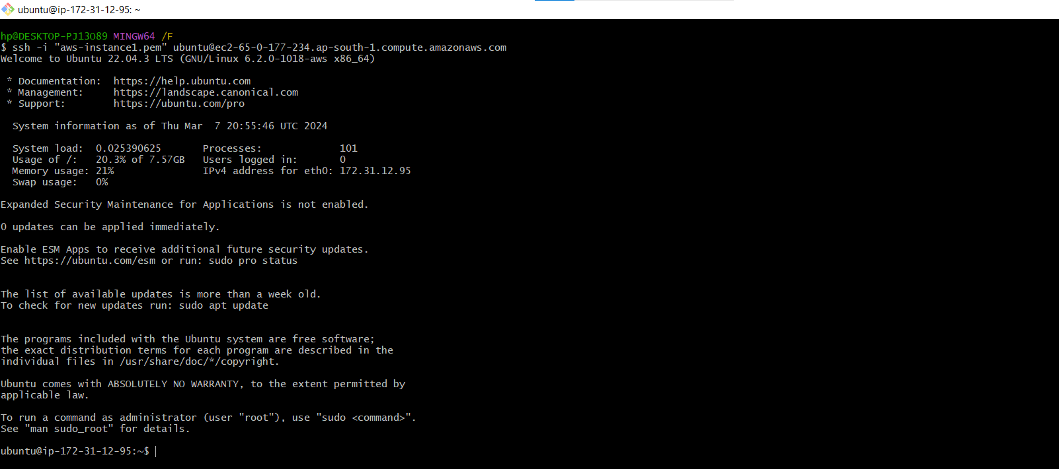

**Installing Docker in EC2 instance:**

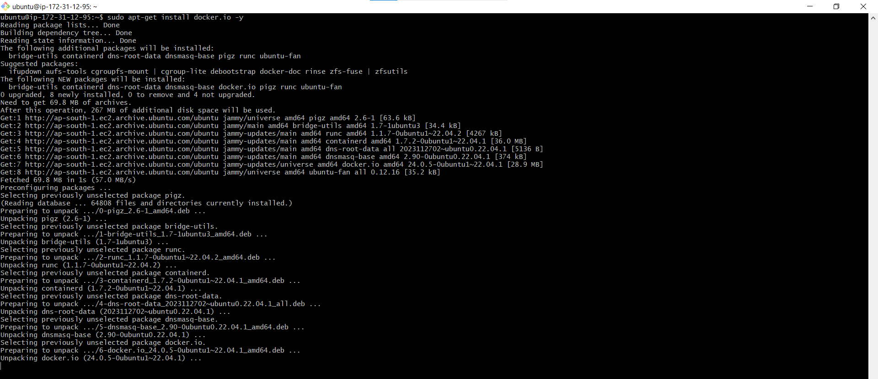



**Adding user in Docker group:**

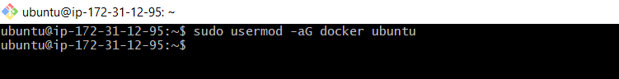

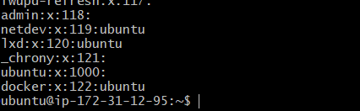

**Creating Deploy.sh to Pull Image from Dockerhub and deploying the created application:**

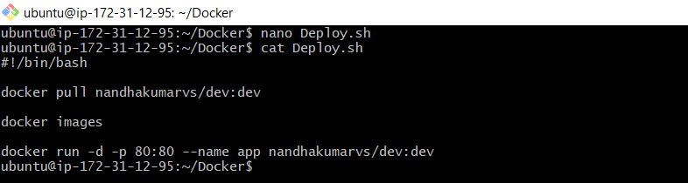

**Executing the Deploy.sh file to deploy the created application:**

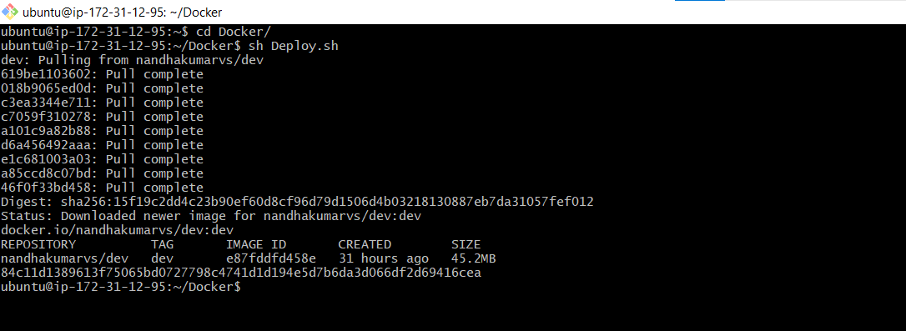

**NOTE: Unfortunatly the above launched EC2 instance got destroyed. So, I created another EC2 instance with same configurations.**

**Deployed locally:** [**http://13.235.67.104/**](http://13.235.67.104/)

**Checking in localhost using EC2 public IP:**

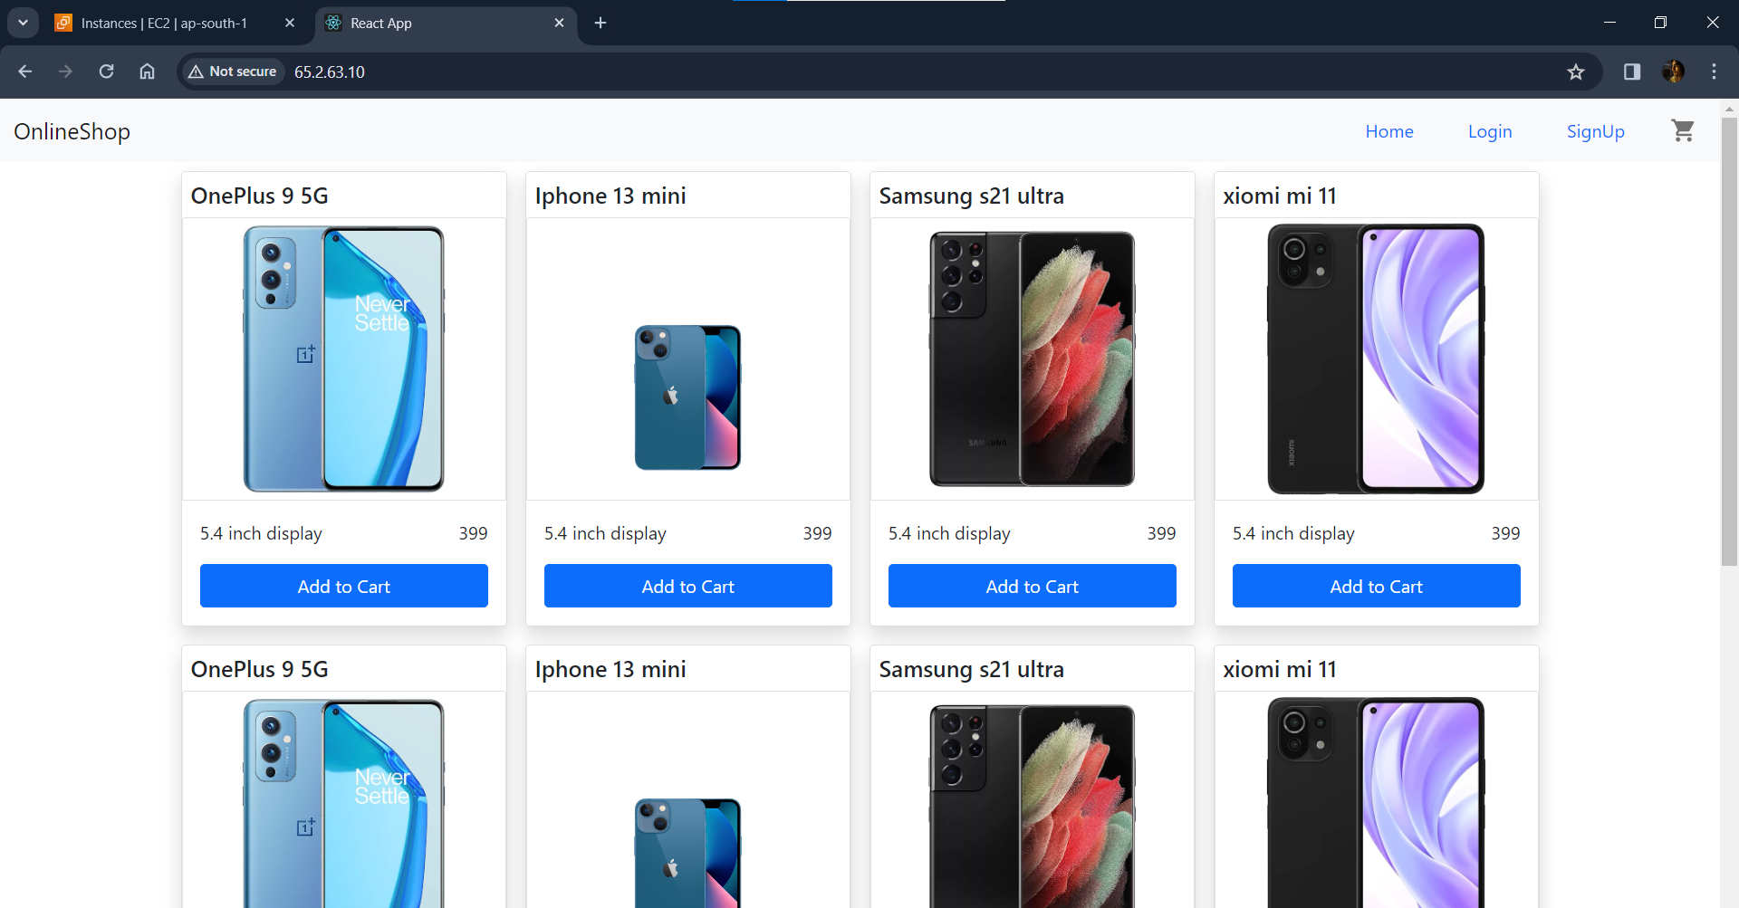

**Monitoring Set-UP:**

**Installing Grafana in EC2 using script file:**

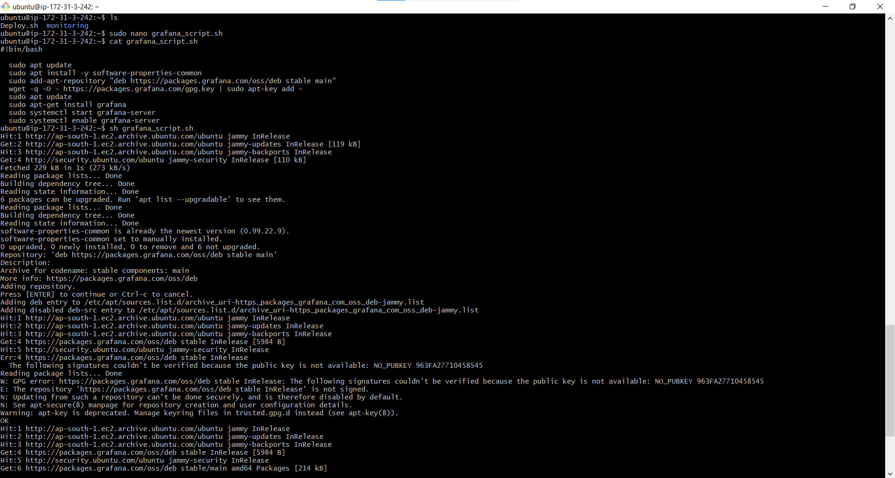

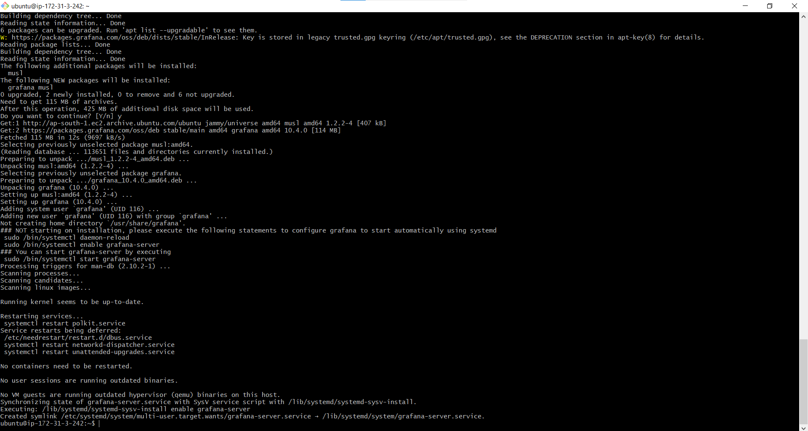

**Launching Grafana in browser unsing EC2 public ID: (**[**http://13.235.67.104:3000/**](http://13.235.67.104:3000/)**)**

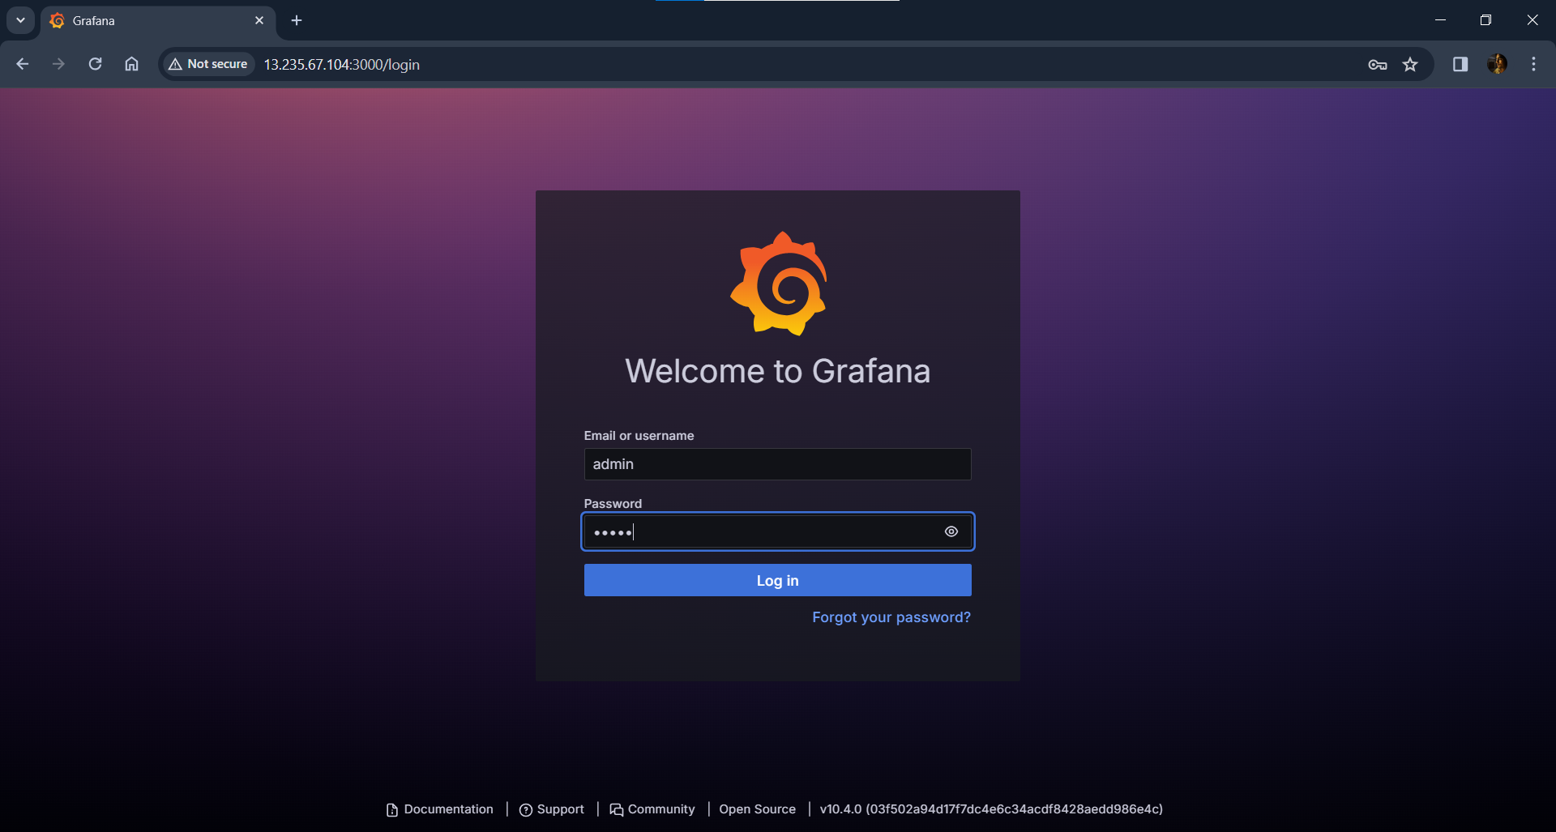

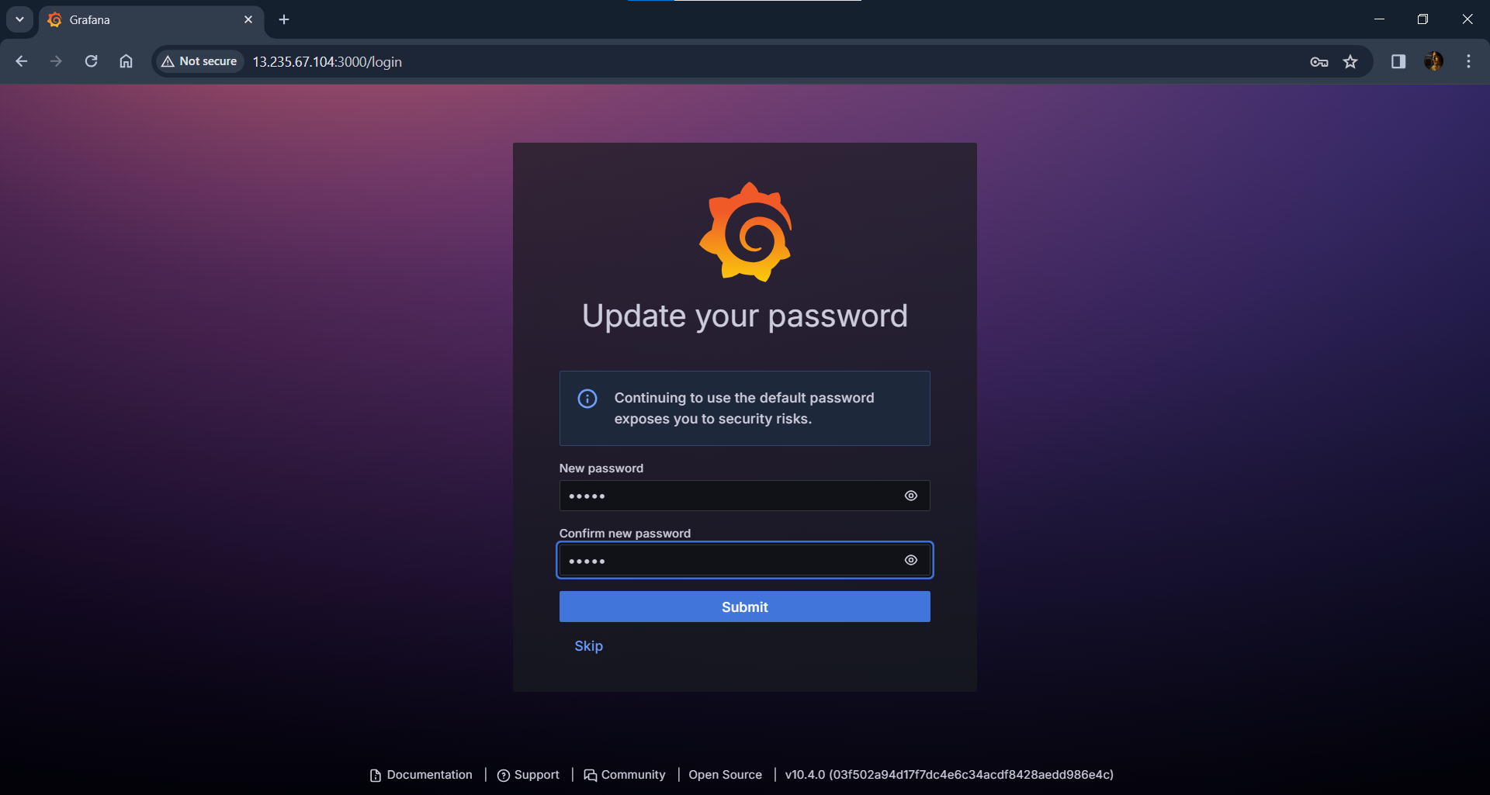

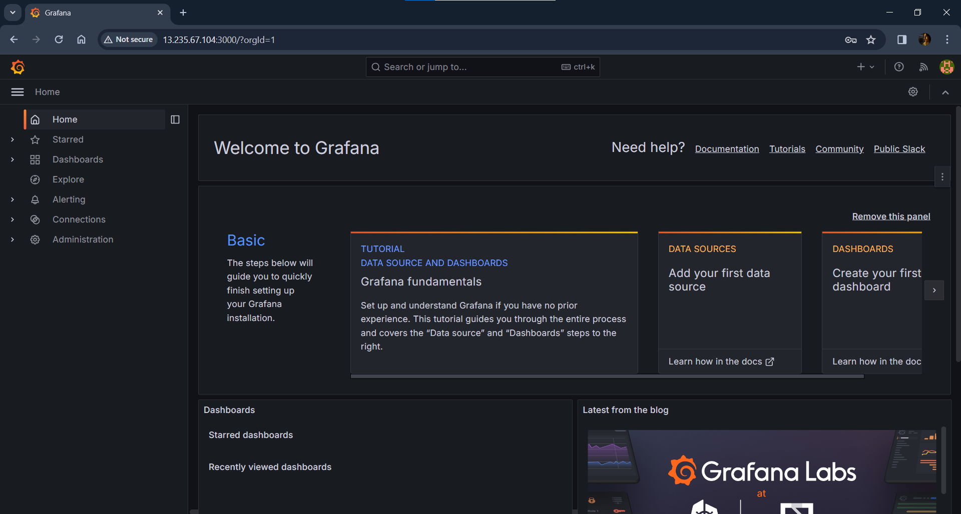

**Installing Prometheus:**

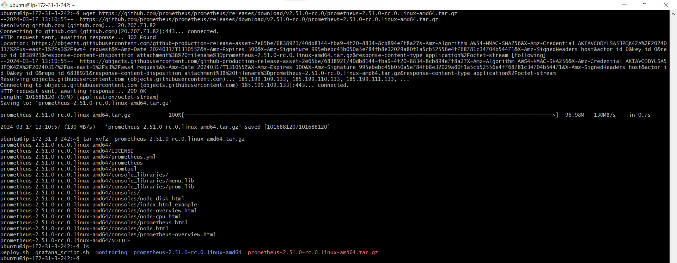

**Running Prometheus:**

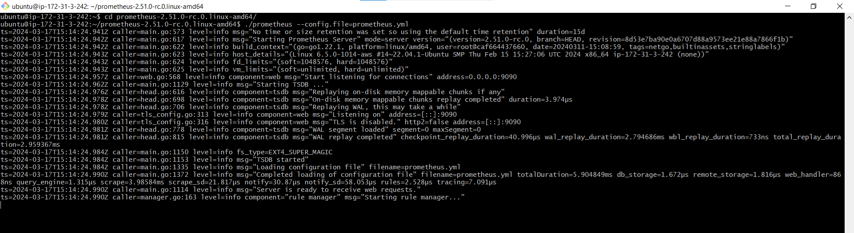

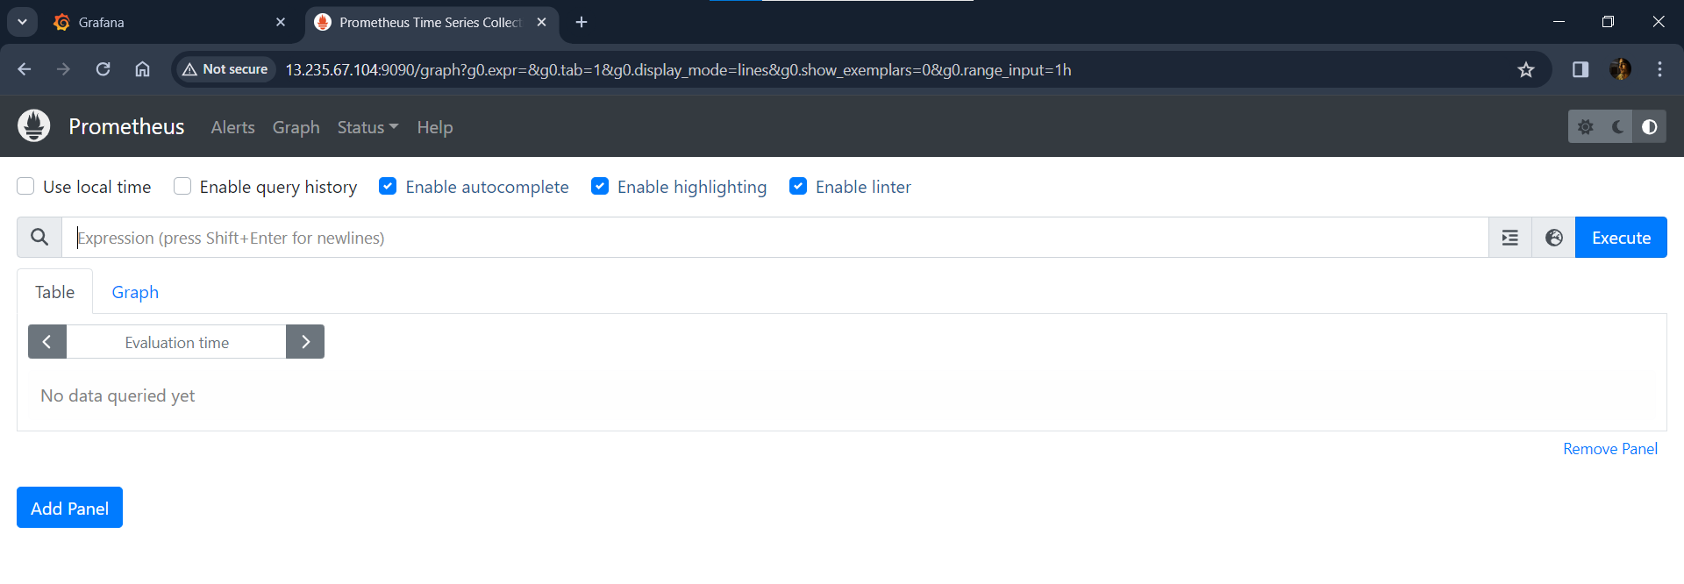

**Setting up daemon.json file: (to collect metrics from docker)**

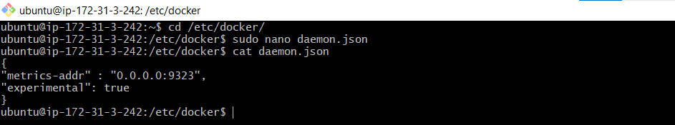

* *After daemon.json set-up, restarted docker*

**Configuring prometheus.yml file: (Adding target)**

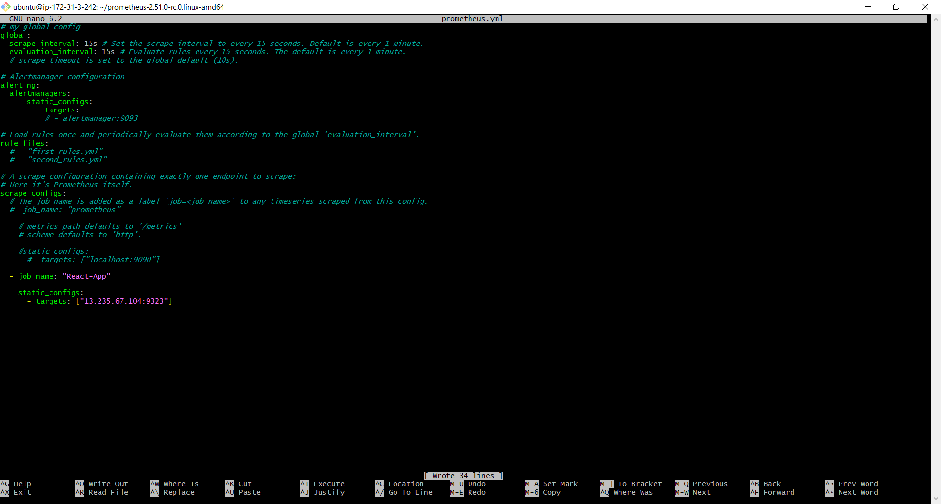

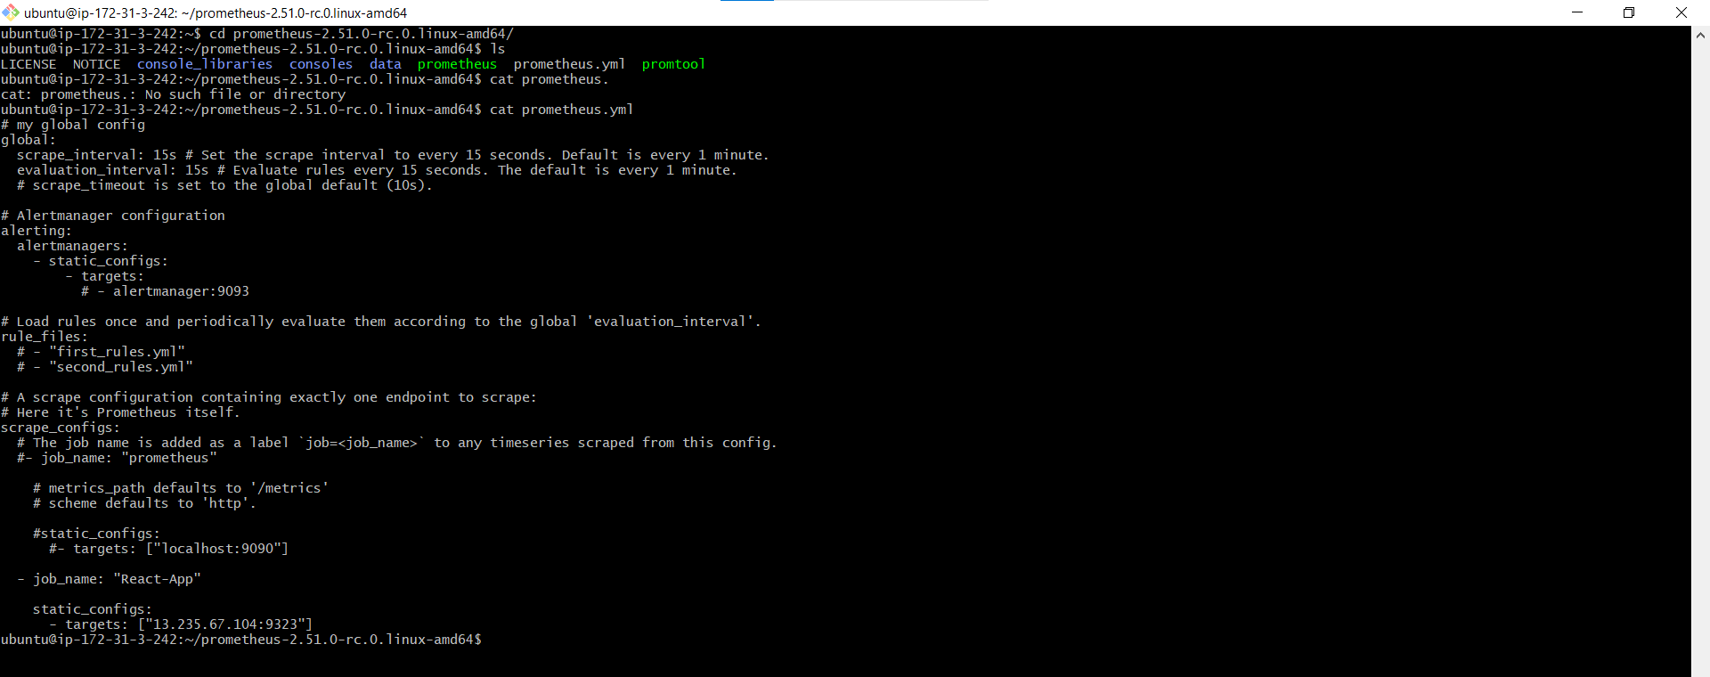

* *After adding target, Prometheus was restarted*

**Checking Prometheus console:**

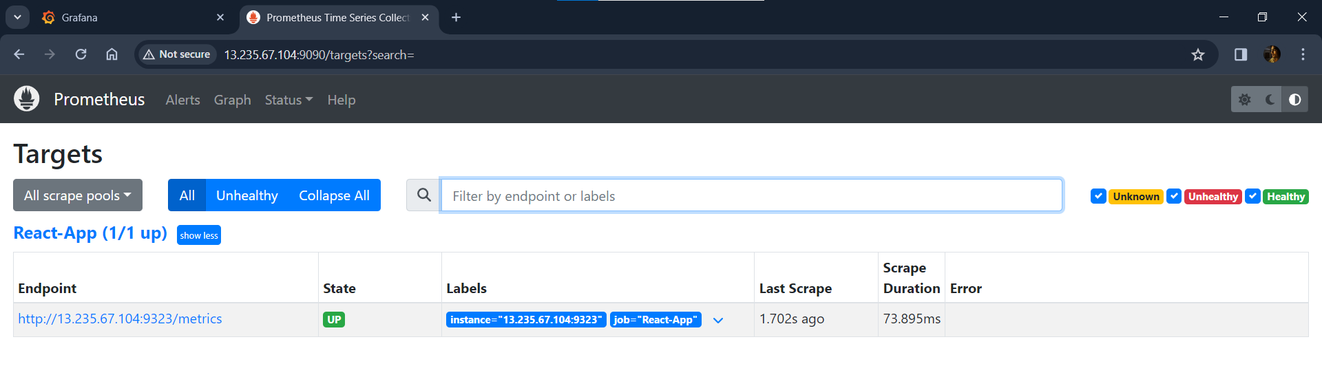

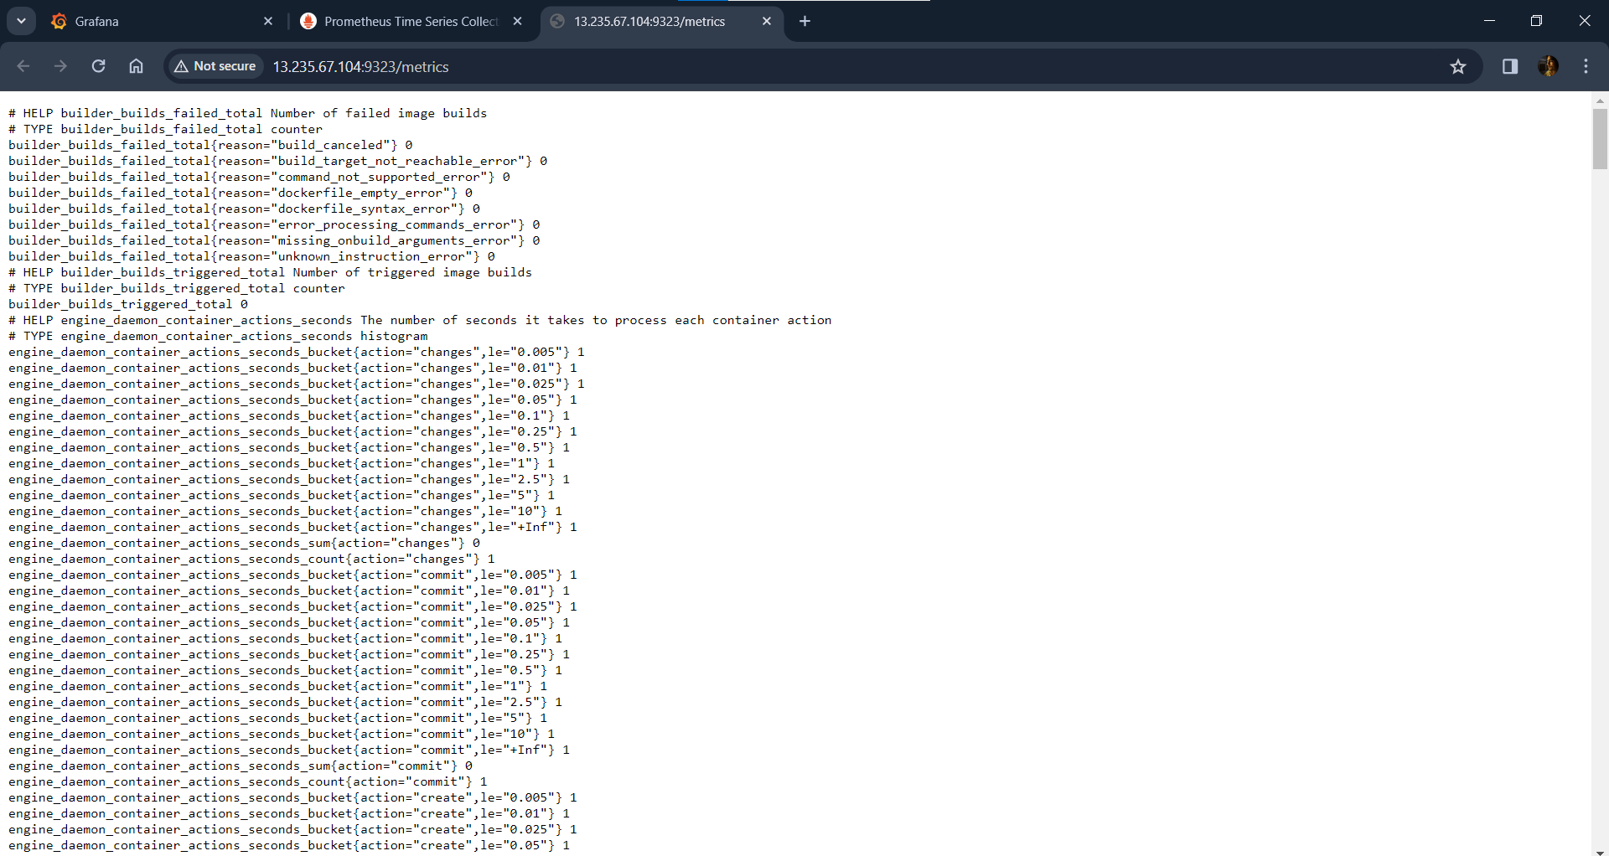

* *Docker metrics are collecting successfully*

**Running docker image:**



**Setting Alert in Grafana:**

**Adding new Data Source**

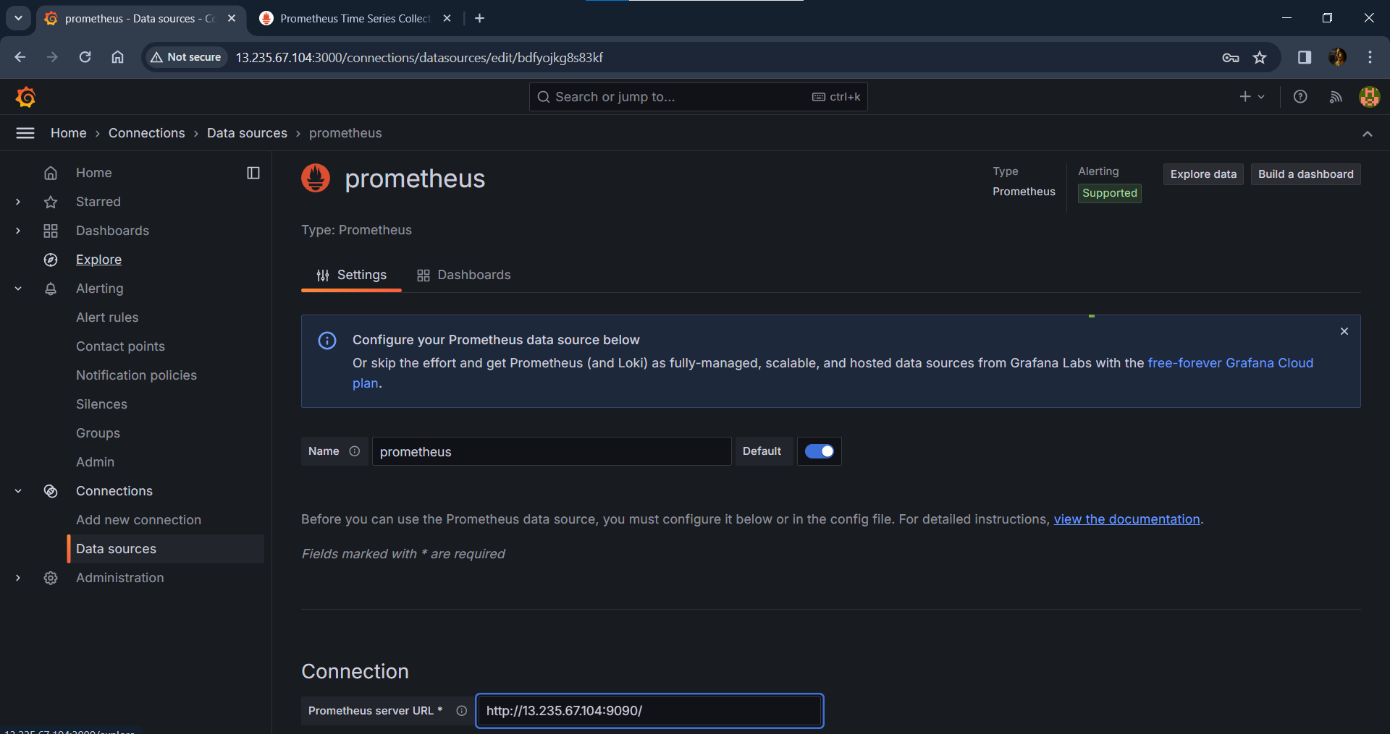

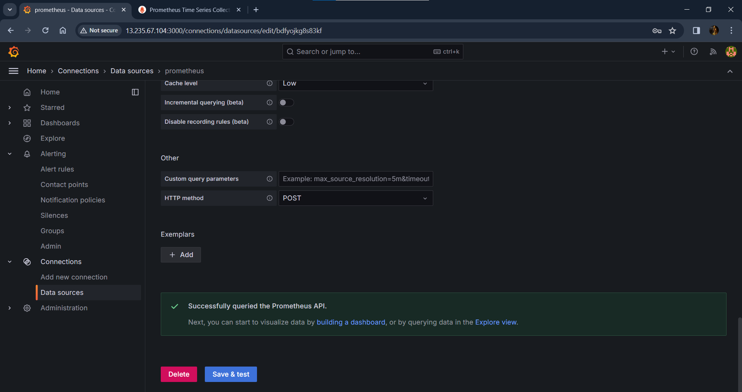

**Setting metric to collect: (Collects only stopped containers)**

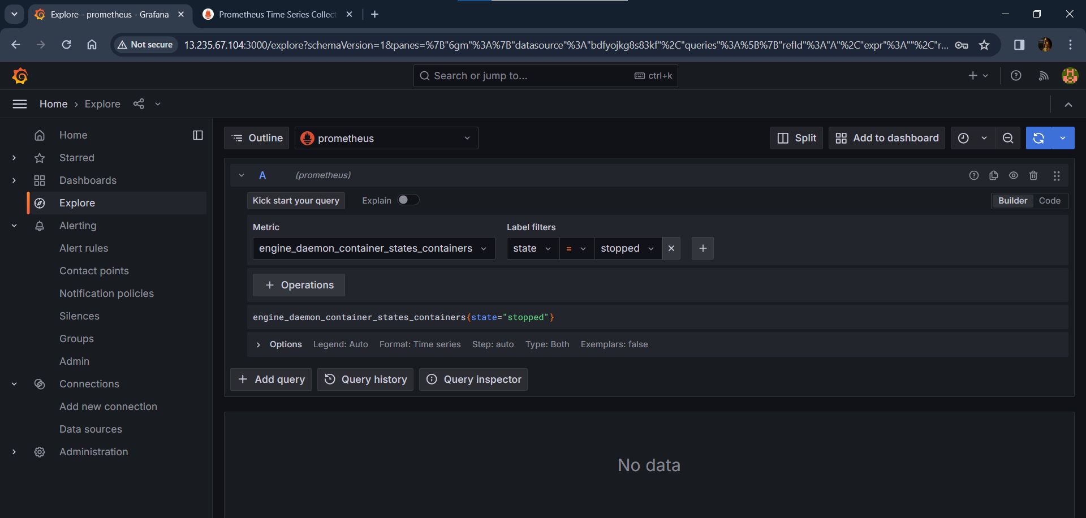

**Stopping docker container: (React-App)**

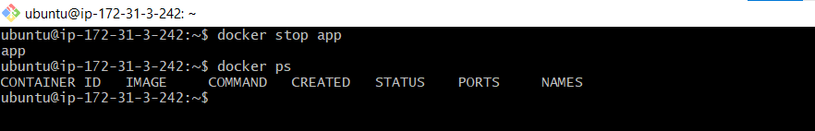

**Checking Grafana Console:**

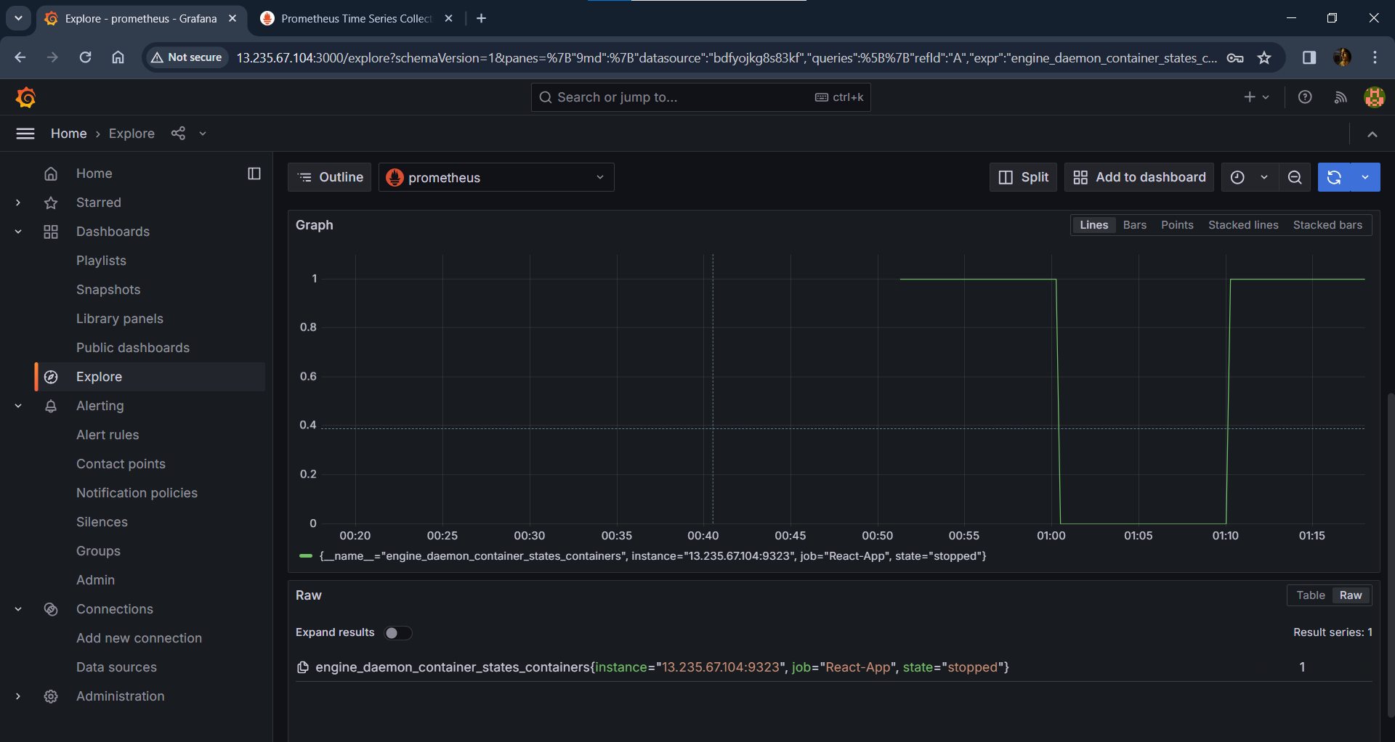

* *Successfully collected metrics from docker and displaying stopped containers*

**Adding to Dashboard:**

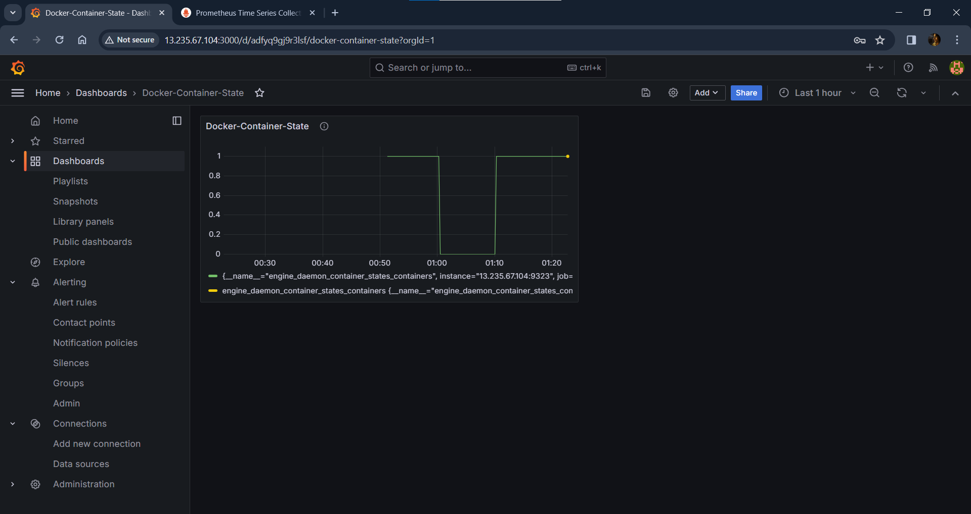

**Setting Alert rules: [To fire if docker container(React-App) is stopped]**

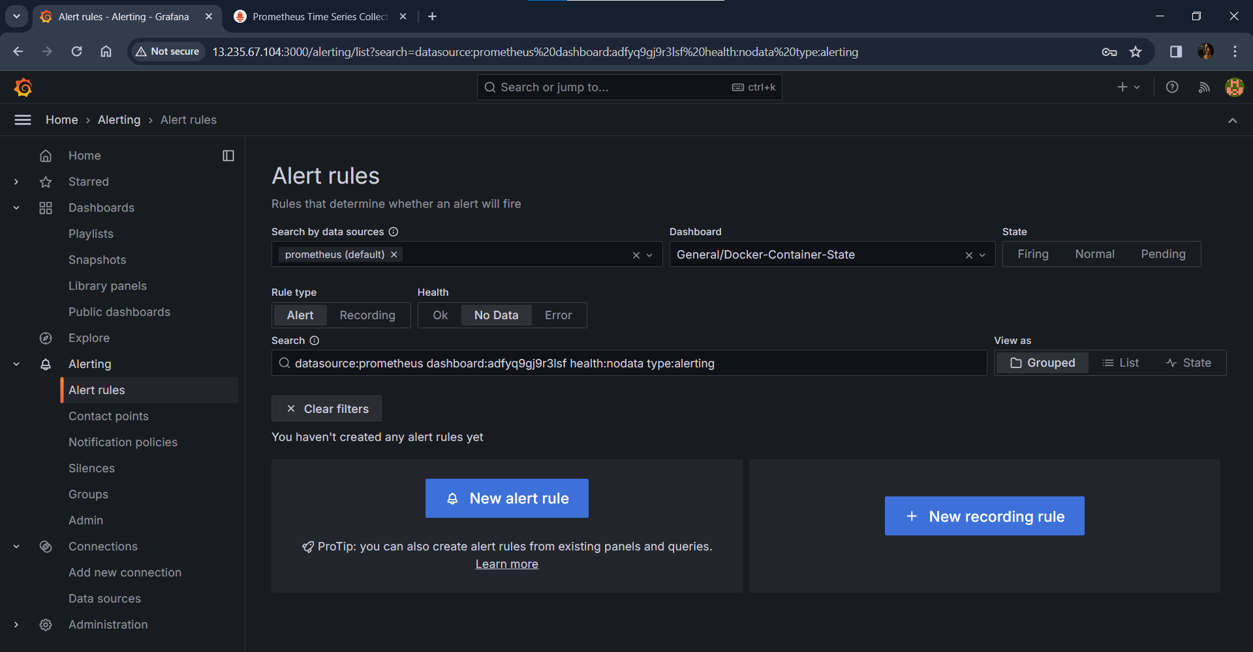

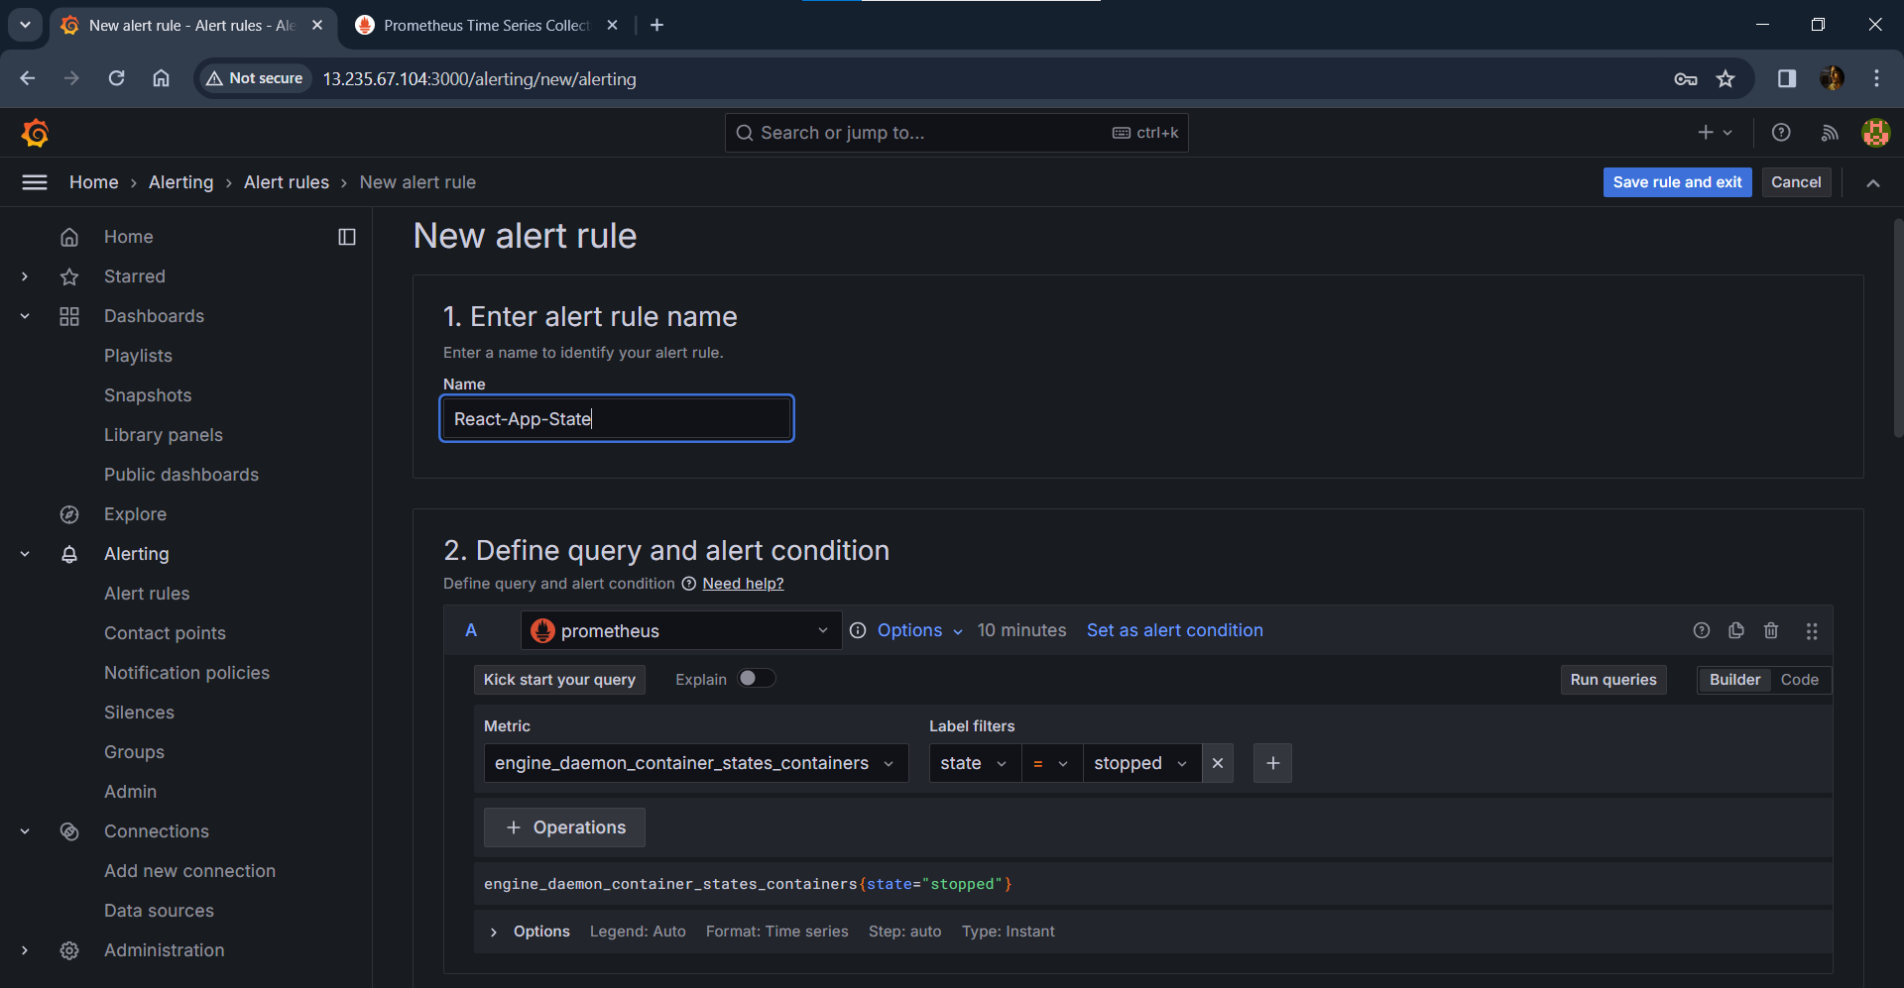

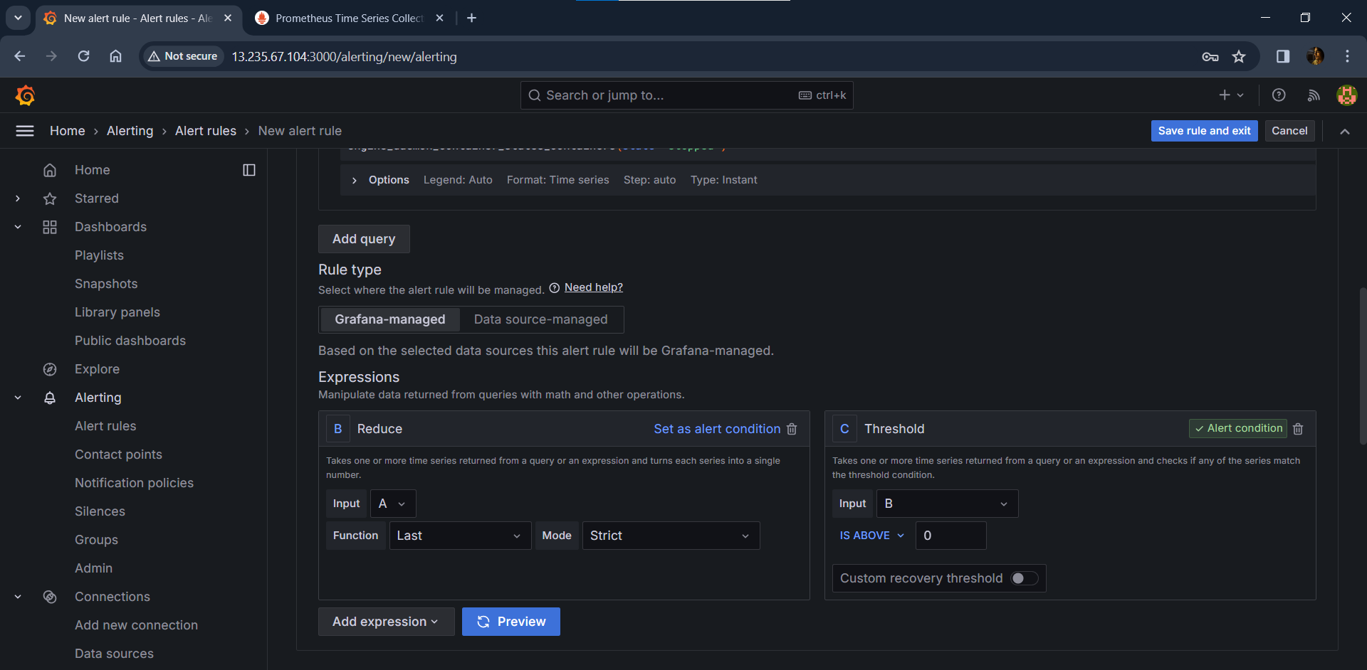

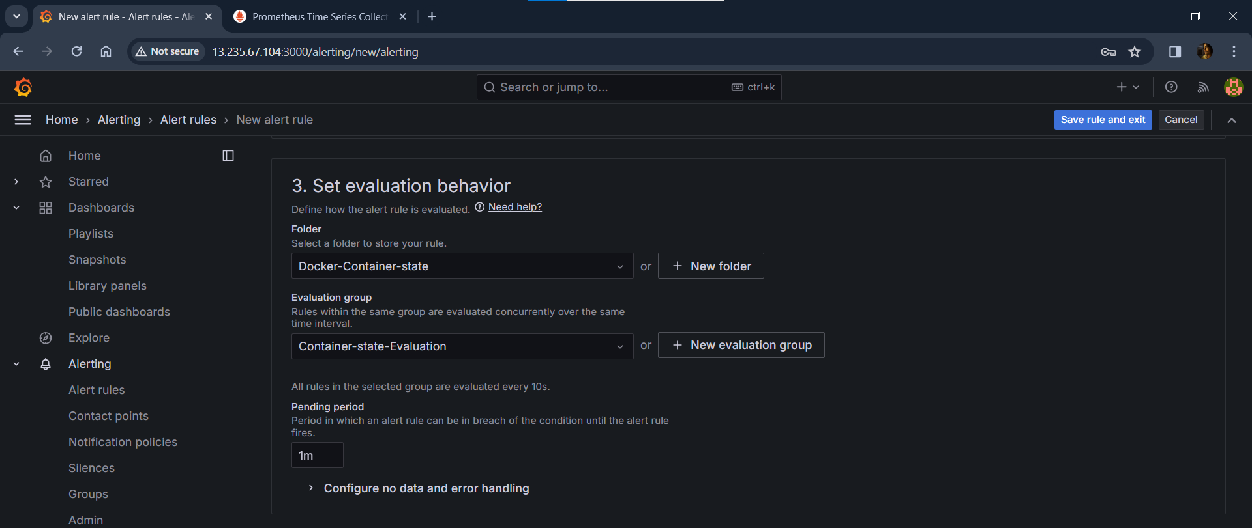

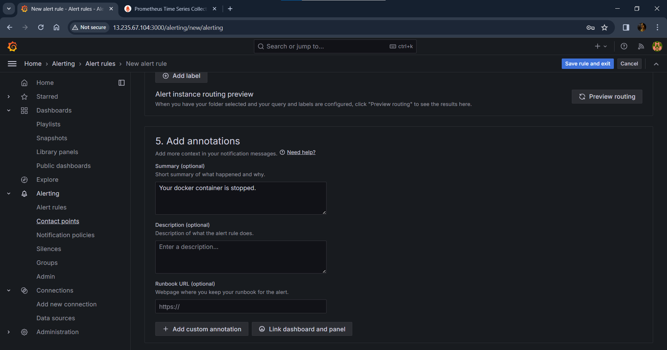

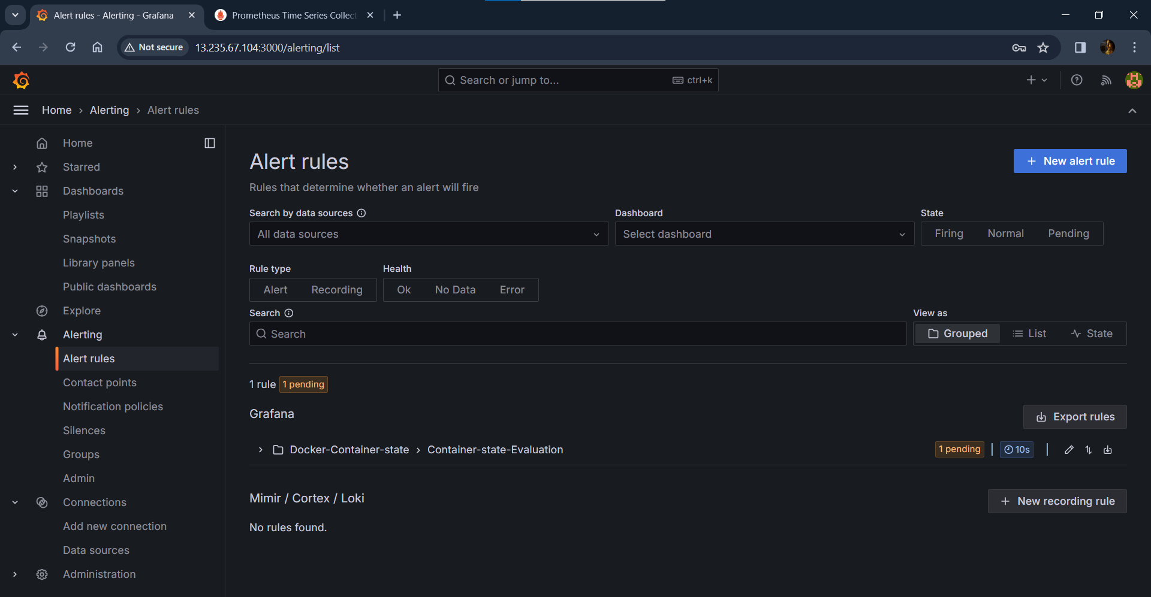

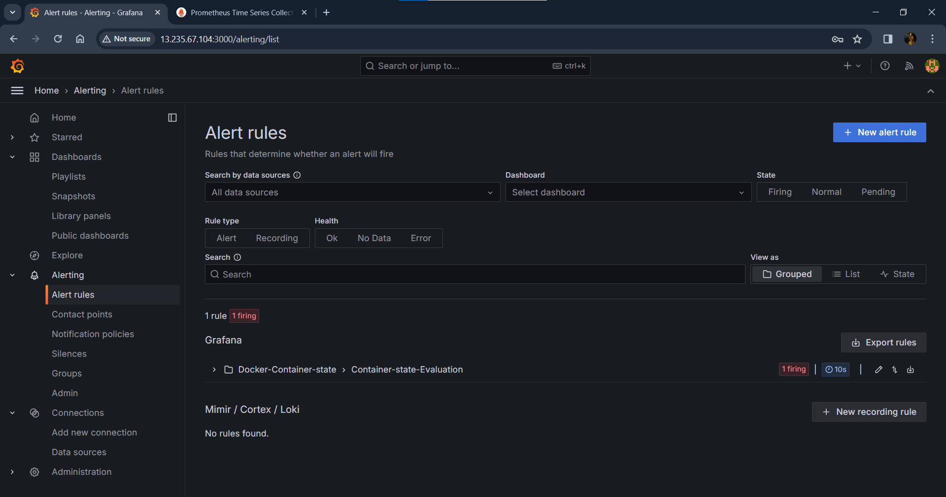

* *Successfully firing alert for stopped container.*

**Starting Docker Container: (React-App)**

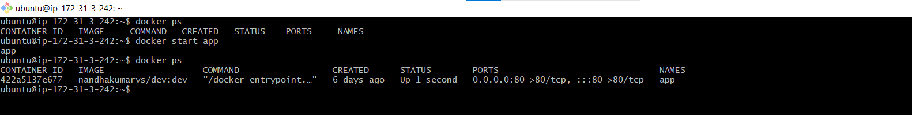

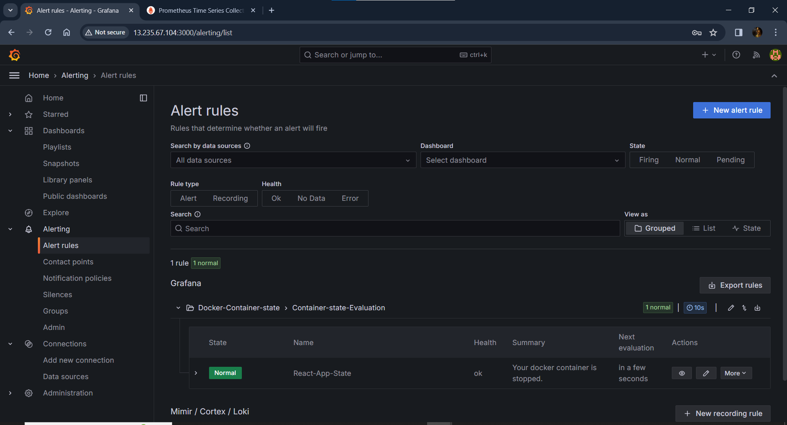

* *Now, Successfully showing result as normal for running containers.*

**Notification Alert Set-UP: (Email notification)**

**Configuring grafana.ini file: (Setting up SMTP data)**

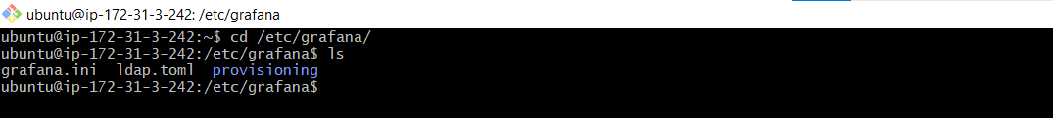

**Uncommanding SMTP configurations:**

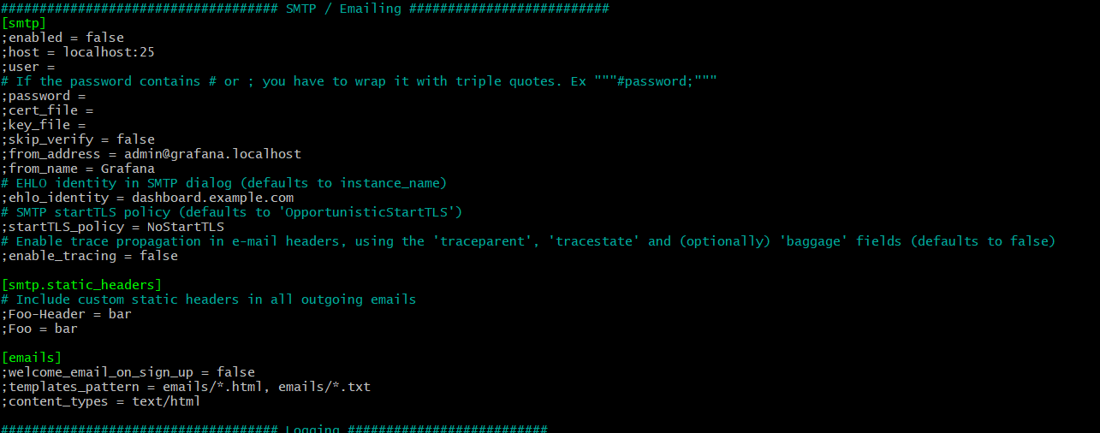

**Modified SMTP part:**

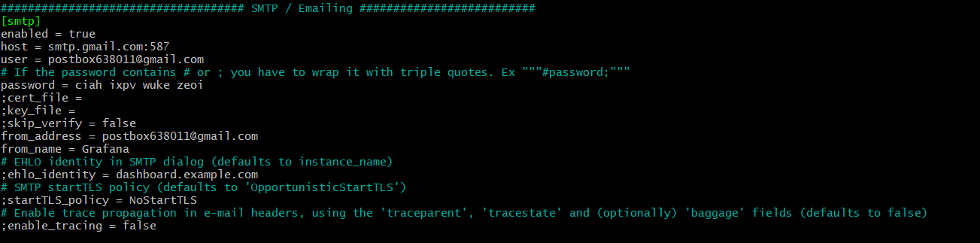



* *After configuration restarted grafana*

**Adding New Contact Point:**

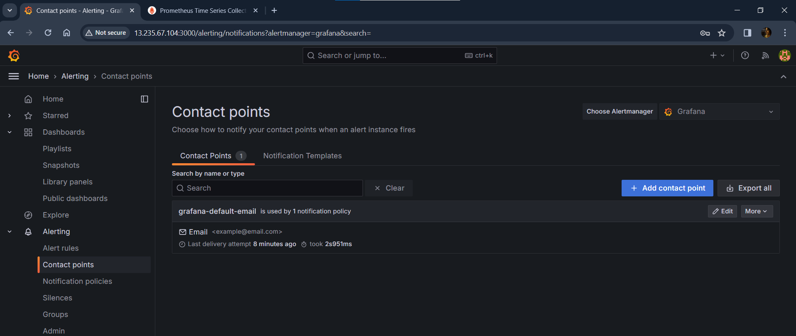

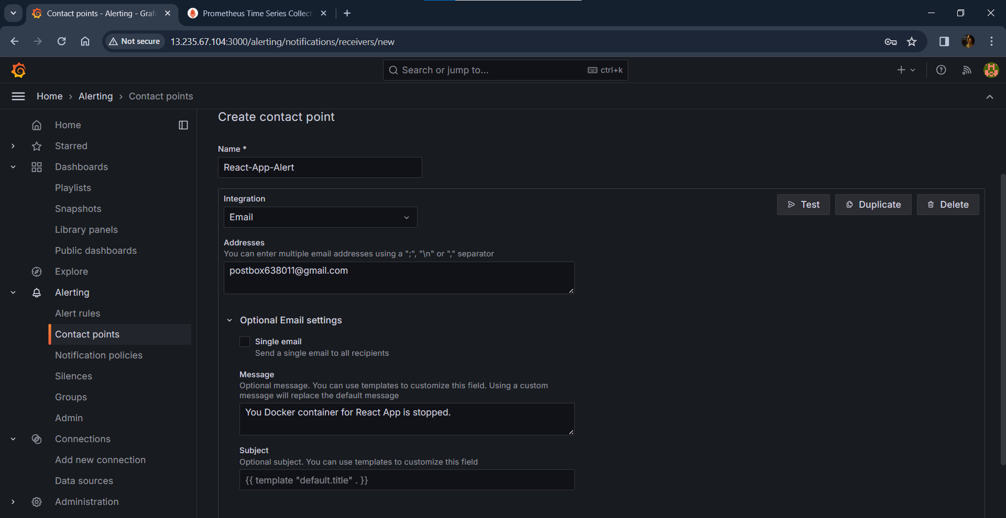

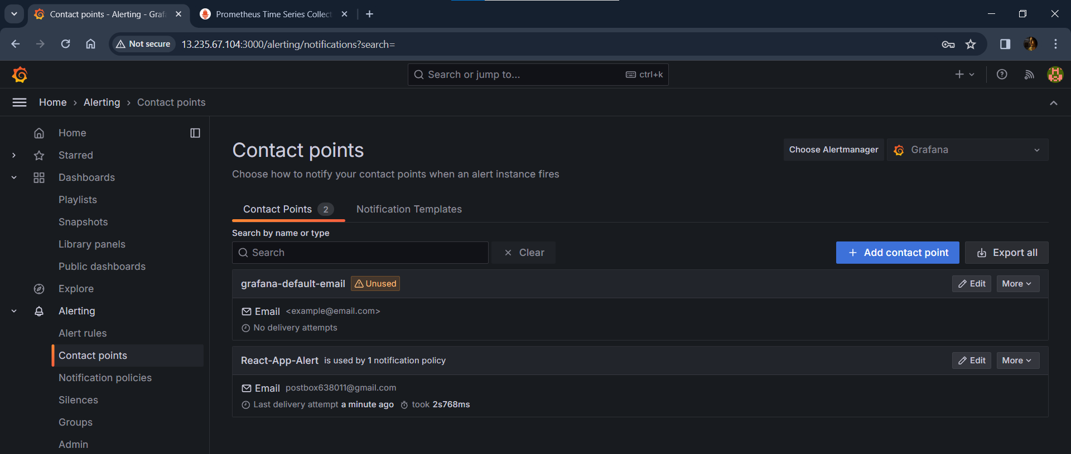

* *Successfully added contact point*

**Stopping Docker Container: (React-App)**

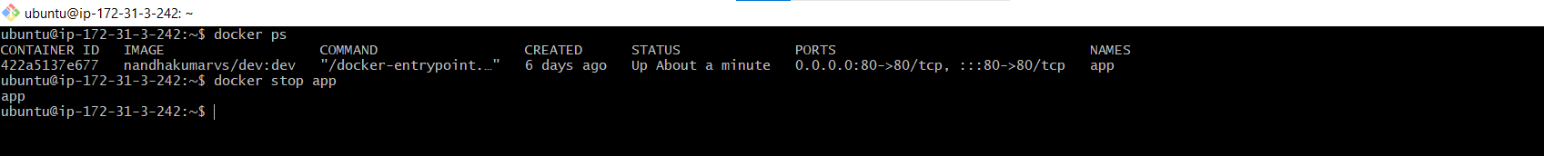

**Checking Grafana Dashboard:**

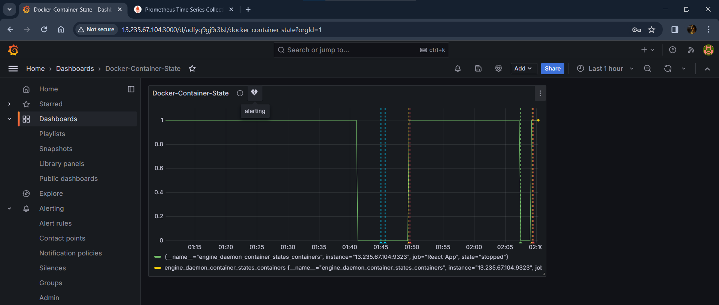

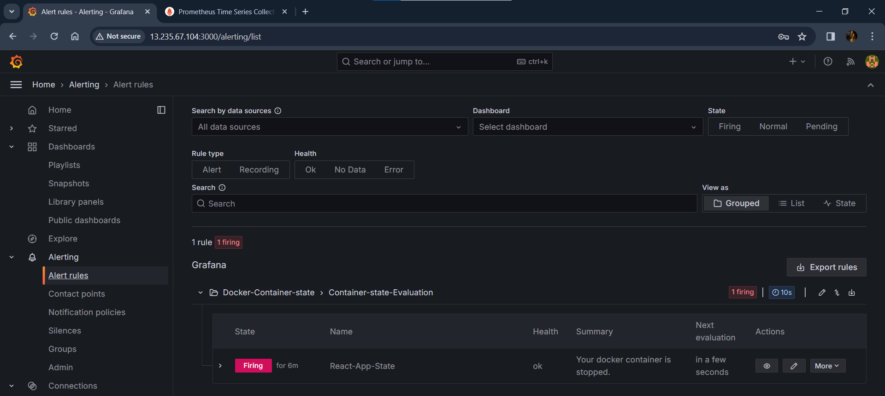

* *Successfully firing alert for stopped container.*

**Checking Email notification: (GMAIL)**

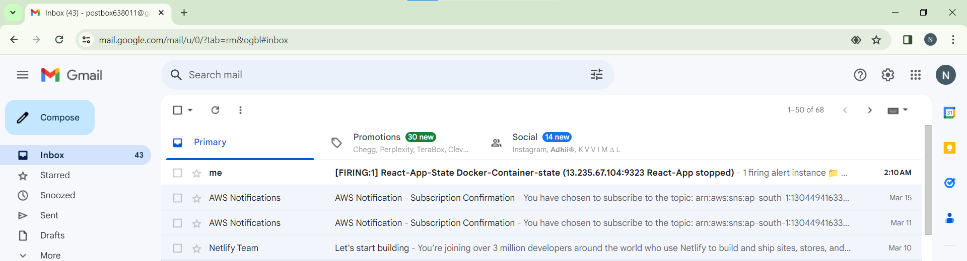

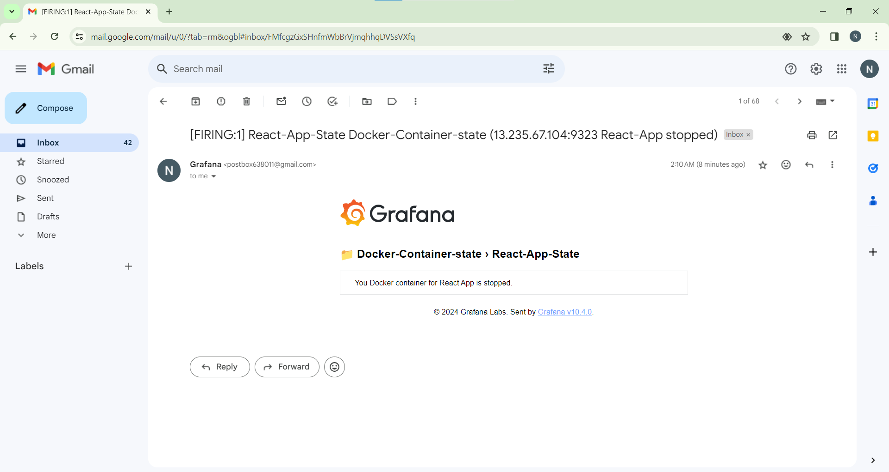

* *Successfully alert notification recevied to mail for stopped container (React-App)*

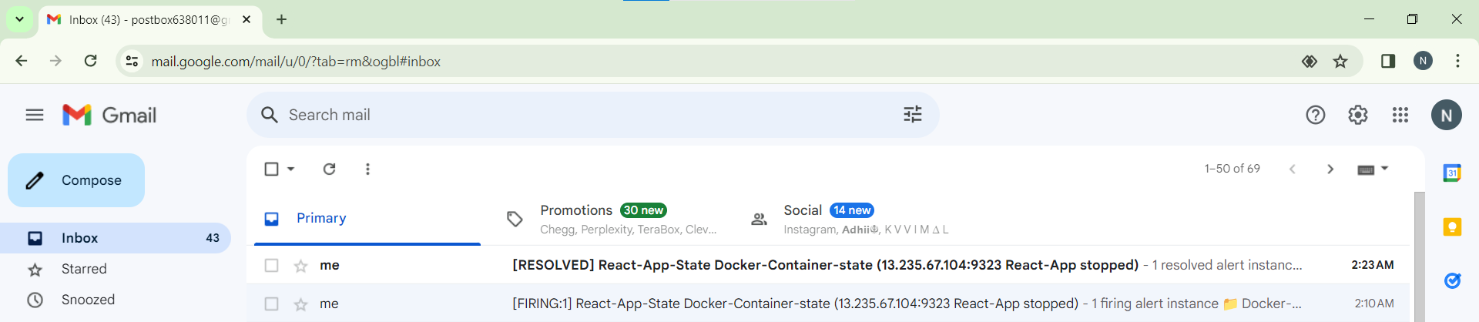

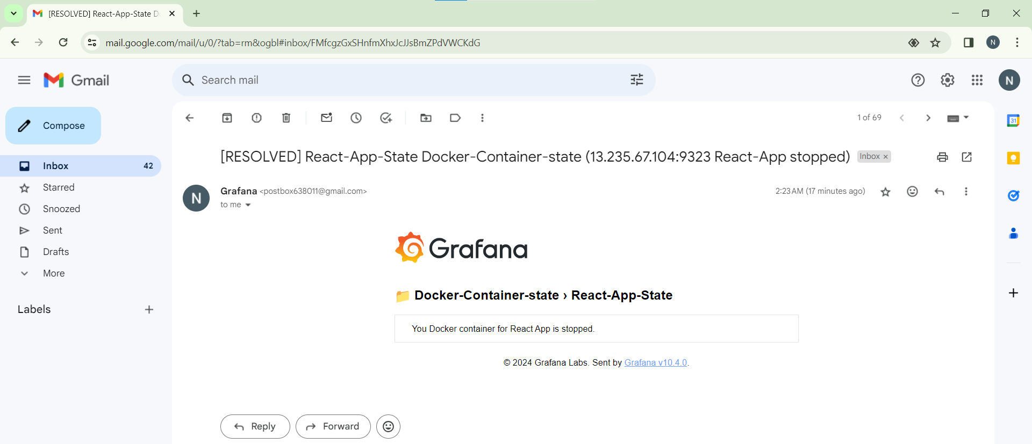

* *Resolved notification also sent as mail*

**Deployed locally:** [**http://13.235.67.104/**](http://13.235.67.104/)

**Hosted react-application using Netlify:**

[**https://nandhakumart-guvi-capstone-project.netlify.app/**](https://nandhakumart-guvi-capstone-project.netlify.app/)

